**Postman**

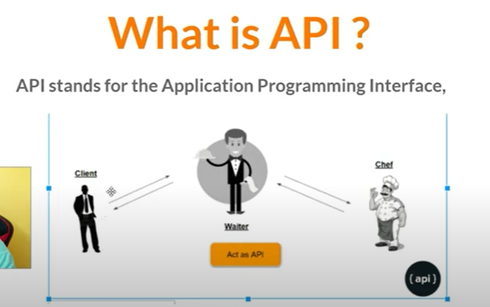

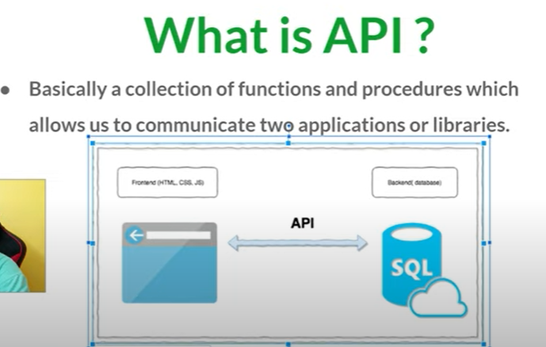

* There are three types of web api

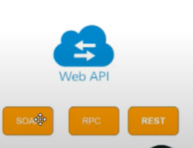

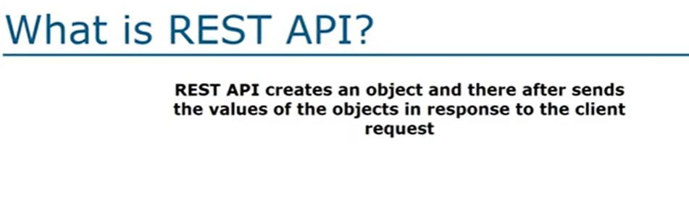



REST = Represental state transfer.

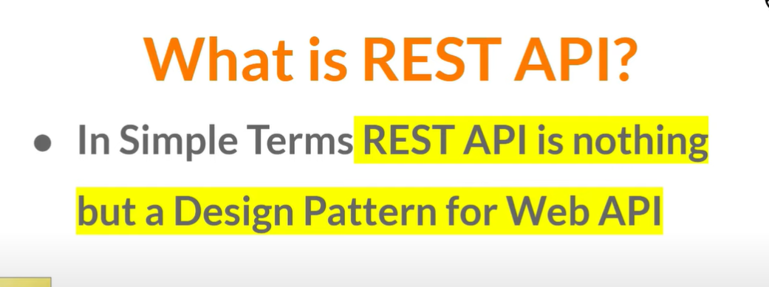

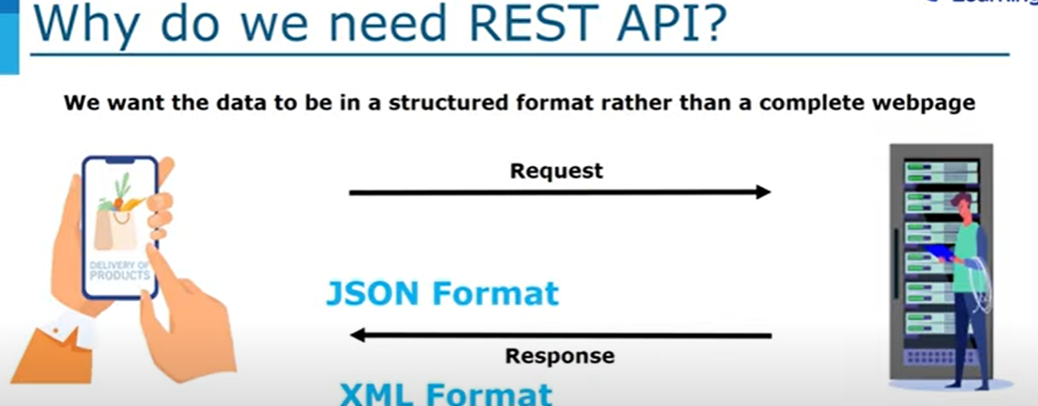

* We received data in json format and xml format

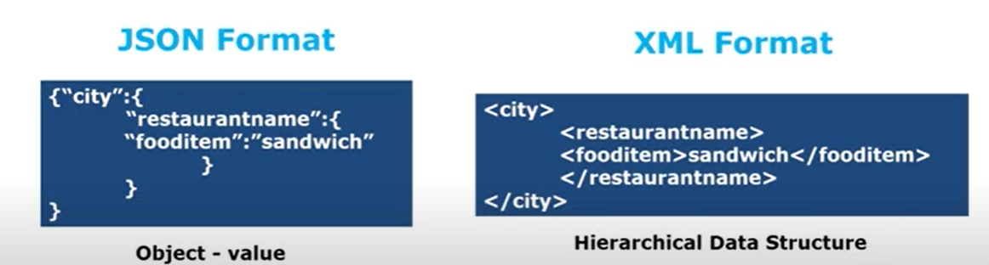

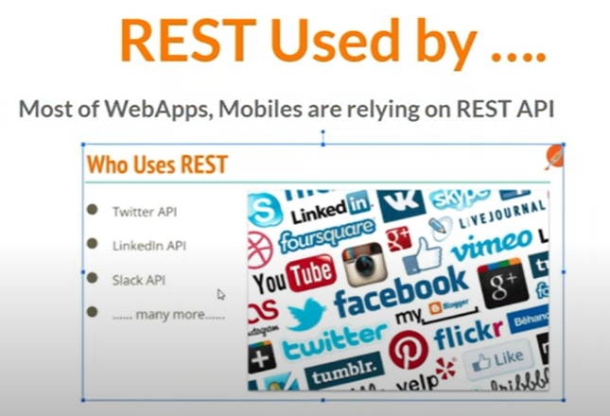

* If any api can follow these 6 rules it means this is rest api

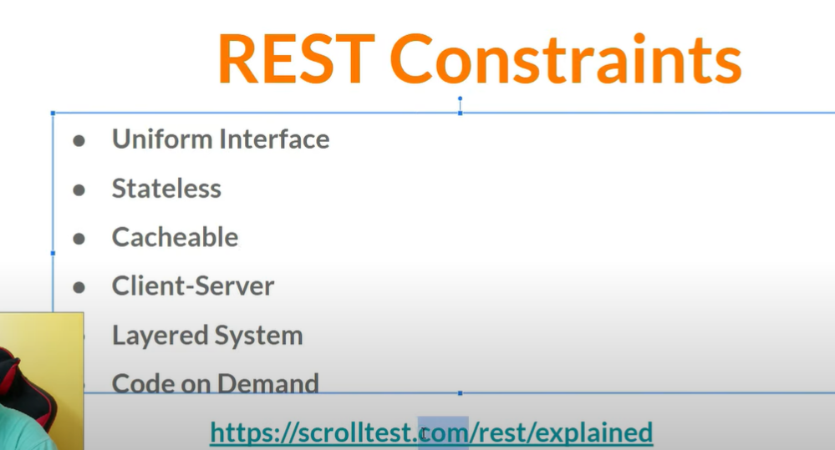

Types of testing in API testing

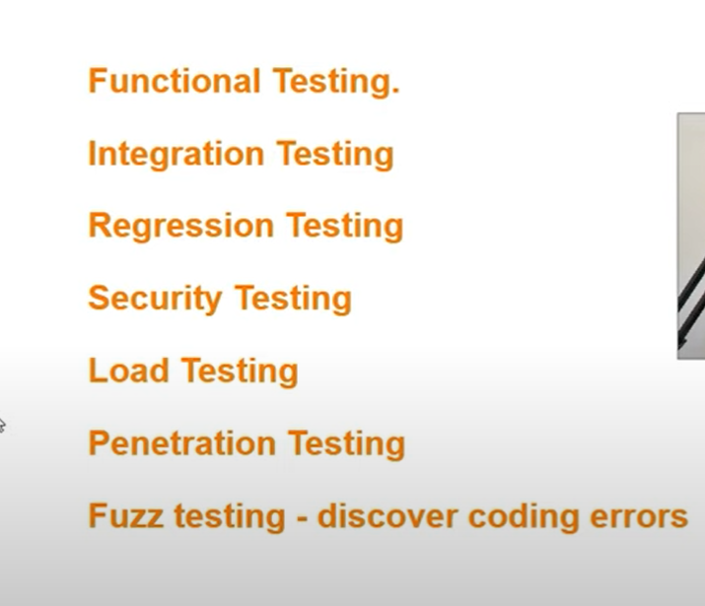

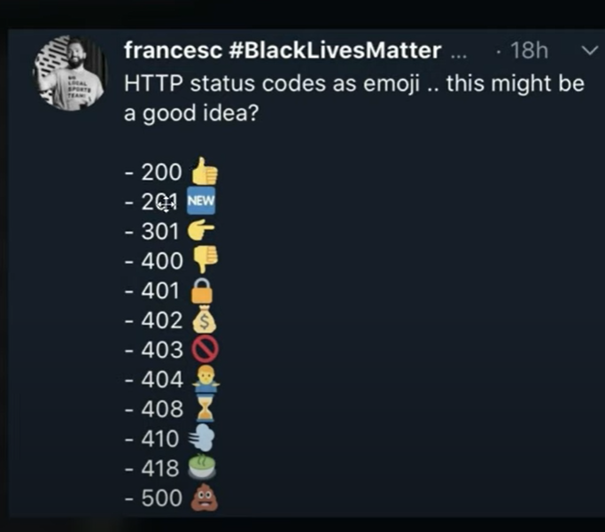

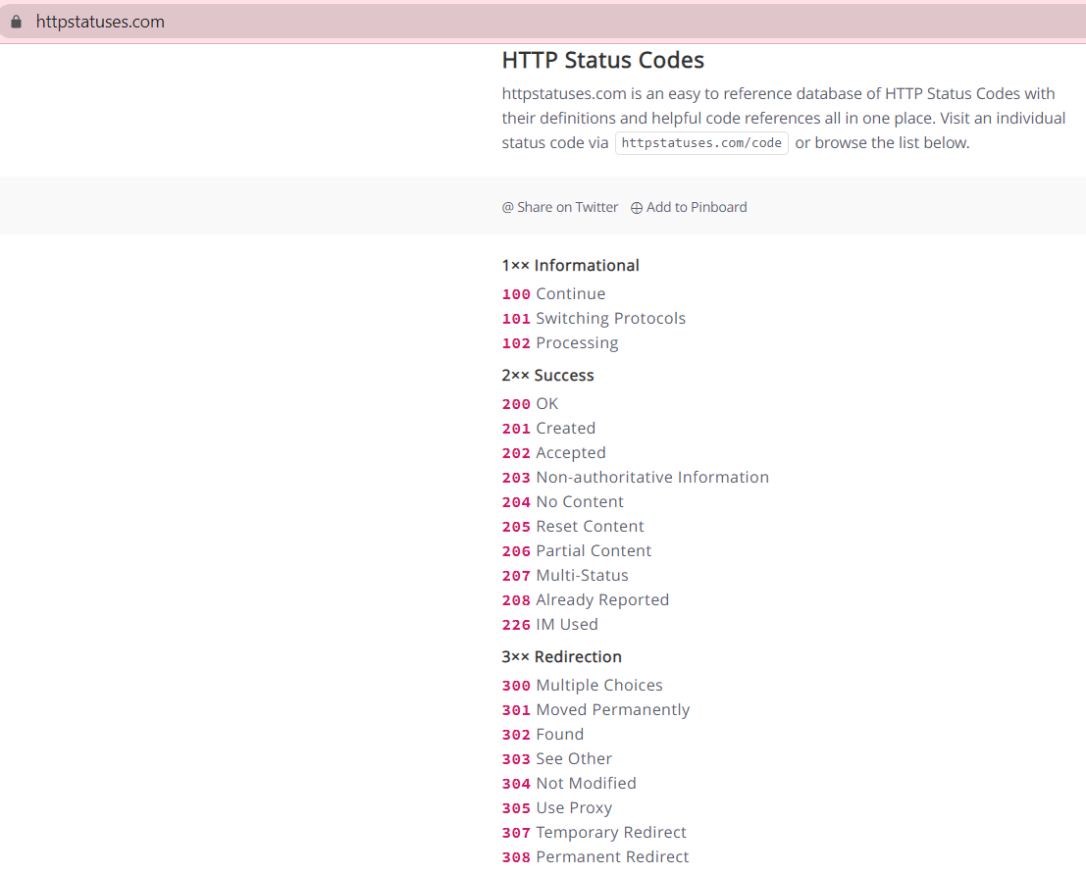

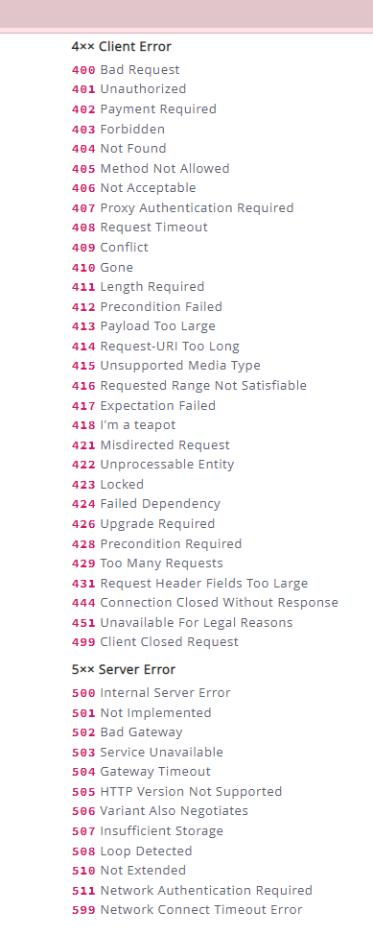

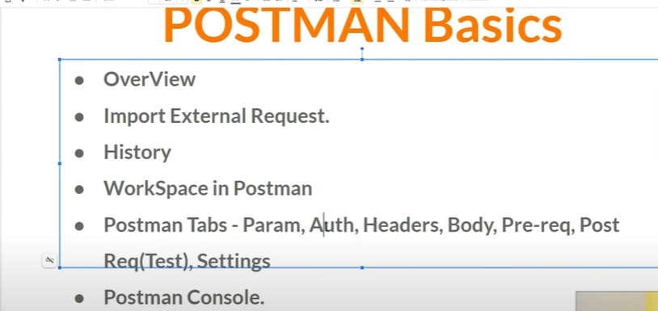

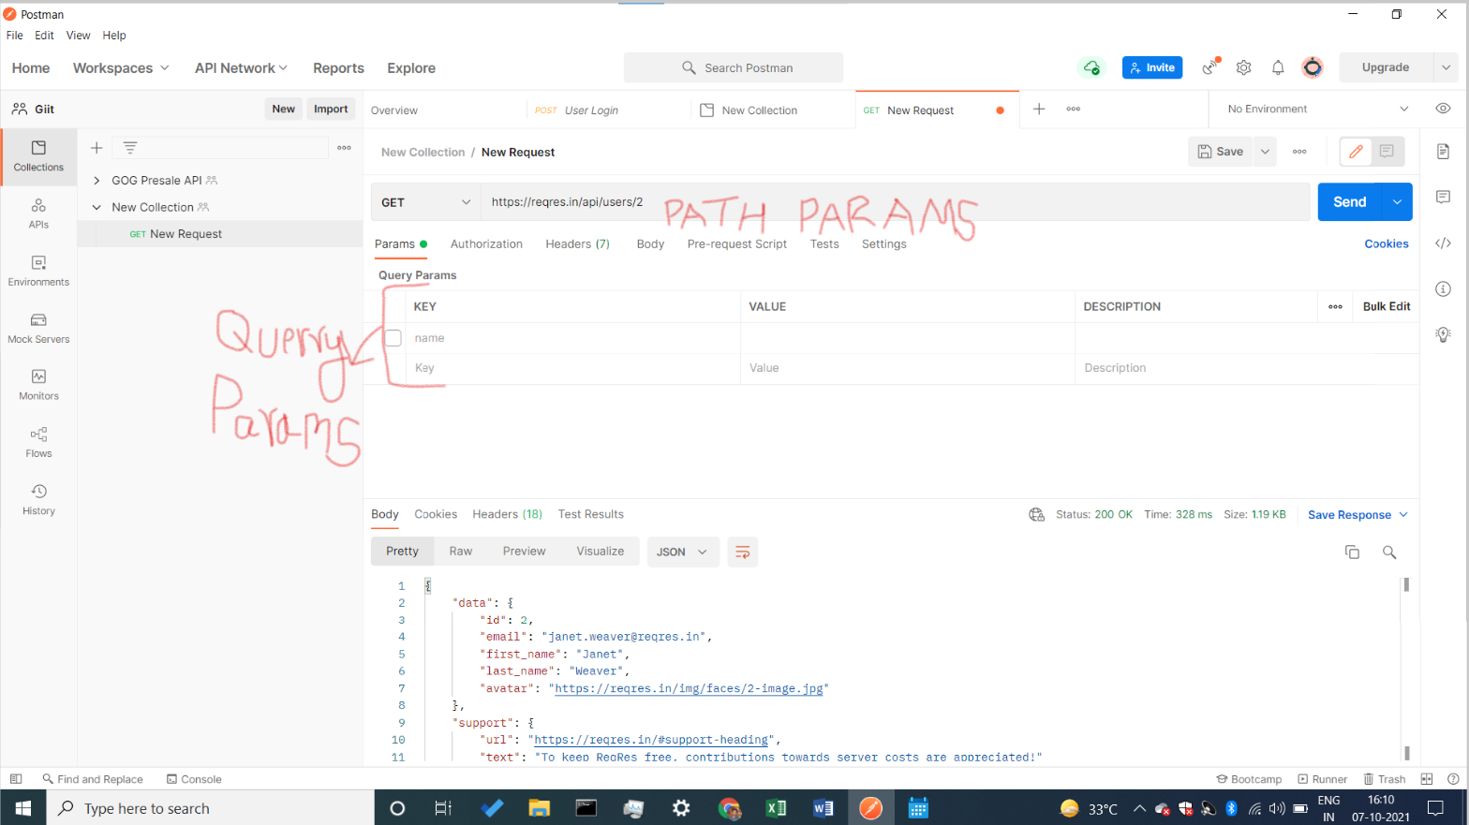

Open test link = [**https://reqres.in/**](https://reqres.in/)

🡪 <https://reqres.in/api/users/1> (data change)

* <https://reqres.in/api/users/2> (data change )

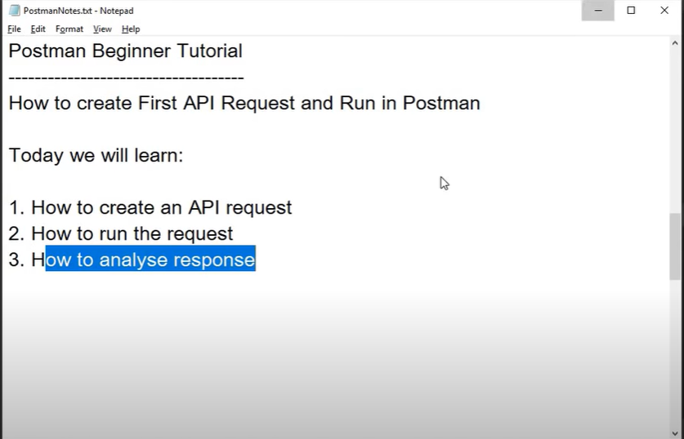

* If we want to have a sample api we use this website to get the sample api. = <https://reqres.in/>
* Select any GET request and paste in new tab url you get the same data.
* 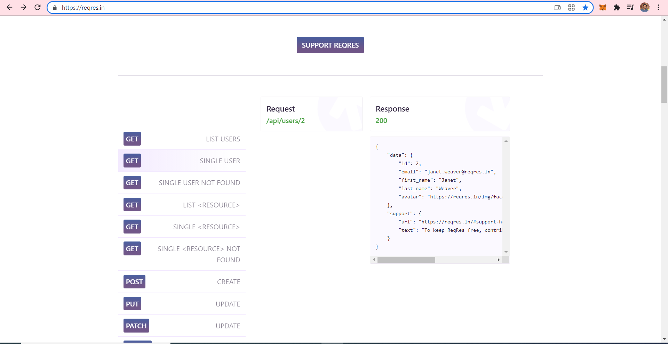
* Copy url & also copy get request id & then paste whole url in new tab .



* Create a new workspace postman.
* Select get request & enter this URL https://reqres.in/api/users/2 you get the same data.
* we get same data in postman also

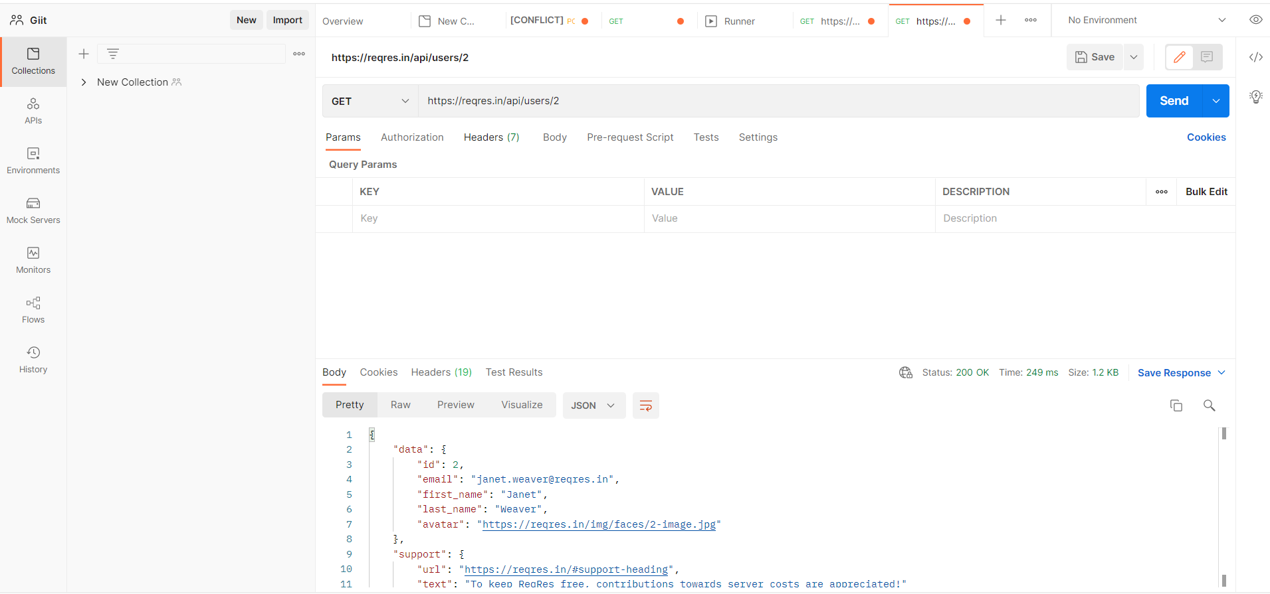

* Types of data format

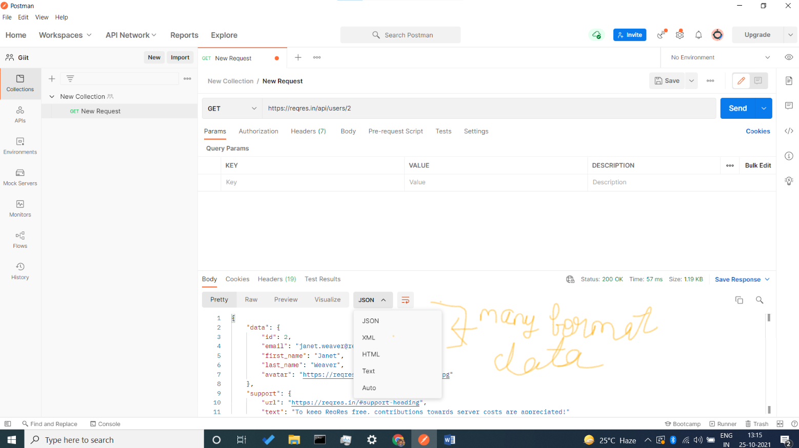

* Status code ,response size, time taken

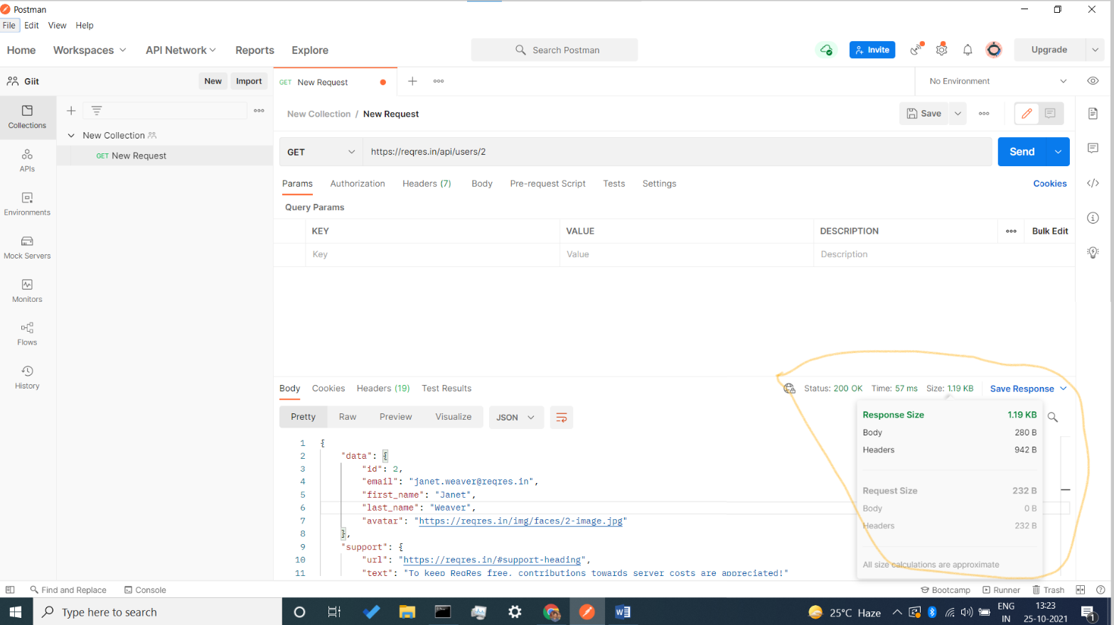

STEP 2:-

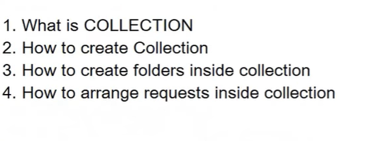

* Collection is a group of api request that can be stored and saved in logical arrangement.
* When you create a collection you have option to use security function like authorization, in authorization you can select **auth** to create username and password that means, firstly when user run your api Enter the name and password, then the API will provide you the data..
* If you don’t want to use authentication you don’t select it.
* We have also an option to share our collection with our colleague and anyone whom we want to share.
* We can also create an folder.

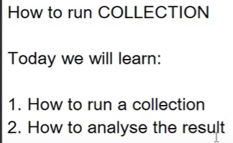

We create a folder in the collection and in the folder we put all our **GET** request file, so when we run our folder all API are run continuously.

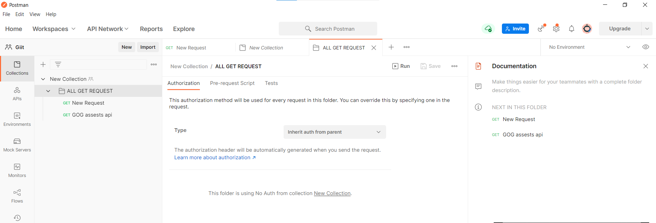

* Run multiple api in same time

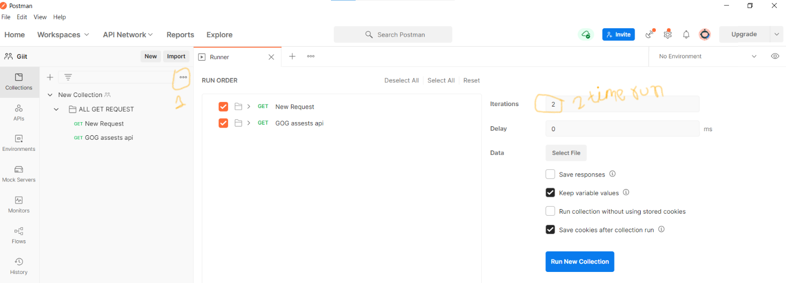

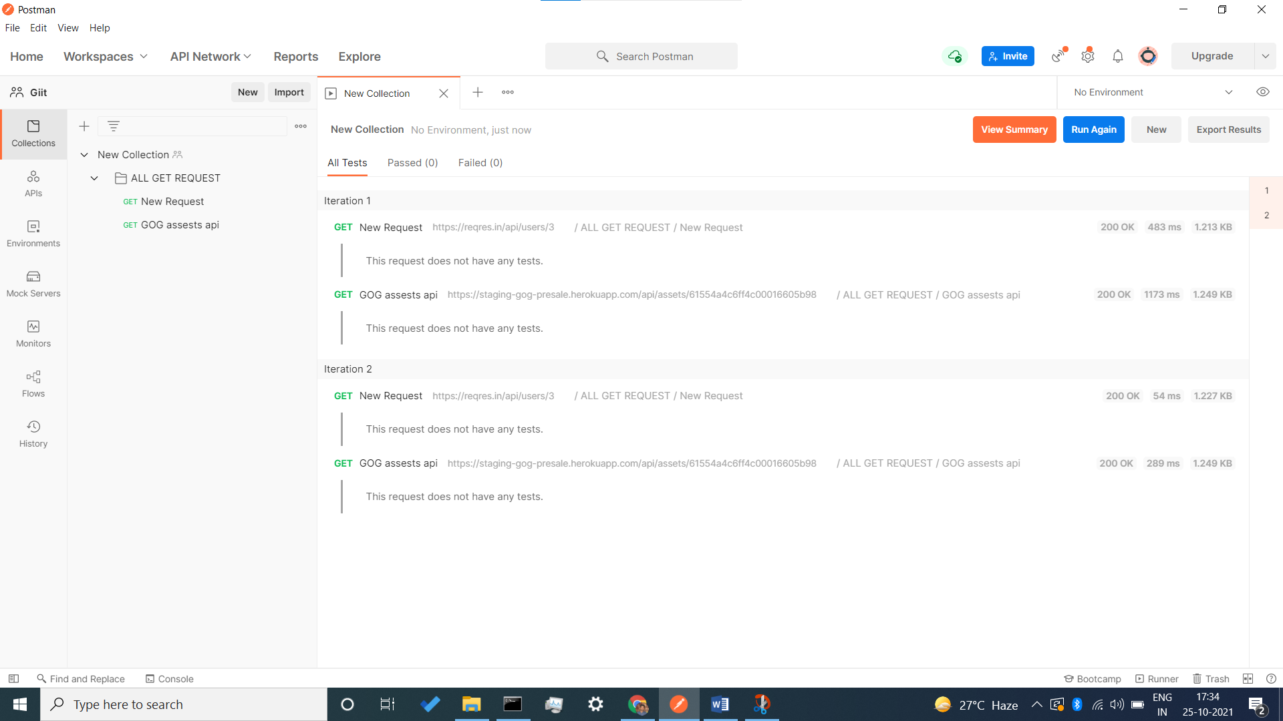

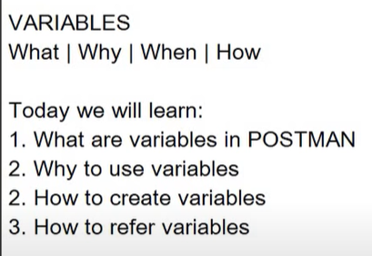

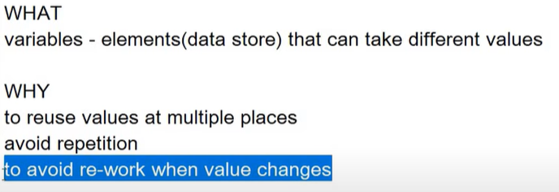

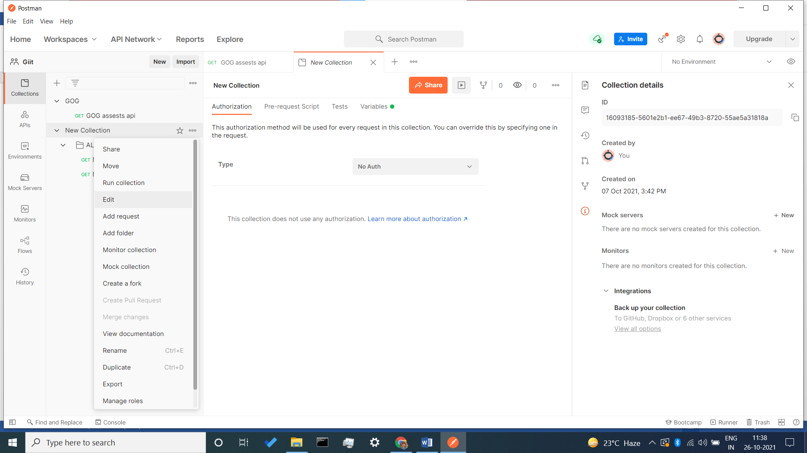

* If we want to call a URL again and again, then we store that URL in a variable and keep it.

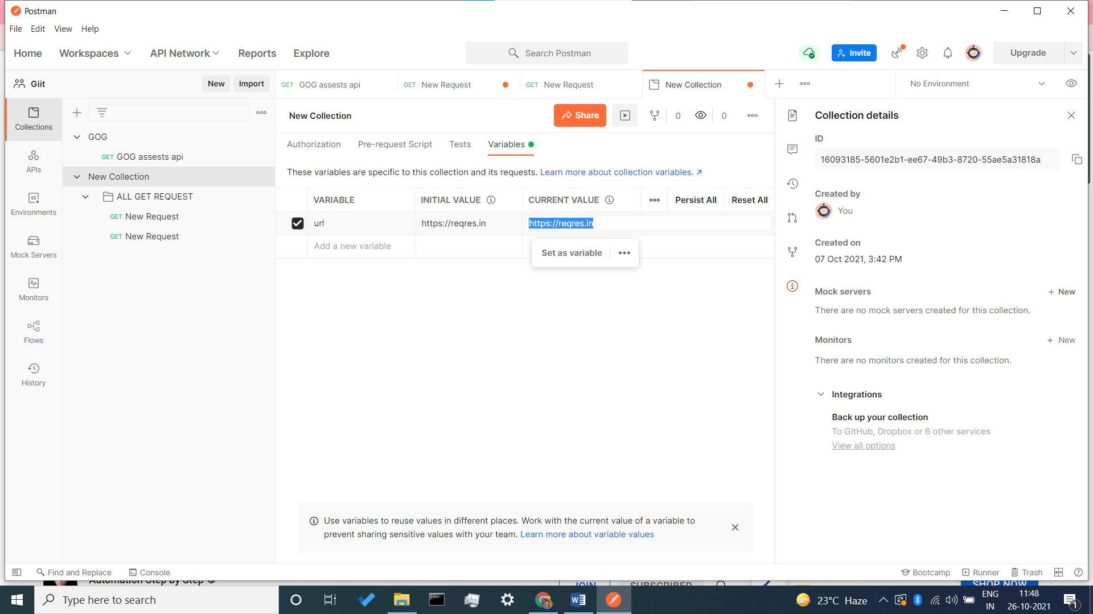

* In the search URL, first we put the variable name in brackets where you store the common link.& then give the url - api details & you see your data is visible.

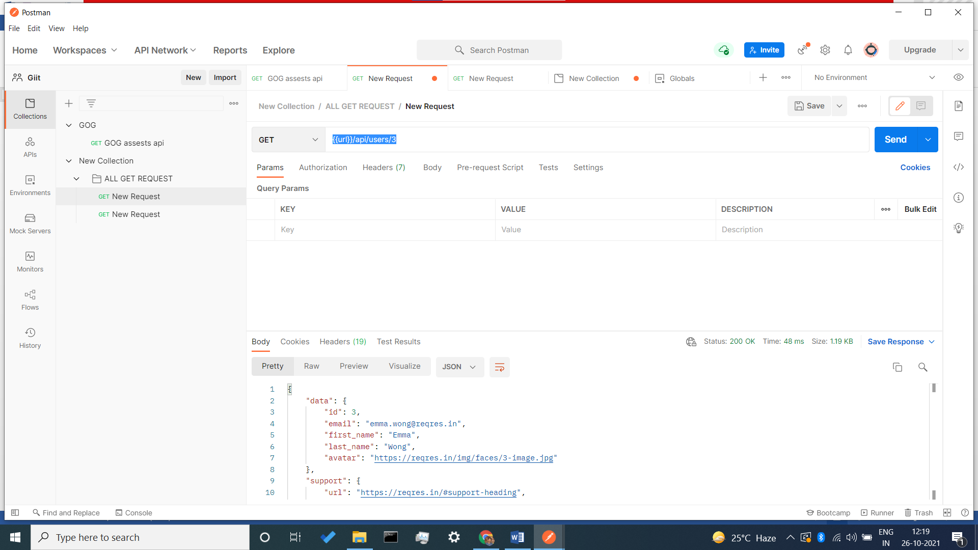

* If you want to see your data in postman console you have a option to see this

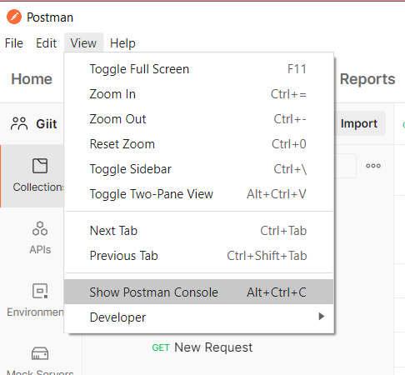

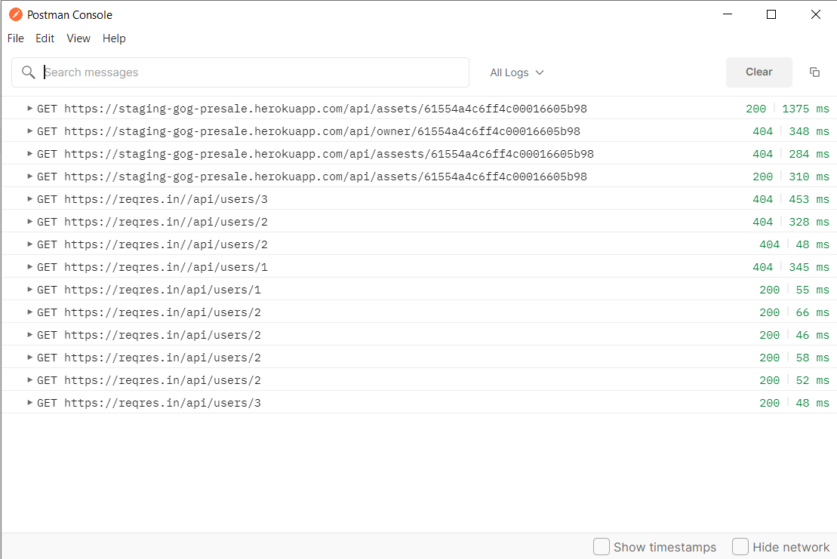

* How can we set & get variable through a script.

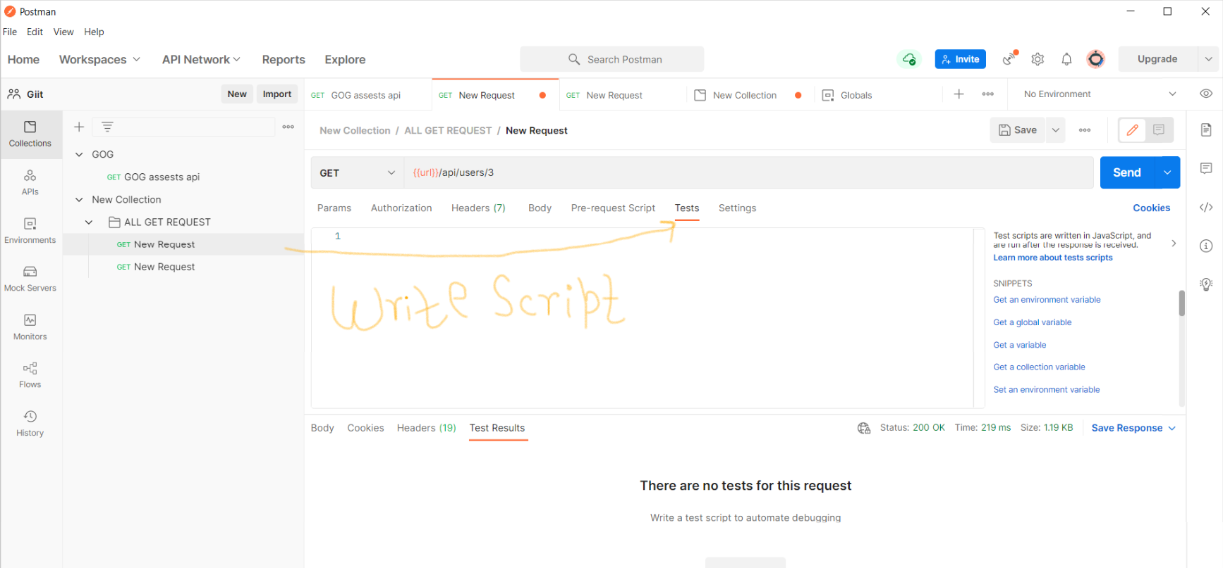

* Script =>

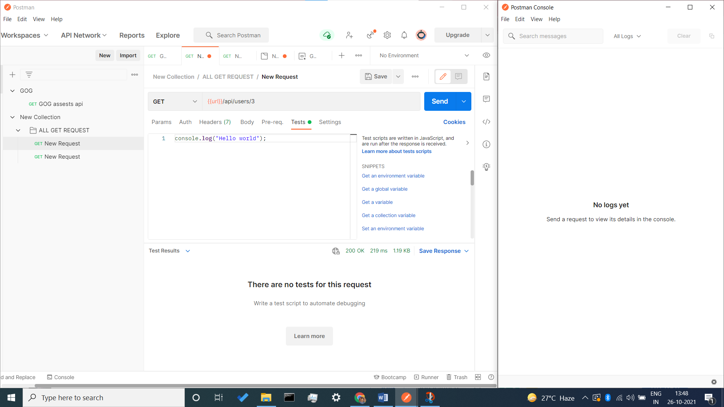

* Result in console :-

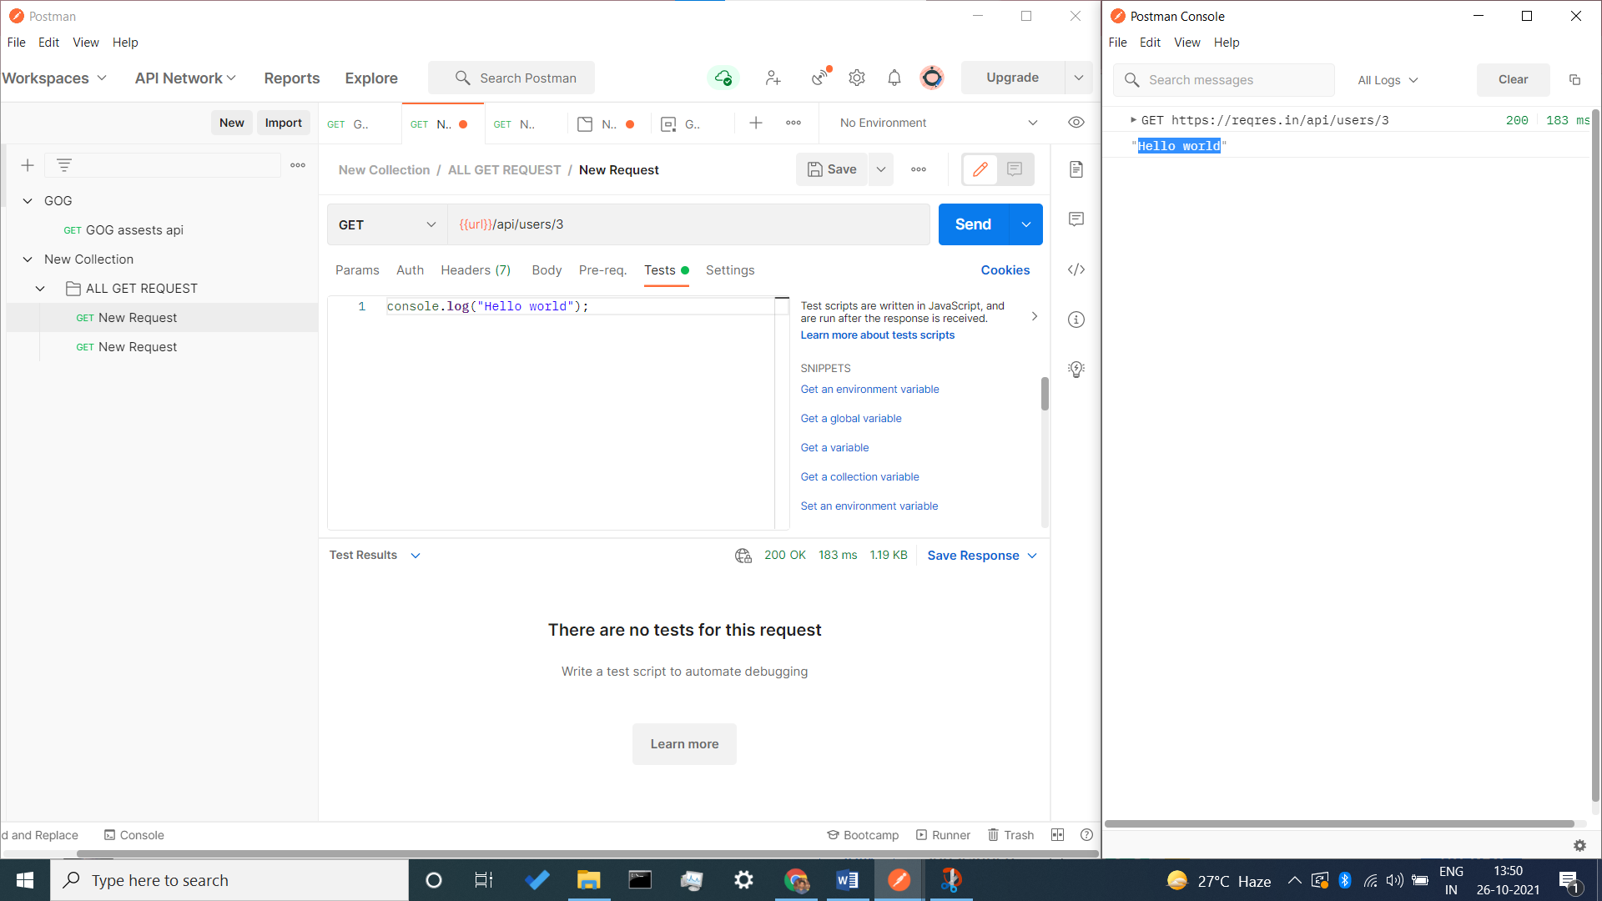

* If we want to see our log files we see in console

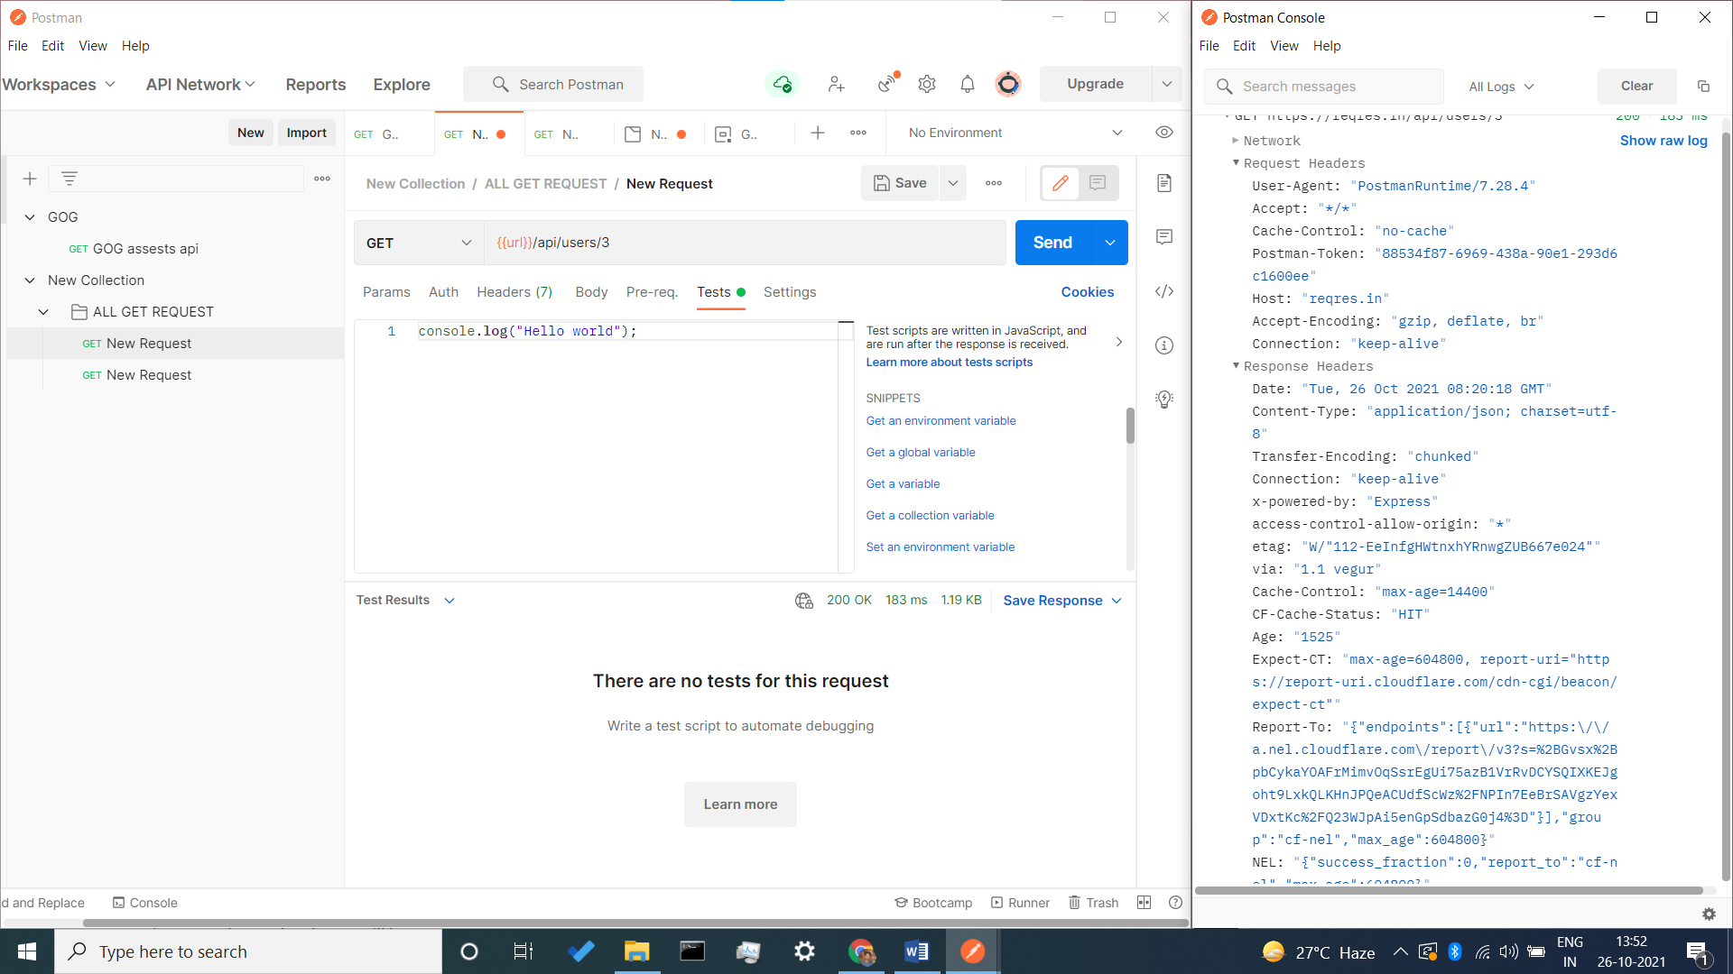

* **Using test case to print**

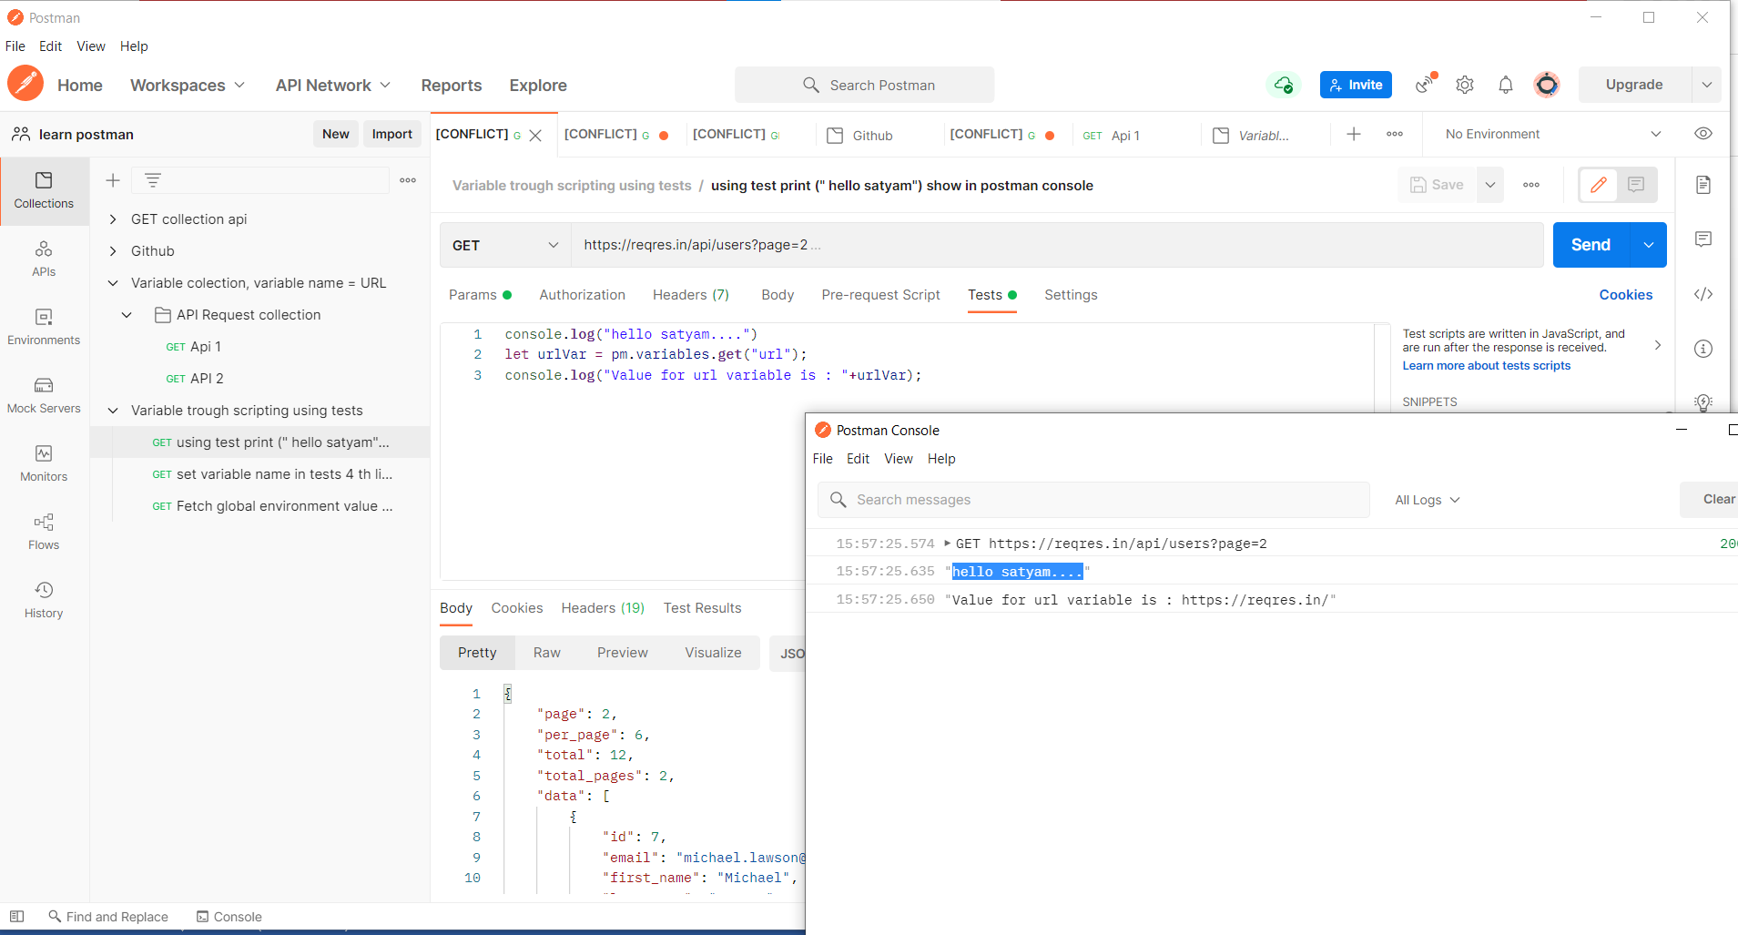

* **Using test casr to set a variable**

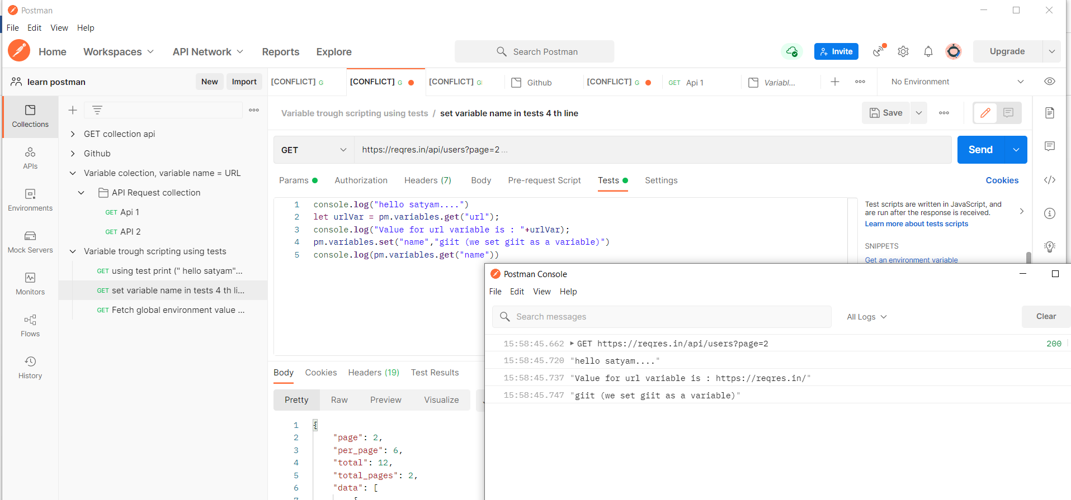

* Using test case to fetch global environment

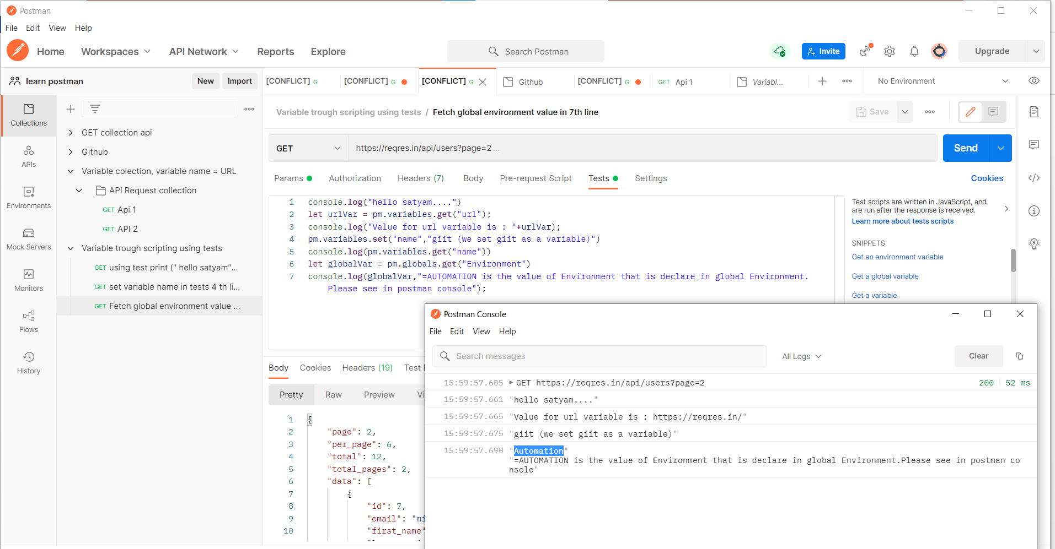

* Connect postman to github
* Api /import/ code repository /github

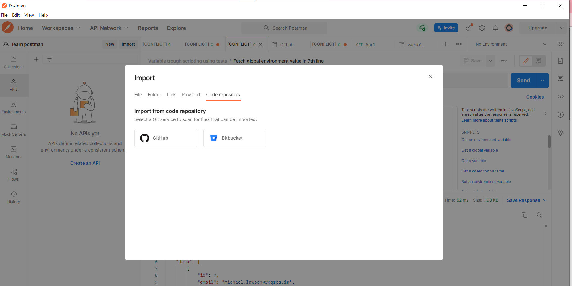

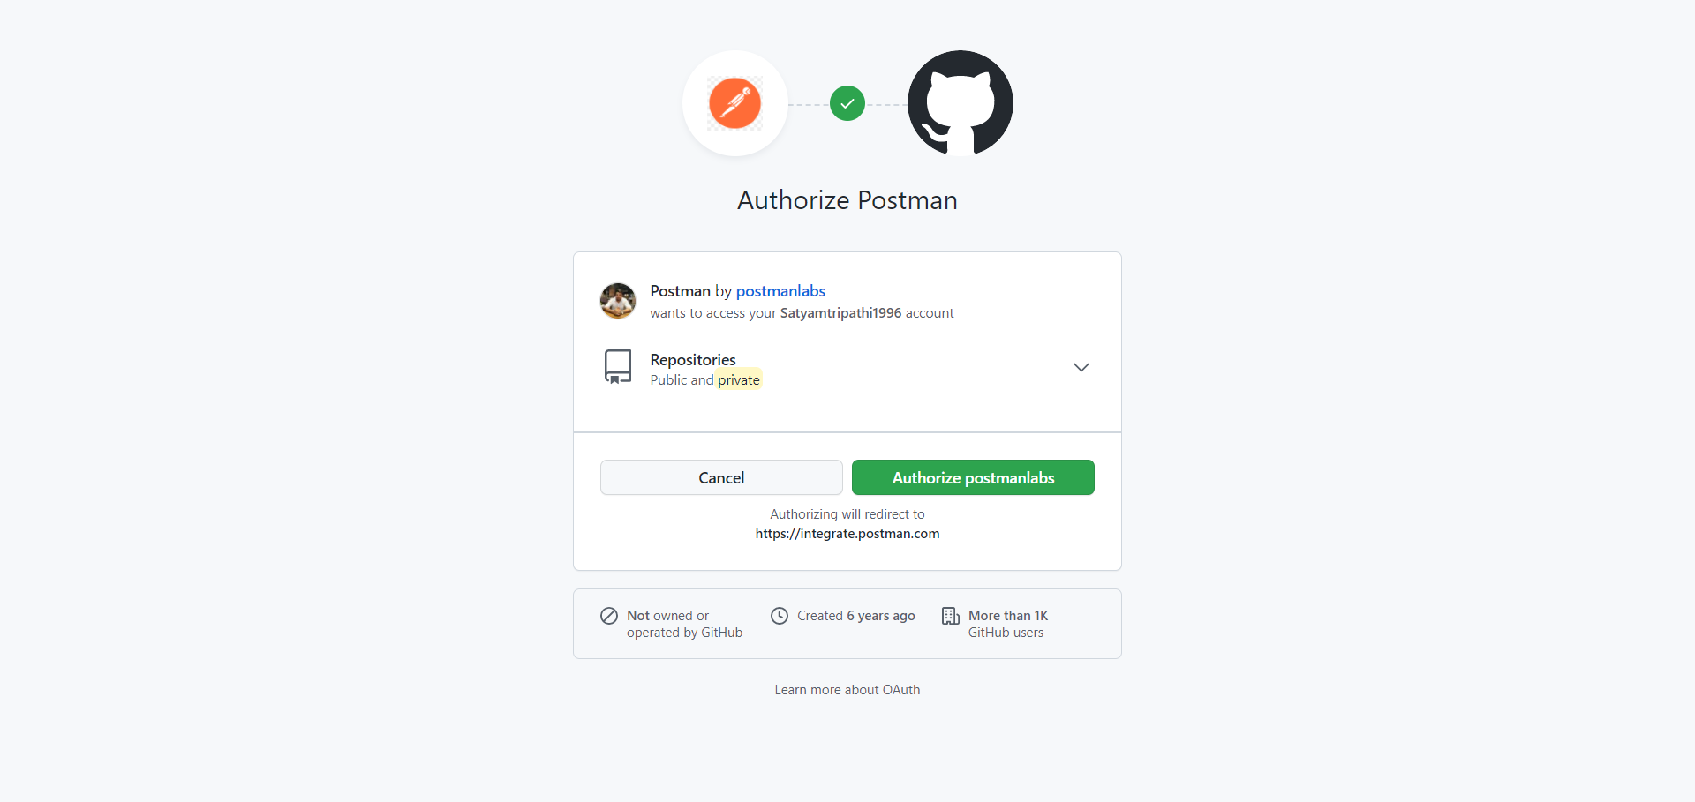

* Connected github in postman, choose your repo

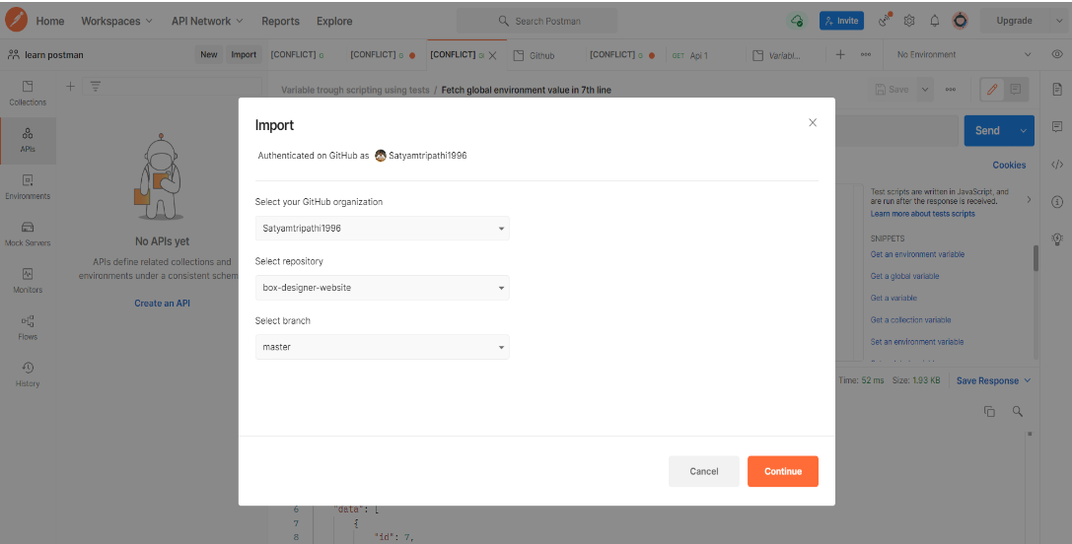

Github has changed the API starting November 13, 2020 and authentication using a username and a password is NO LONGER PERMITTED.

You need to generate a **personal access token.**

**Only some of the content in this section will work BUT not all. I am sorry about this.**

**The main concepts remain the same.**

Step 1. Create a Github.com account if you don't have one already and go to Settings.

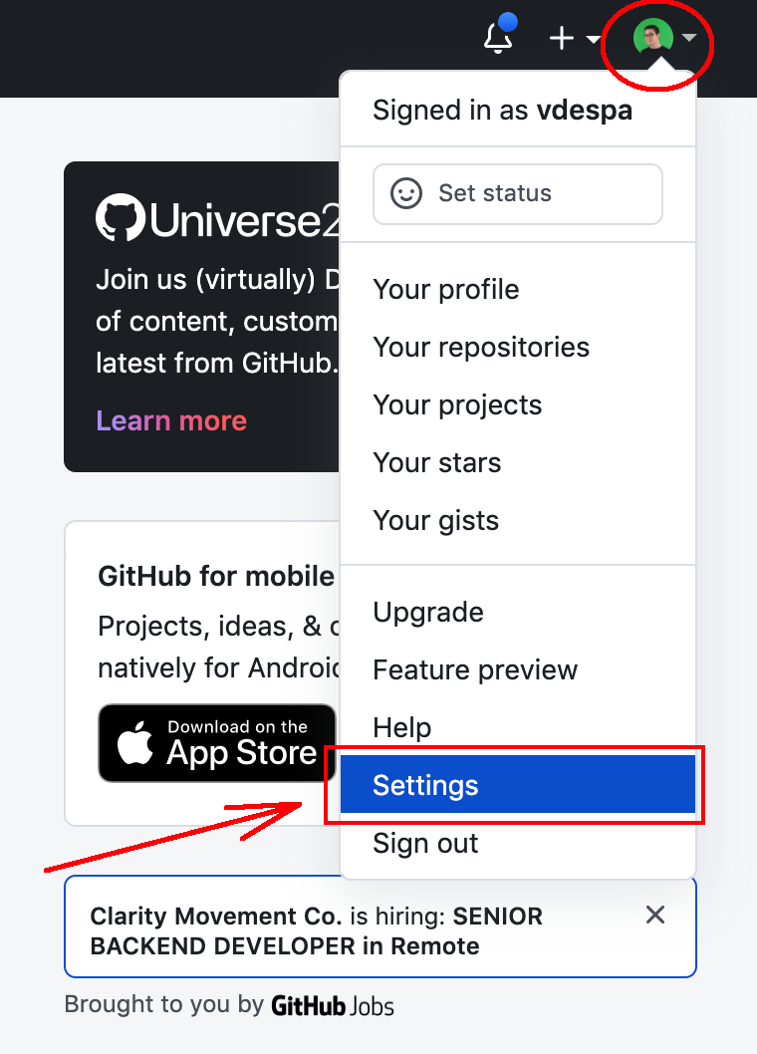

Step 2. From the left sidebar, select **Developer Settings.**

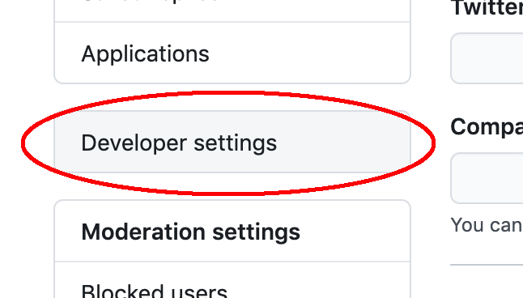

Step 3. From the left sidebar, select **Personal access tokens.**

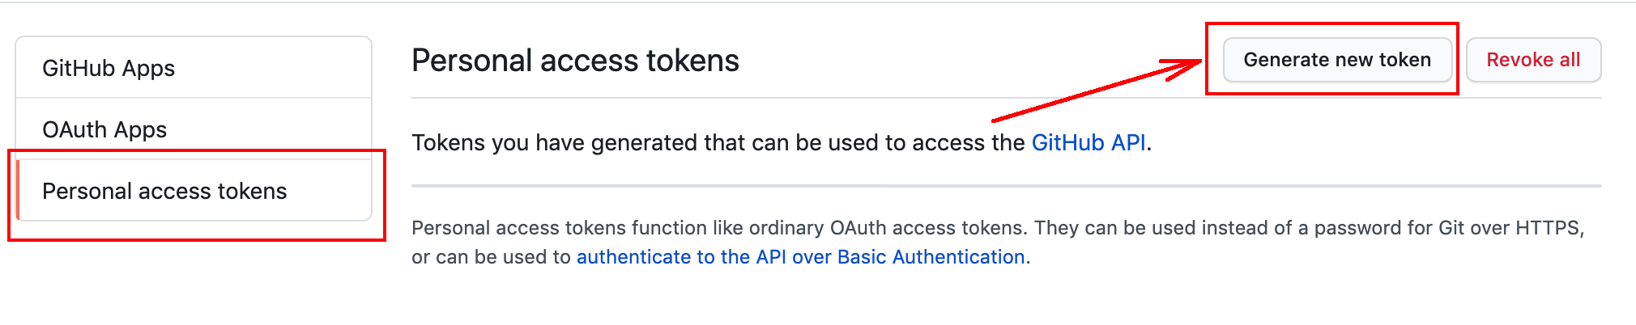

Step 3. Click on **Generate new token**.

Step 4. Name your token Postman or as you prefer. Select the permissions as in the image below.

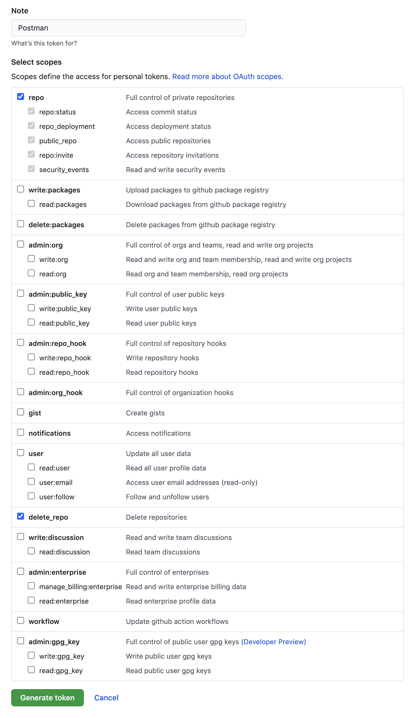

Step 5. Click on **Generate token**.

Step 6. Keep this page open otherwise, you will not see the token.

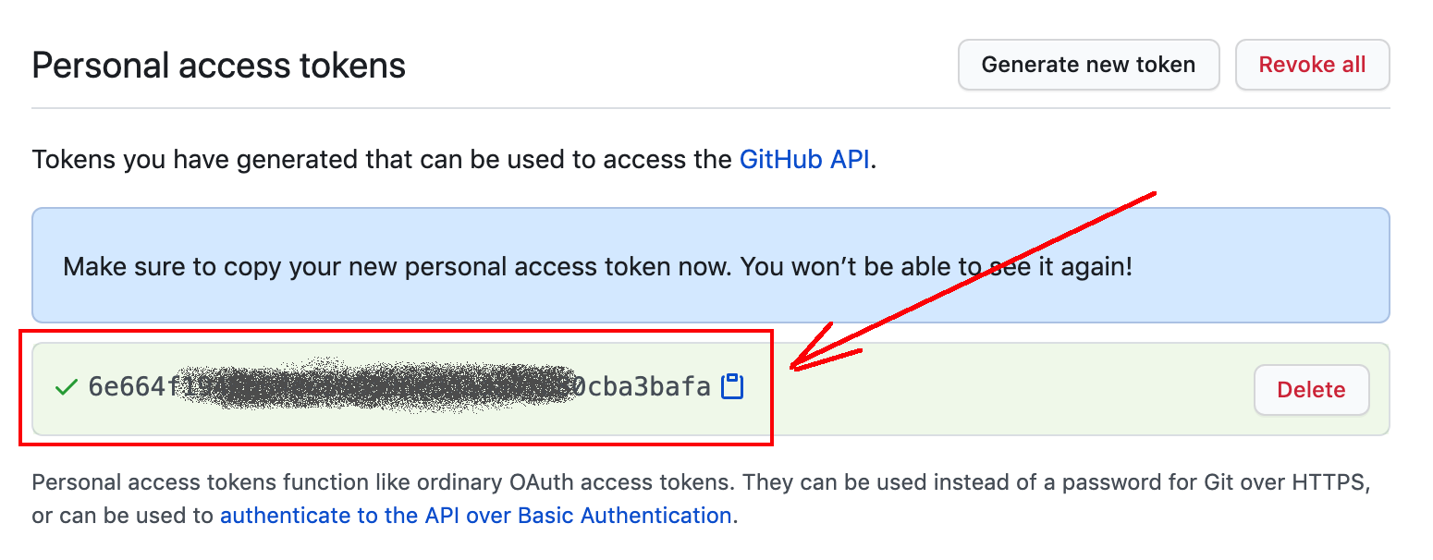

Step 7. In Postman, instead of using Basic Auth, select Bearer Token.

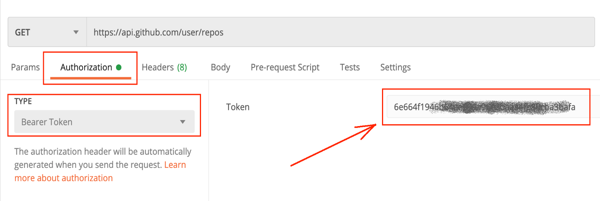

* **Aws Signature use**

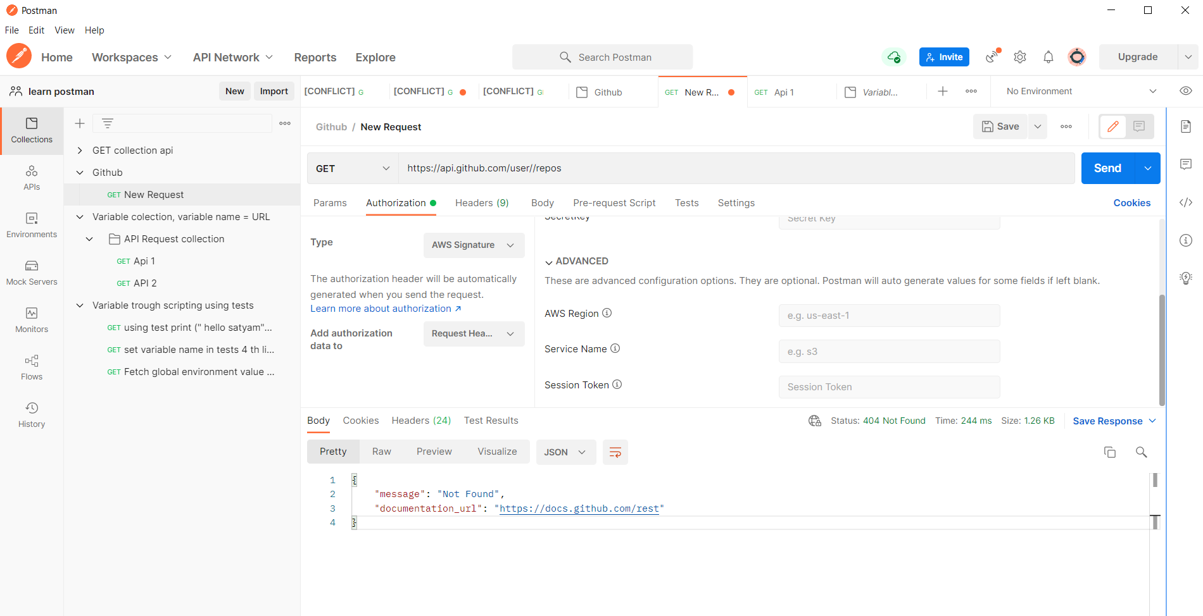

**Step 1**

Add a new request to the collection that **creates a new Github repository** with the following properties:

- name: Test repository (*random string*)

- description: This is a test repository created by Postman

Add one **test** that checks the status code (expected 201).

***Note****: by visiting your profile, you can notice that the repository is now visible.*

***Hint:****in order to create the repository, you need to send JSON in your request body.*

**Step 2**

Add a new request to the collection that **retrieves (with GET) the newly created Github repository.**

Add one **test** that checks the status code (expected 200).

This is an additional test step that ensures that the repository was indeed created.

**Step 3**

Add a new request to the collection that **creates a few issue**inside the repository with the following content:

- title: Found a bug

- body: This issue has been automatically created by Postman.

Add one **test** that checks the status code (expected 201).

**Step 4**

Add a new request to the collection that **retrieves (with GET) the newly created Github repository issue.**

Add one **test** that checks the status code (expected 200).

Add one **test** that checks the issue title (expected "Found a bug").

This is an additional test step that ensures that the issues was created.

**Step 5**

Time to clean-up, otherwise your account will be filled with repositories which you don't need.

Make sure you **delete the repository** that you have created.

Add one **test** that checks the status code (expected 204).

**Step 6**

Try again to fetch (with GET) the repository that you have just deleted (similar to Step 2).

Add one **test** that checks the status code (expected 404 Not found).

Clear any variables that you have used in this collection.

**Questions for this assignment**

**How does your collection look like?**

Add here screenshots or better generate a link with your collection and use it here.

***Important!****Make sure you don't include any usernames / tokens / passwords.*

**How was this assignment?**

Thank you for looking into this assignment. Please let me know how did you like it, if you feel you have learned something new. Any feedback on how to improve is welcome!

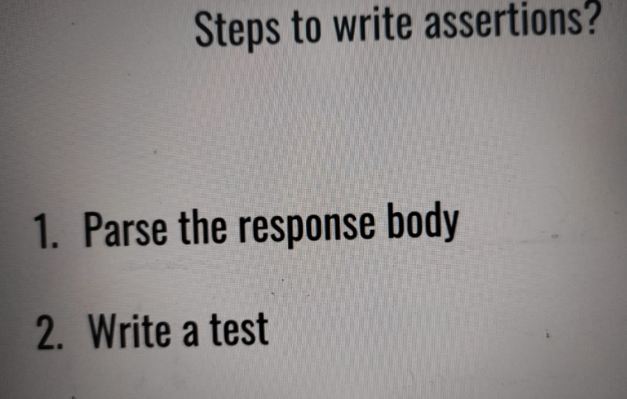

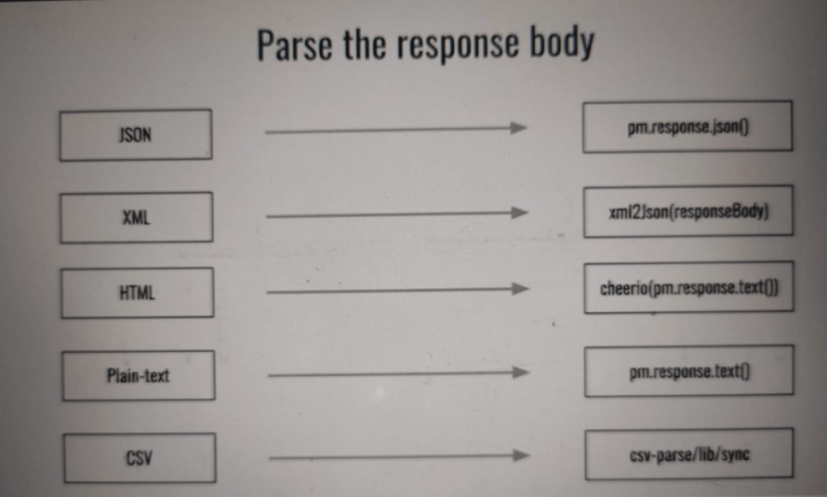

**Assertion**

* **Full response details print in postman console**

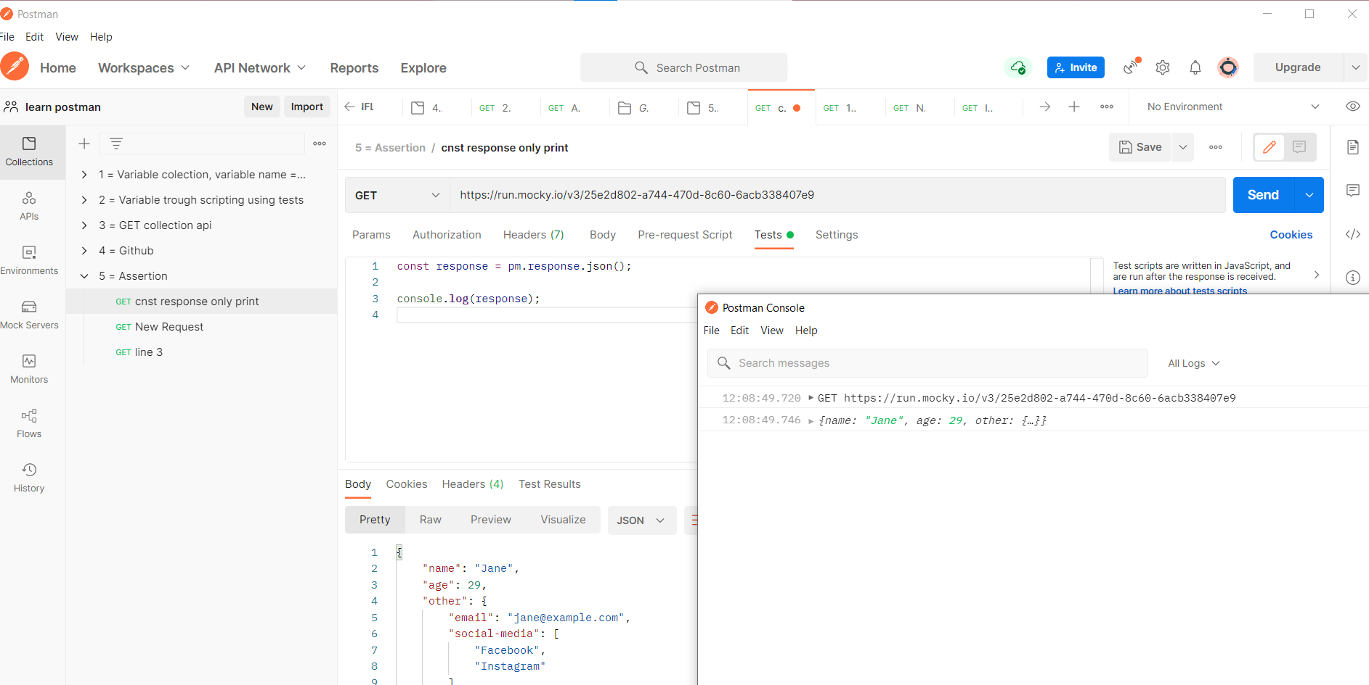

* **In respone only name is print in postman console**

s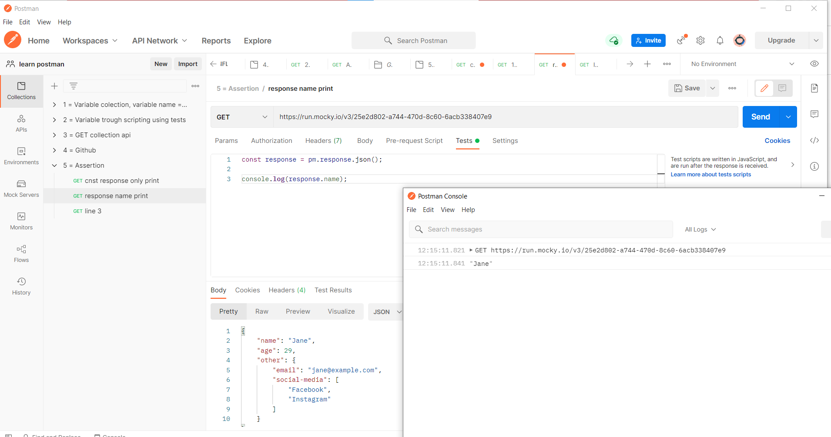

* **If jane is Visible then print it**

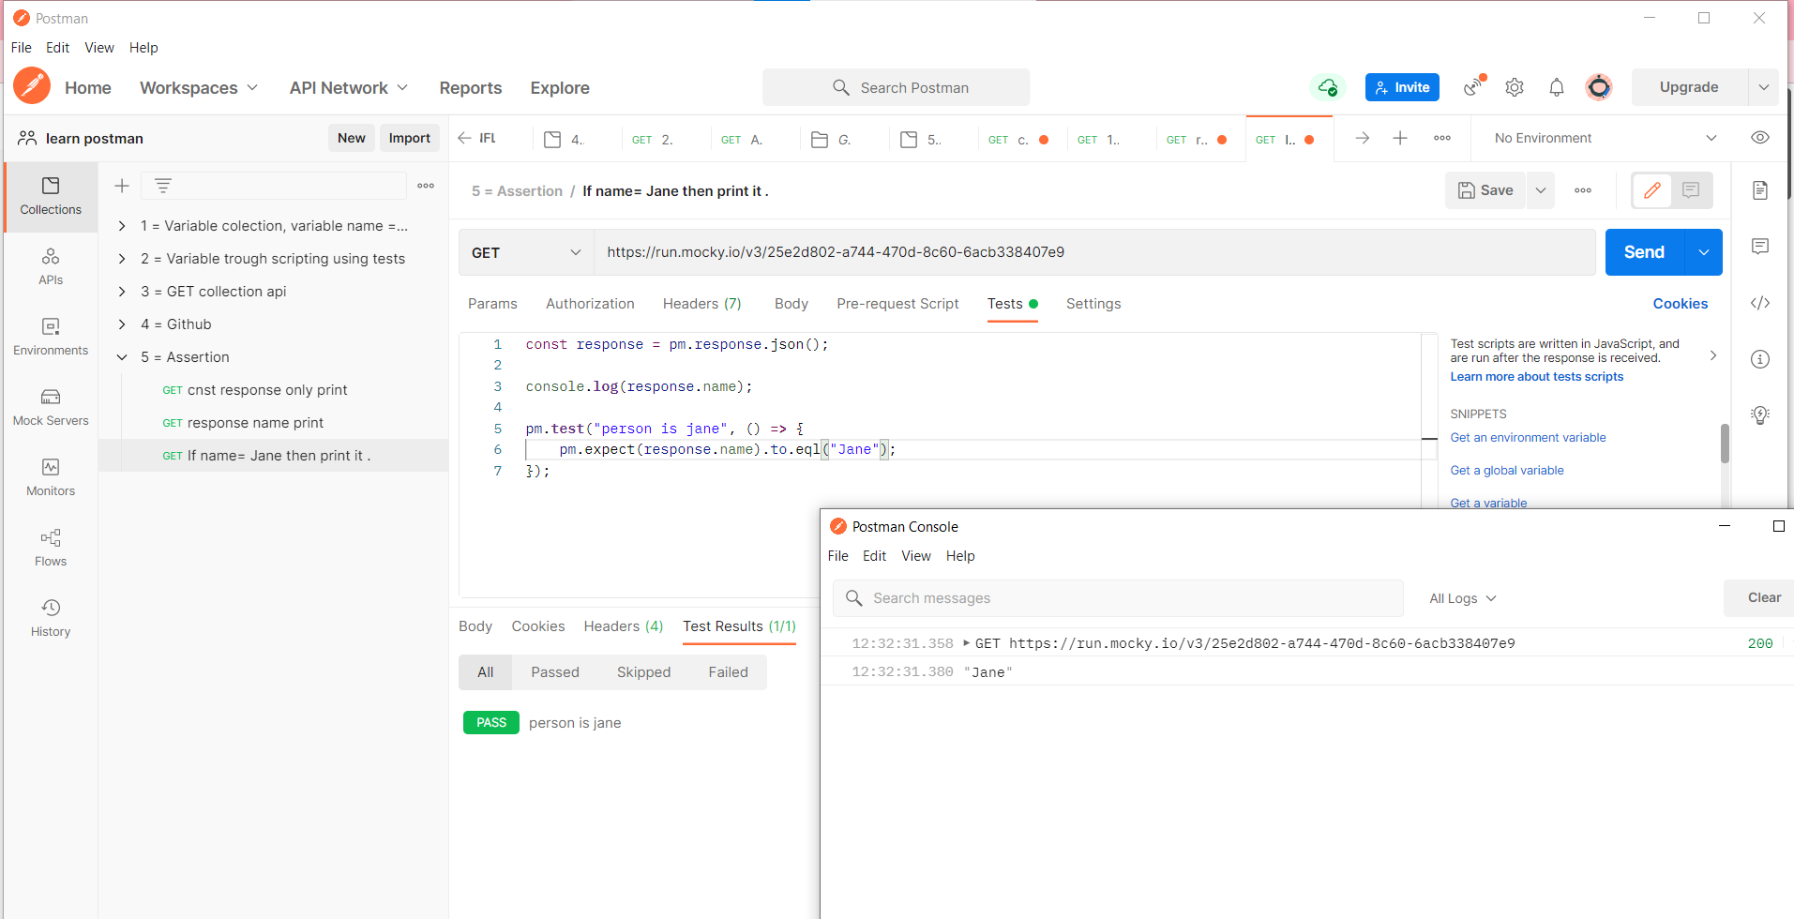

* **If Jake is visible then print it but jake is not available so that’s why error will come.**

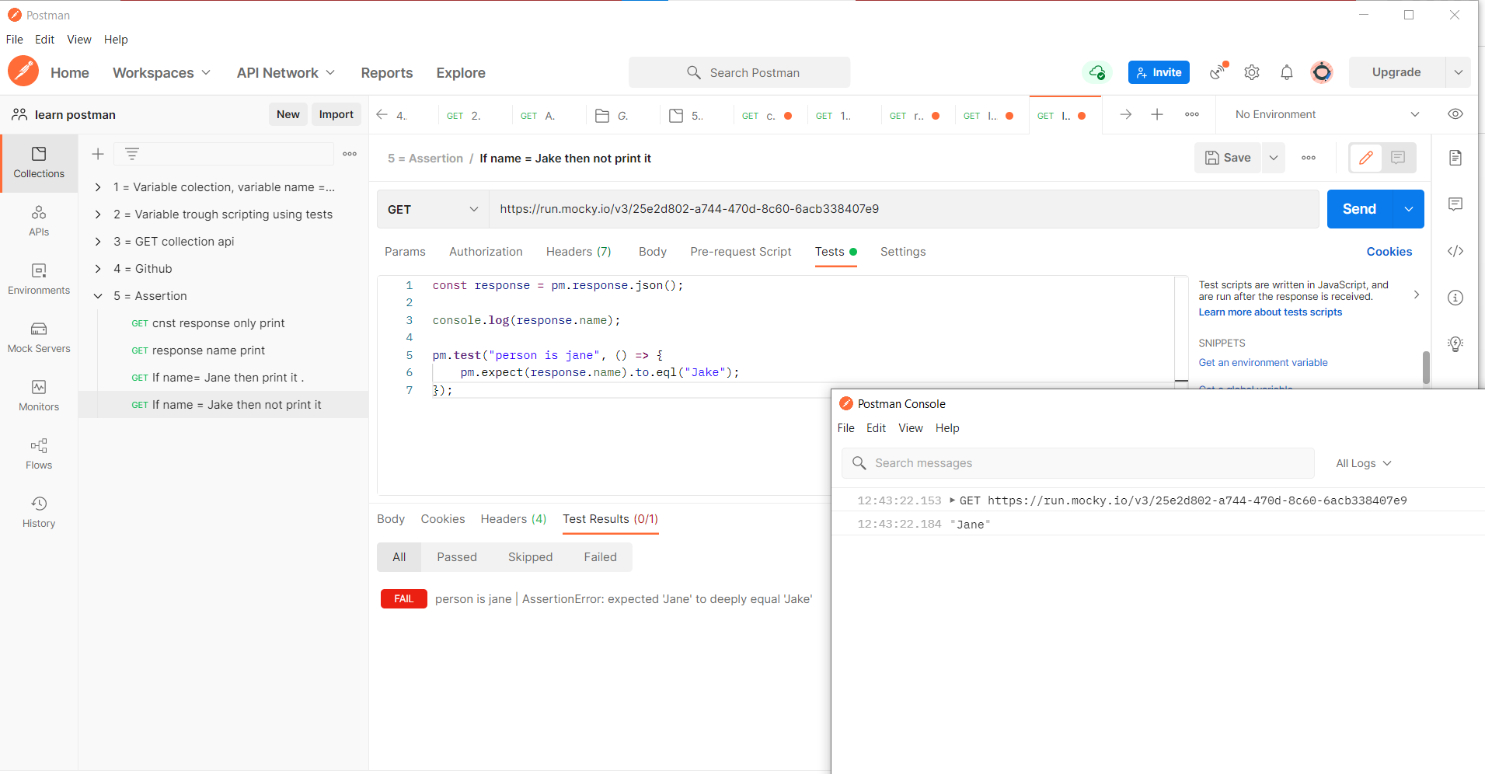

* **Monitor Collection**

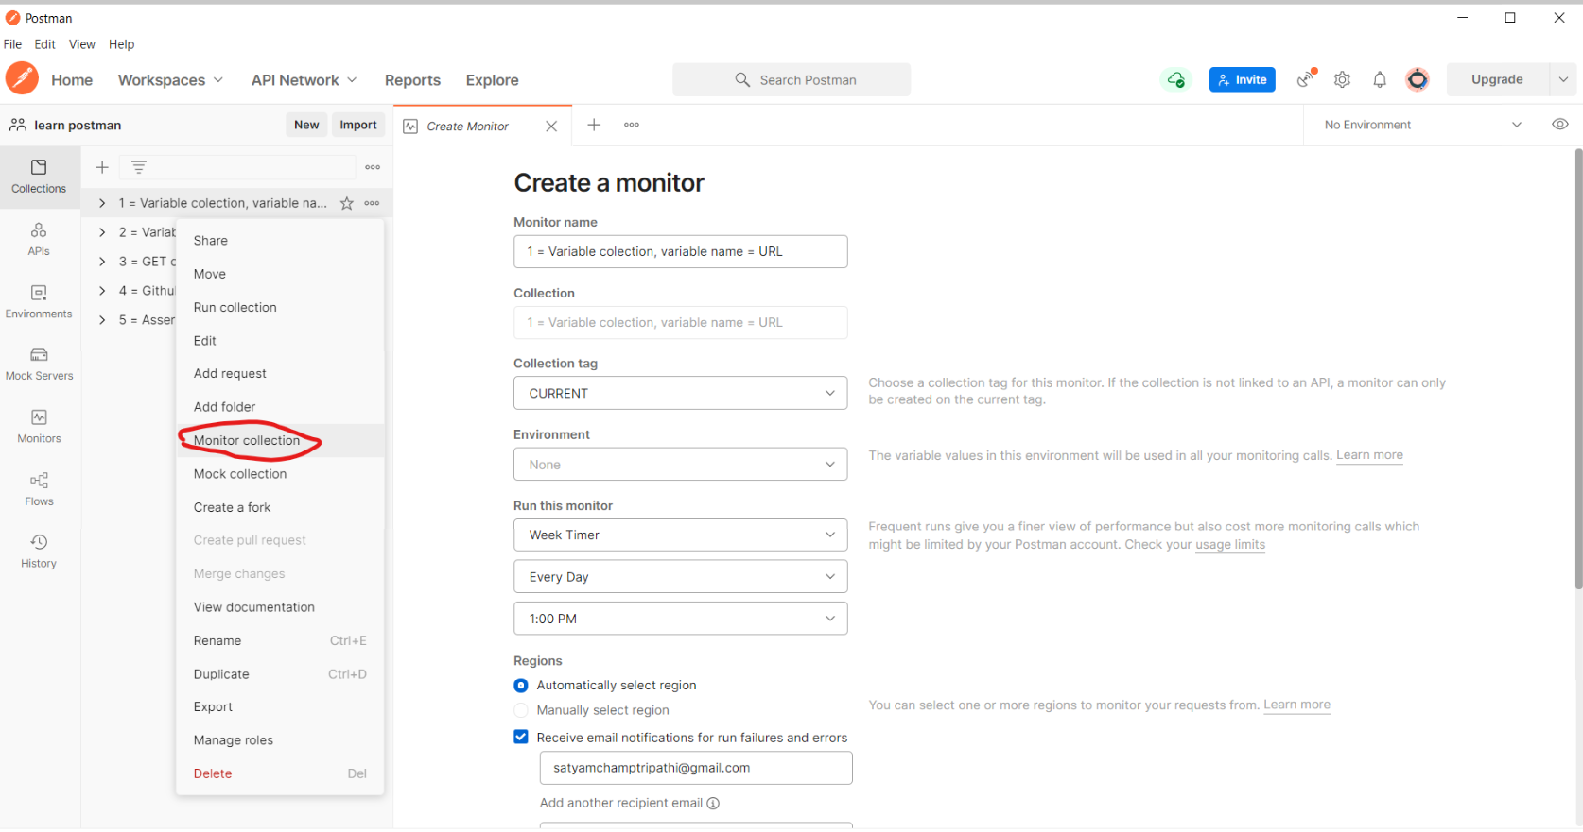

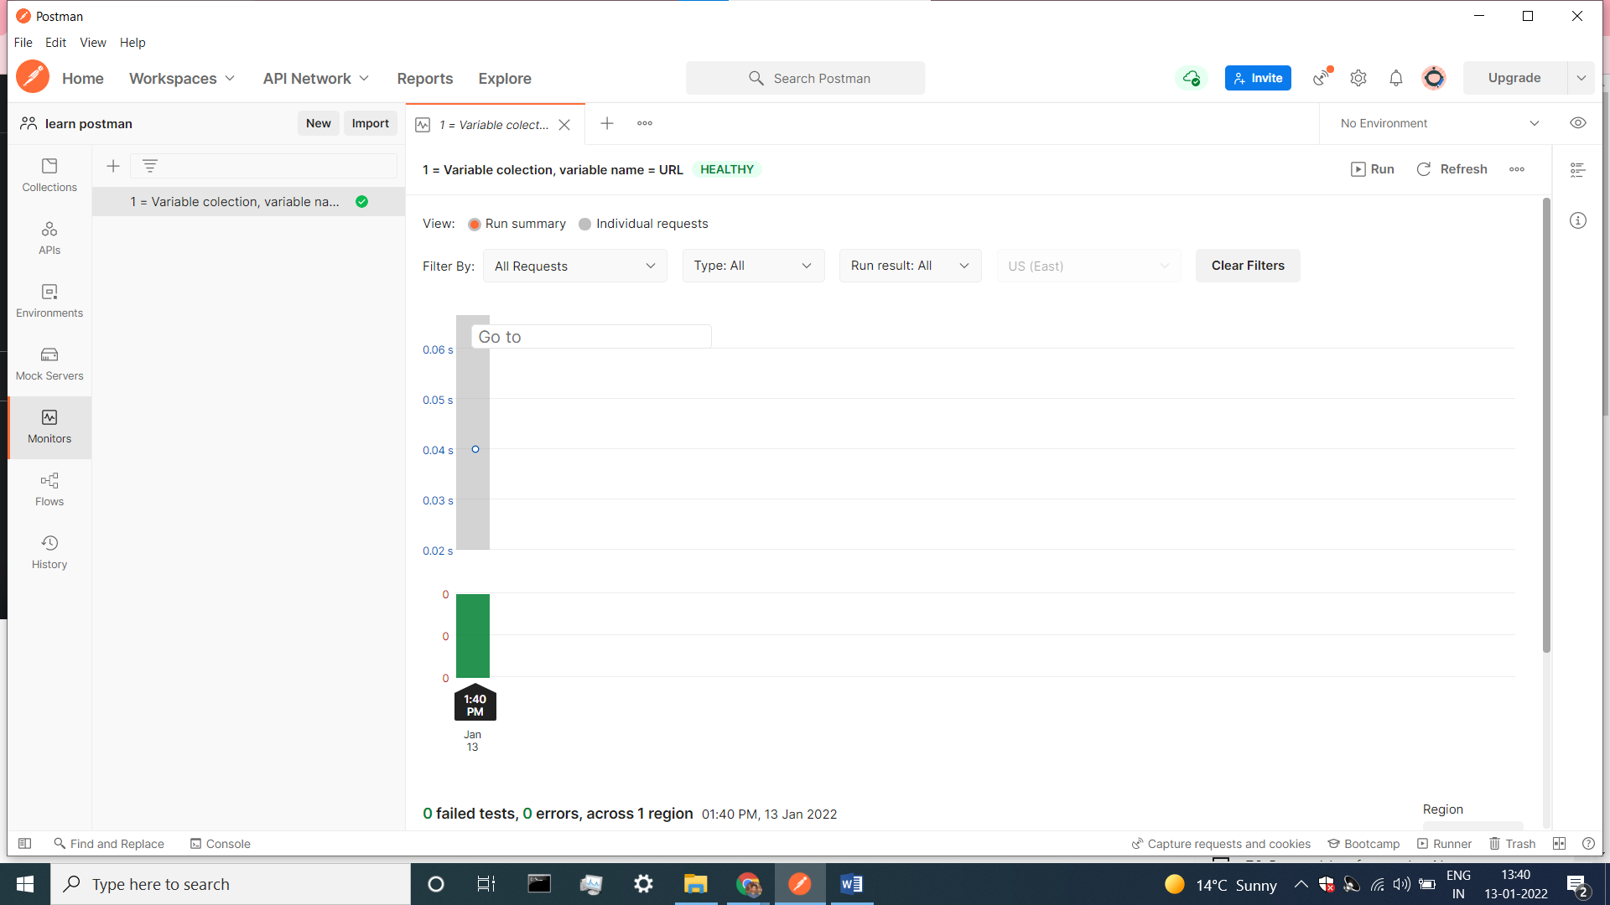

**Newman**

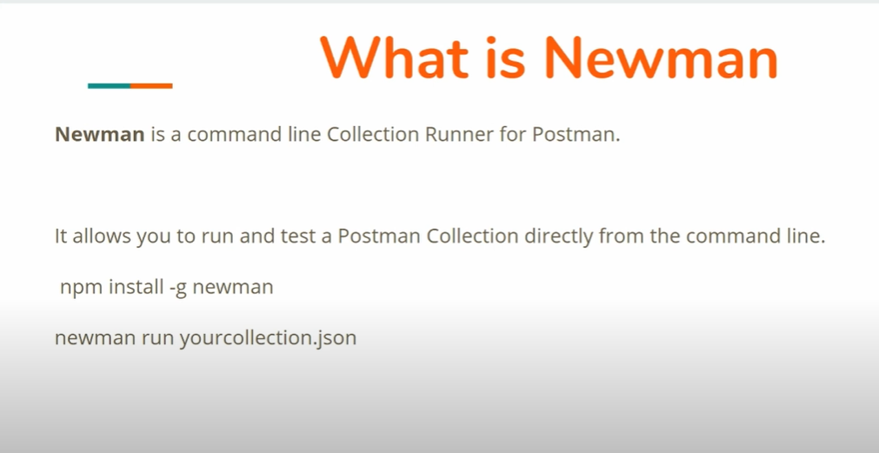

NPM =Node packet manager

Newman install command = npm install –g newman

* Newman is a CLI tool which allows you to run a Postman collection directly from the command line.

**NPM is the Node Package Manager**. This is like a repository of projects and has knowledge of what requirements each project has. For example, you want to install Newman, but it depends on other libraries which themselves depend on other libraries. To figure out all the dependencies each project needs, you just need to have NPM installed and NPM will do this work for you.

In the next video, I have defined Newman as a dependency for my project. This means that the project I have created, cannot run without Newman. When NPM checks the packages.json file, it will figure out what it needs to install, in order for my project to run.

If you are familiar with **Docker**, there is a Docker image that has Newman and all the dependencies already installed. Just let me know so that I can point you in the right direction.

**Install nodejs,NPM, NEWMAN in our Ubuntu machine**

* **Sudo apt-get update**
* **apt install nodejs**
* **node –version**
* **apt install npm**
* **npm install -g newman**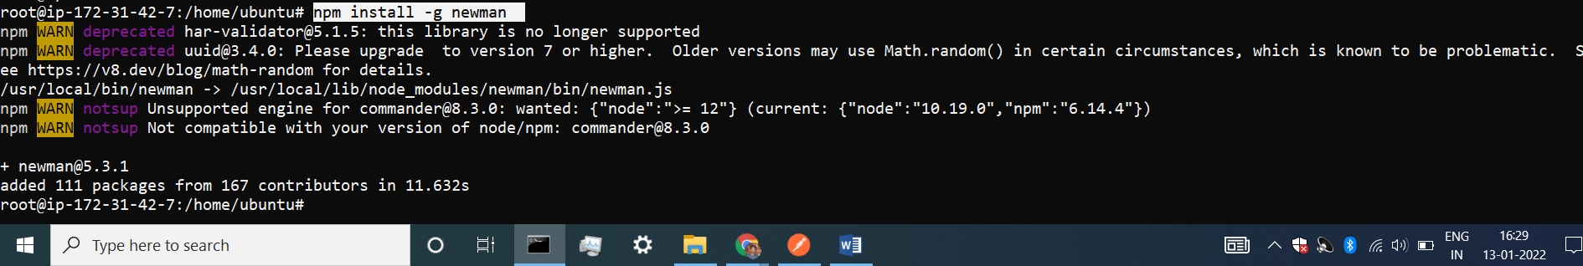

**Troubleshooting Node.js / npm / Newman Problems (for Windows)**

**Windows - Troubleshooting Node.js / npm / Newman Problems  
=======================================================**

**1. Node.js cannot be called from the command prompt**

Once you have successfully installed Node and restarted your computer, when you open a command prompt terminal and type in node -v, you get an error and not a version like v6.9.5

**Possible solution**

In Windows, you need to set node.js folder path into system variables.

1) open Control Panel -> System and Security -> System -> Advanced System Settings -> Environment Variables

2) in "System variables" find variable PATH and add node.js folder path as value. Usually it is C:\Program Files\nodejs;. If variable doesn't exists, create it.

3) Restart your computer.

**2. Newman cannot be called from the command prompt**

Once you have installed newman and restarted your computer, when you open a command prompt terminal and type in newman --version, you get an error and not a version like v4.1.0

**Possible solution**

In Windows, you need to set the folder where node.js is storing global dependencies into system variables.

1) open Control Panel -> System and Security -> System -> Advanced System Settings -> Environment Variables

2) in "System variables" find variable PATH and add the folder path as value. Usually it is something like: C:\Users\YOURUSERNAME\AppData\Roaming\npm

Inside the folder you should see a file called newman.

3) Restart your computer.

* **Running a collection with Newman**
* Copy link
* Then paste in cmd before link write **newman run** link

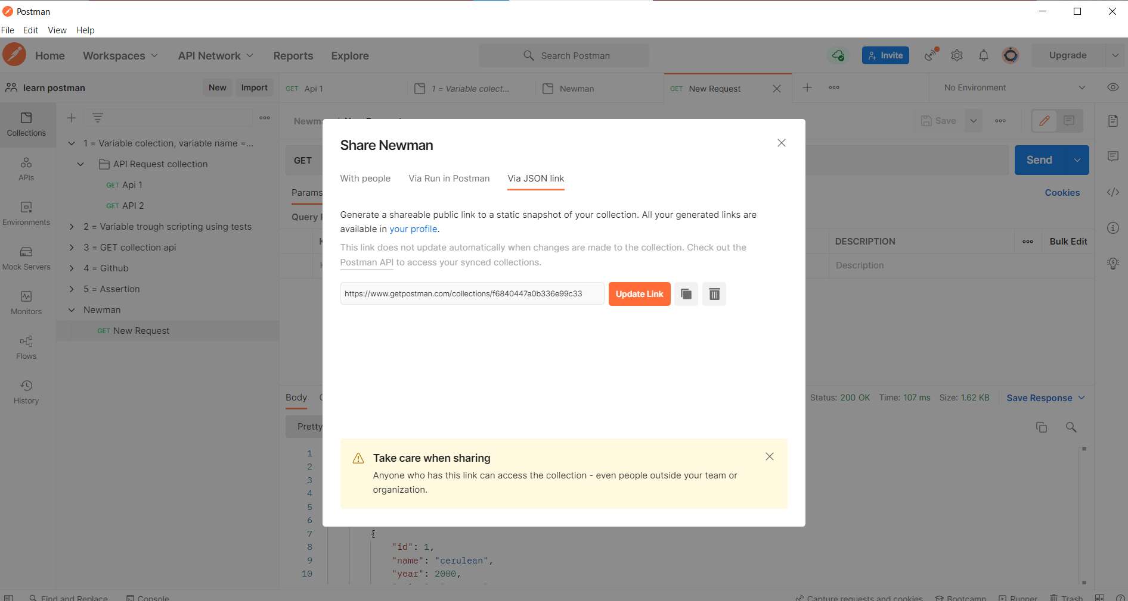

* Now our collection is run .

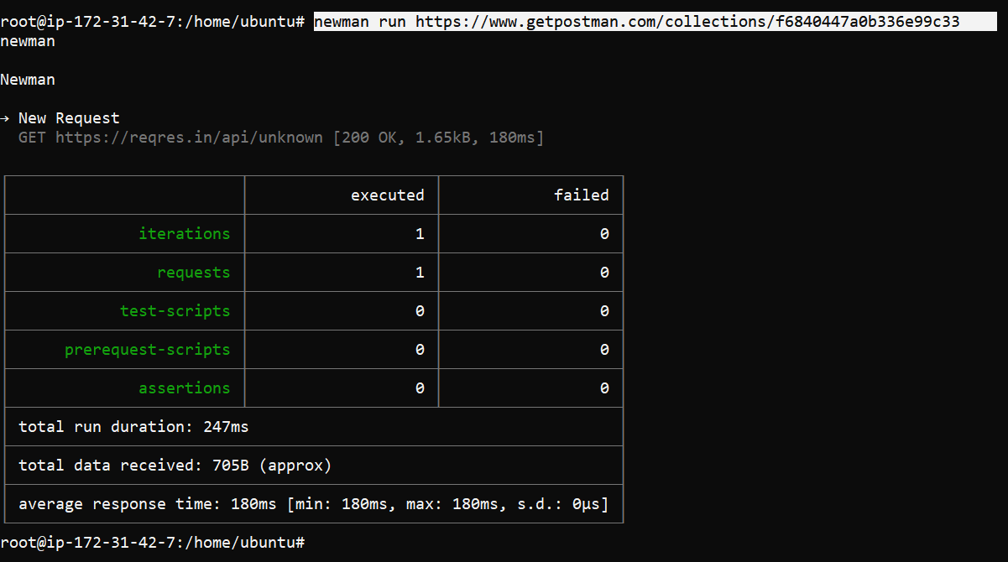

**Running newman on Jenkins**

**Install Jenkins in Ubuntu virtal machine**

**Install java before Installing Jenkins :-**

* sudo apt-get update
* sudo apt-cache search openjdk
* sudo apt-get install openjdk-8-jdk
* java –version

**Install Jenkins :-**

**Follow this link :-** https://pkg.jenkins.io/debian-stable/

* wget -q -O - https://pkg.jenkins.io/debian-stable/jenkins.io.key | sudo apt-key add –
* sudo vi /etc/apt/sources.list

**inside source.list file add this line in last line .**

* deb https://pkg.jenkins.io/debian-stable binary/

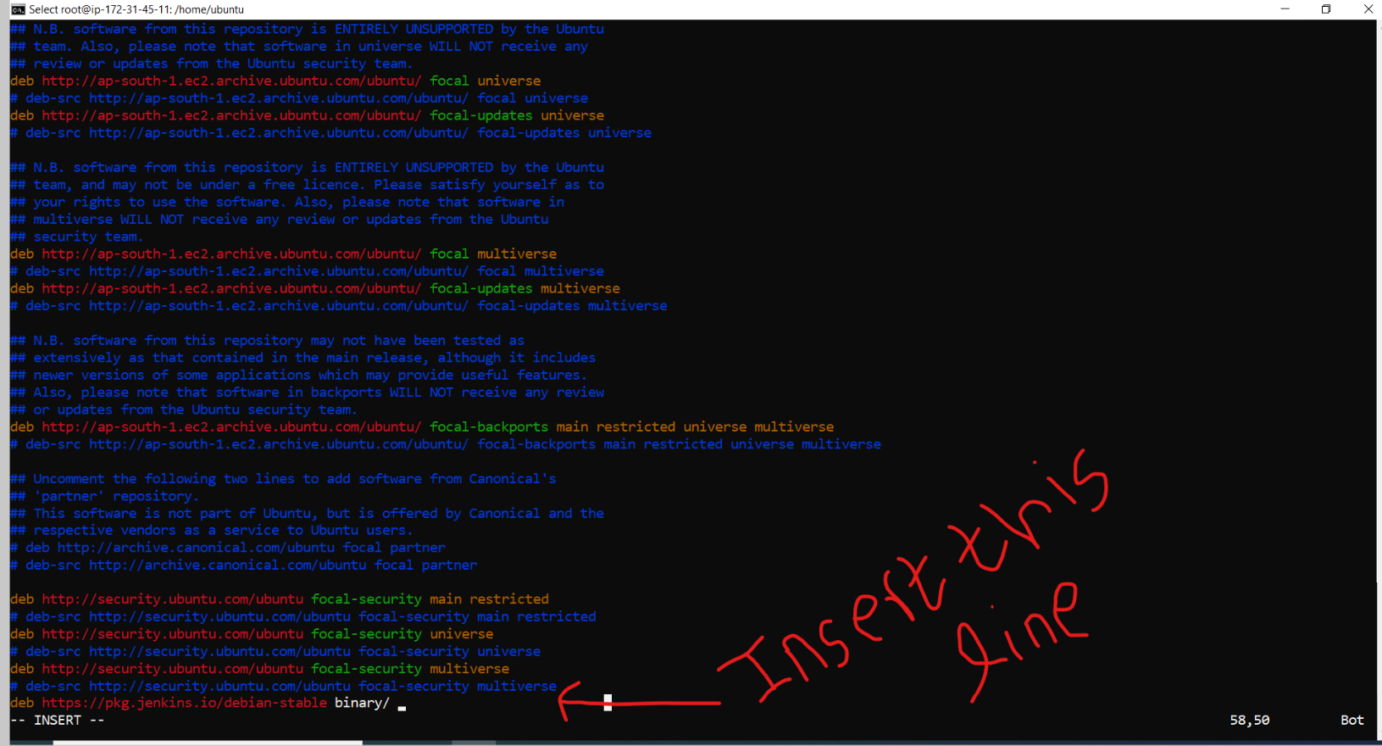

* sudo apt -get update
* sudo apt-cache search Jenkins

**we use ths command** to check the **Jenkins version .**

* sudo apt-cache madison Jenkins

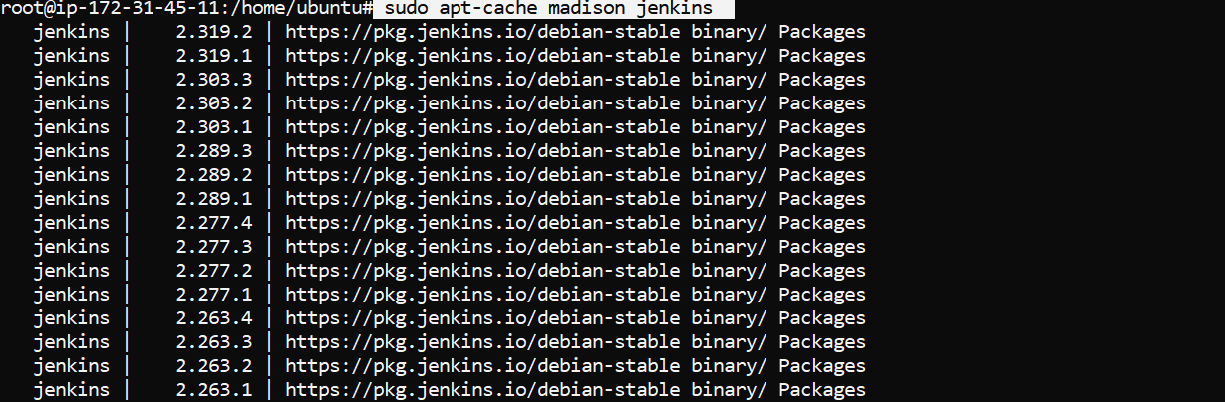

If we want install jenkins in latest version we use this command.

* sudo apt-get install jenkins-y

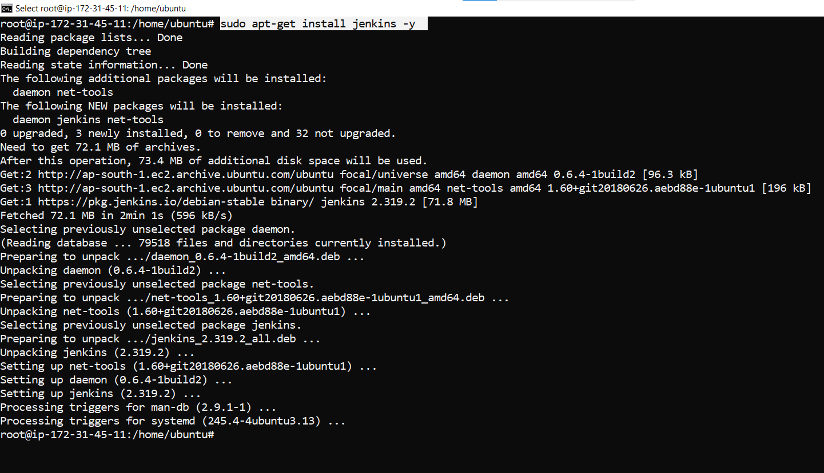

* sudo service Jenkins status

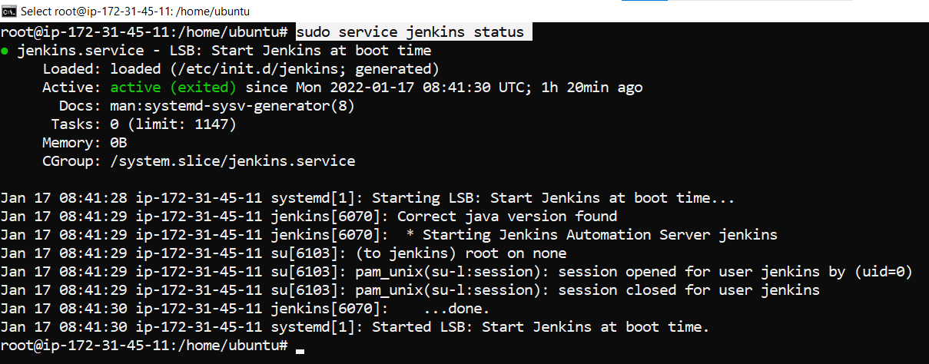

* allow port 8080 in aws machine

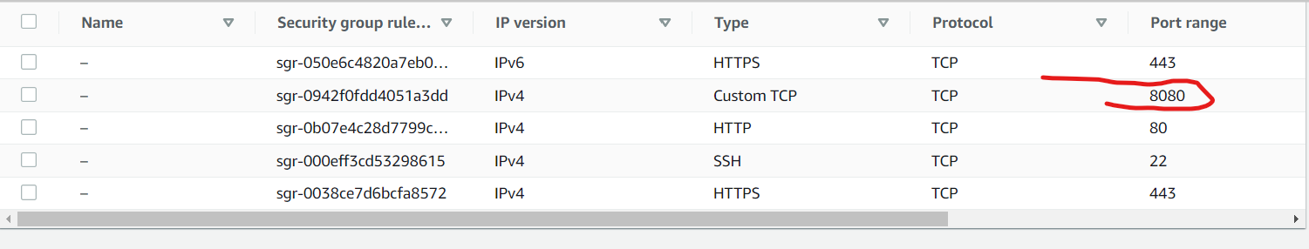

* hit your public ip in browser and then put :8080
* copy the given path and go to the terminal use this command to got your password, and copy password in the terminal then put a password here your Jenkins will ready.
* sudo cat /var/lib/jenkins/secrets/initialAdminPassword

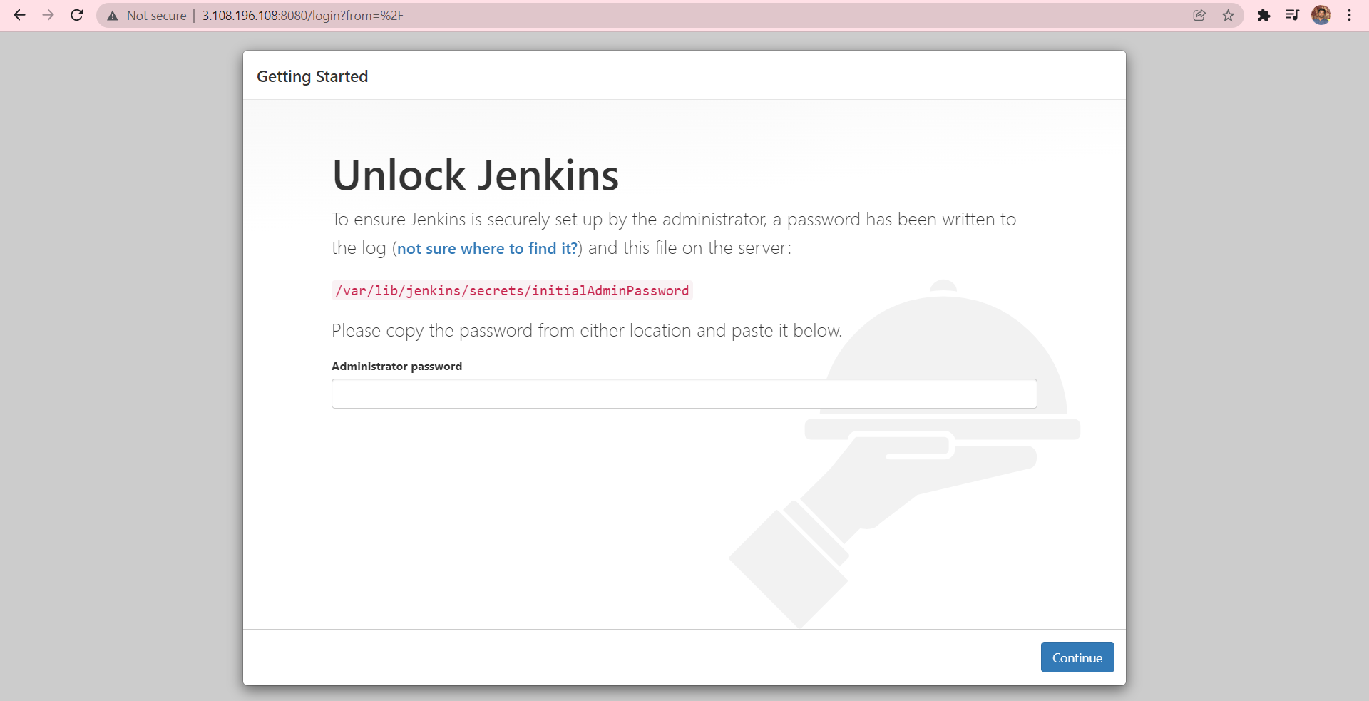



* Click install suggested plugins

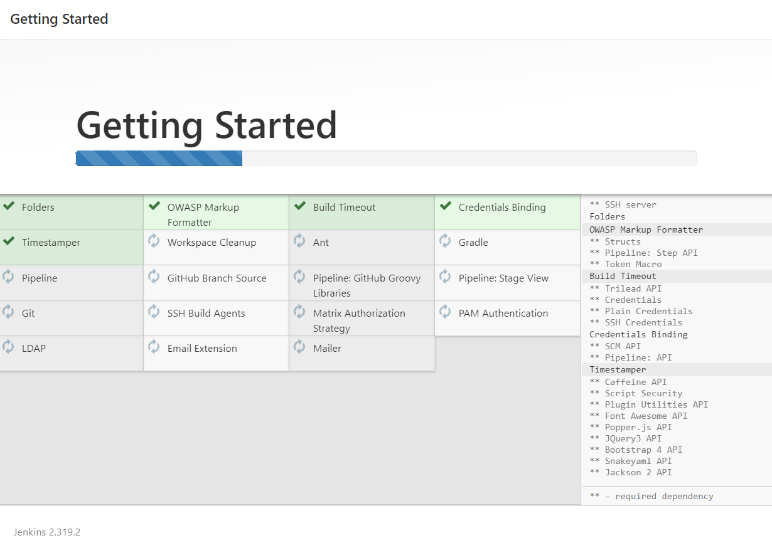

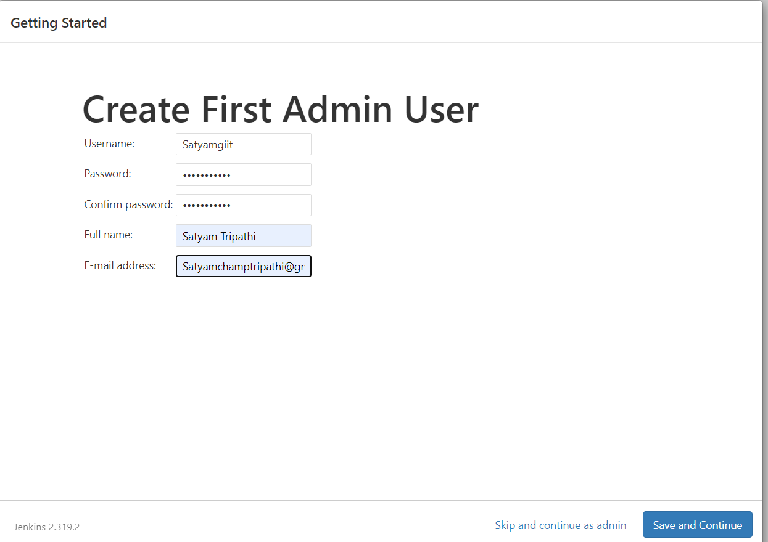

* If I want to change my public ip to private ip we have a option to change it here but right now I don’t want to give my private ip but you have a option to private it .

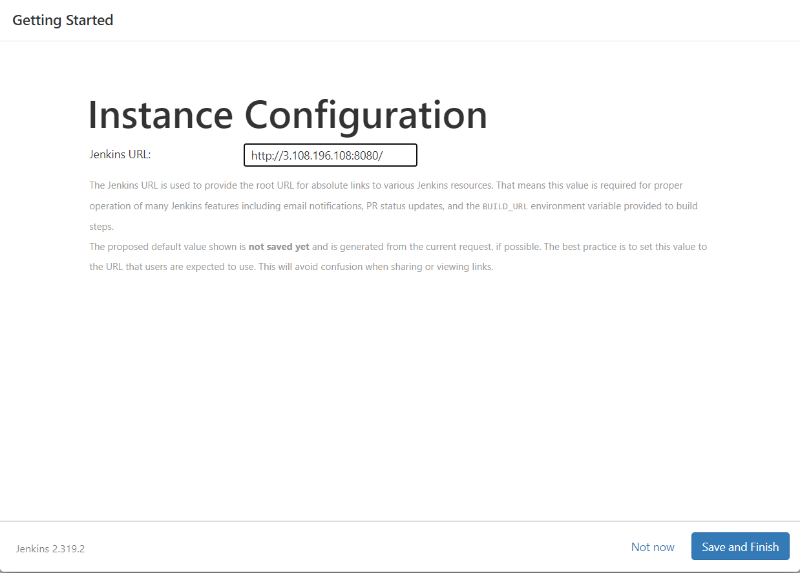

* Jenkins dashboard is ready in aws cloud

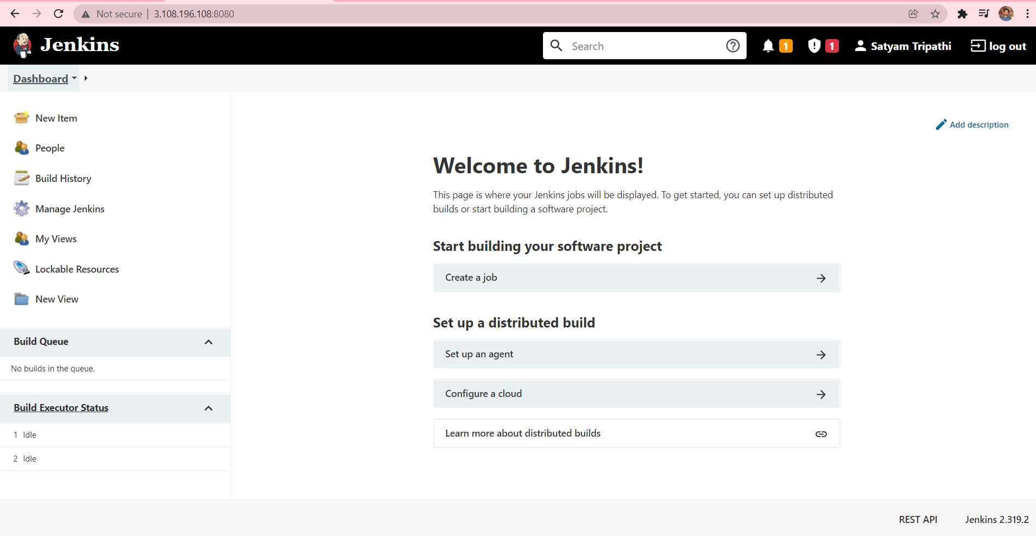

**Before install newman install nodejs**

* **Go this aws doc & install nodejs step by step :-**
* [**https://docs.aws.amazon.com/sdk-for-javascript/v2/developer-guide/setting-up-node-on-ec2-instance.html**](https://docs.aws.amazon.com/sdk-for-javascript/v2/developer-guide/setting-up-node-on-ec2-instance.html)

**Install Newman**

* **npm install -g newman**
* **npm -version**

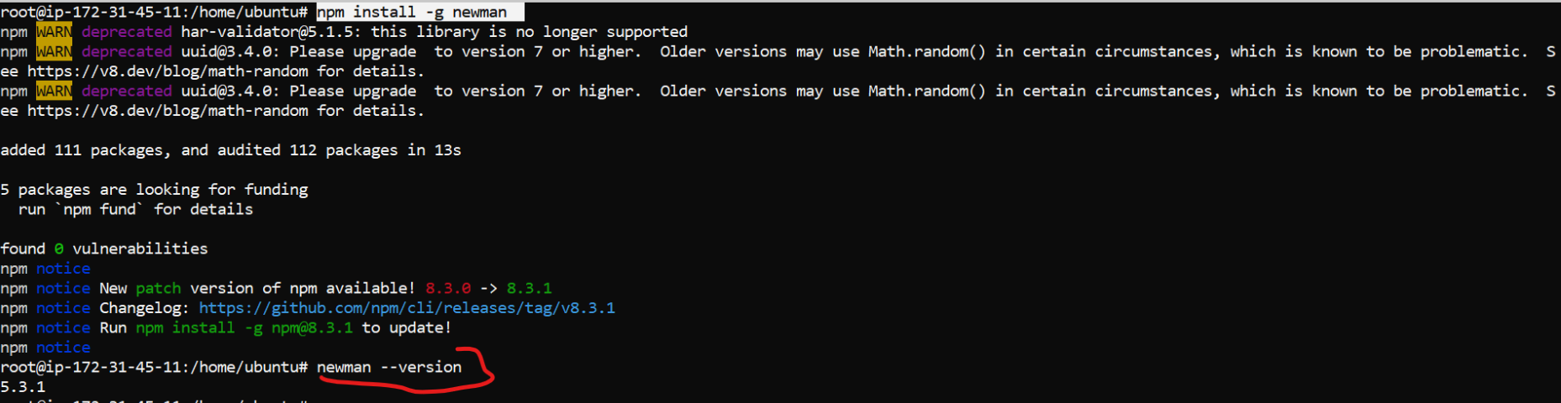

* **Click new item**

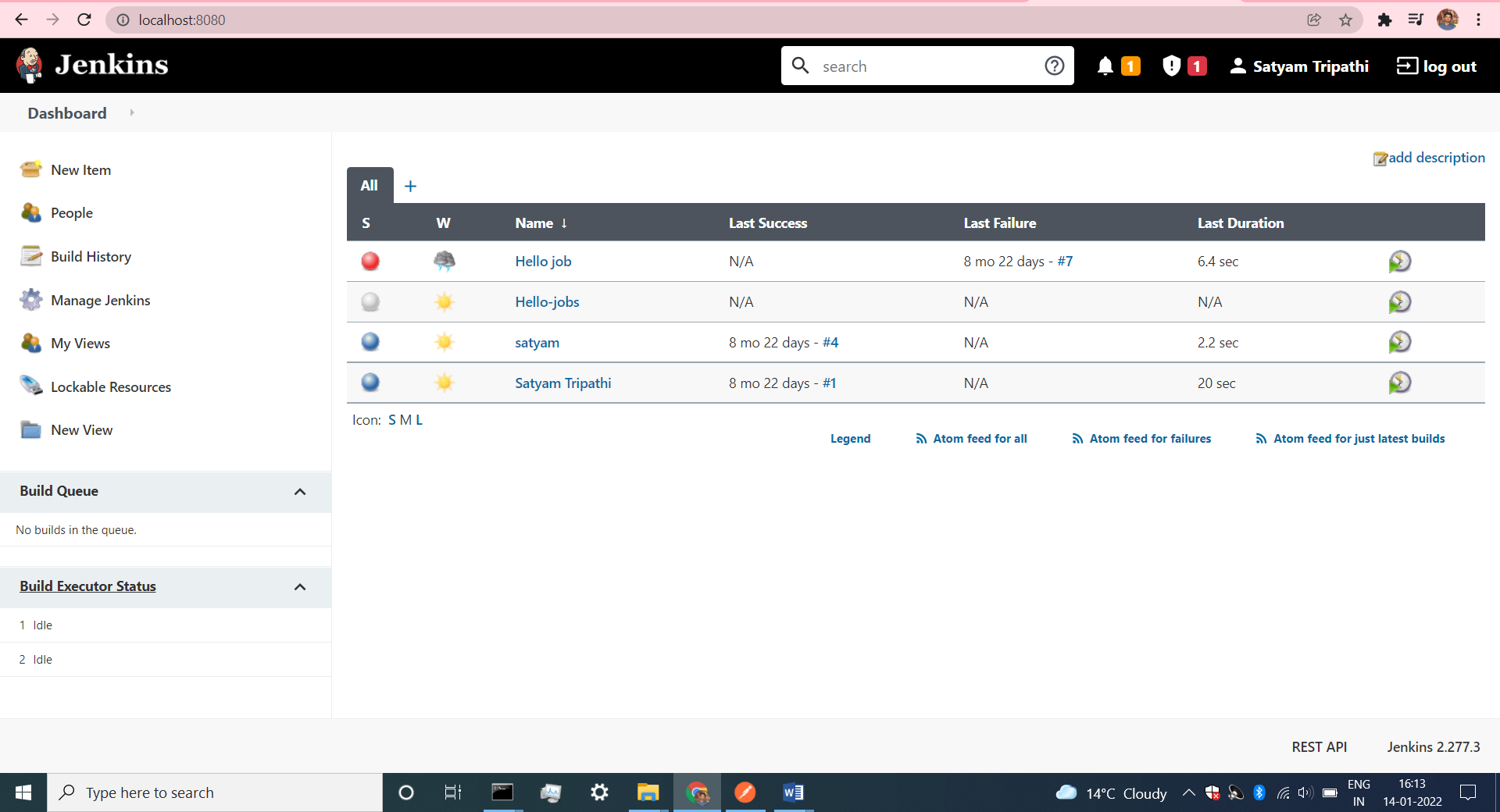

* **Create new names and click freestyle project then enter ok**

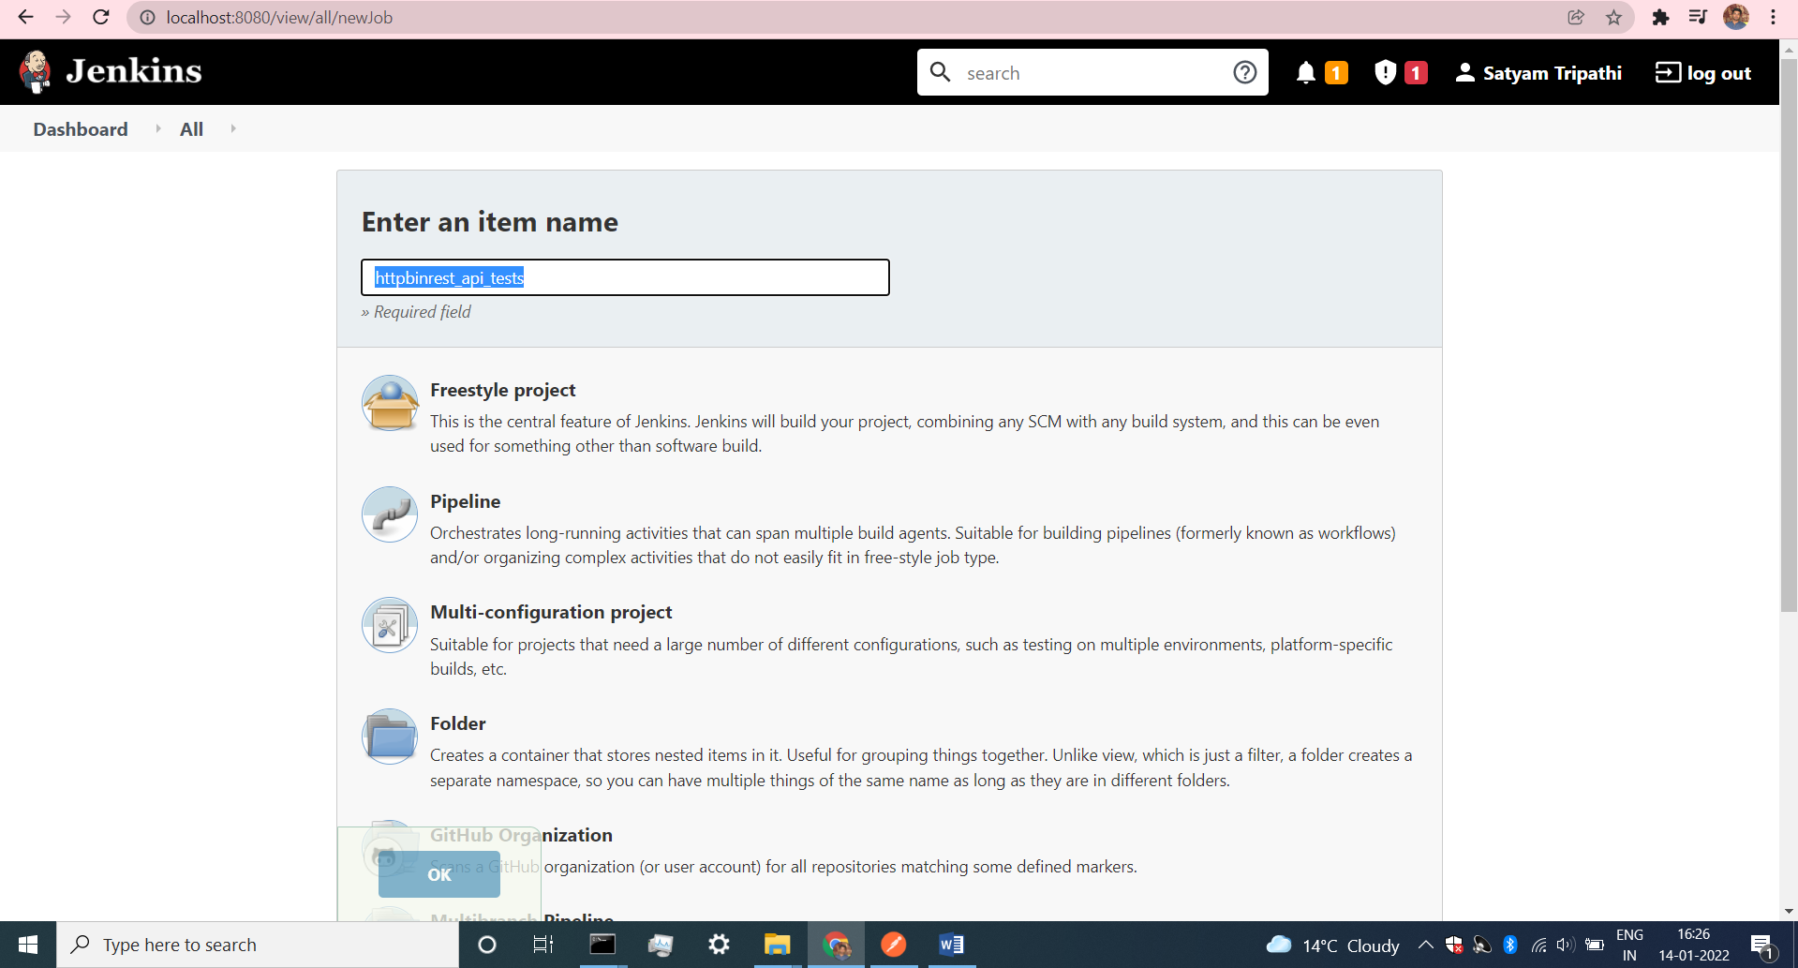

* **Go to build option and cick execute shell**

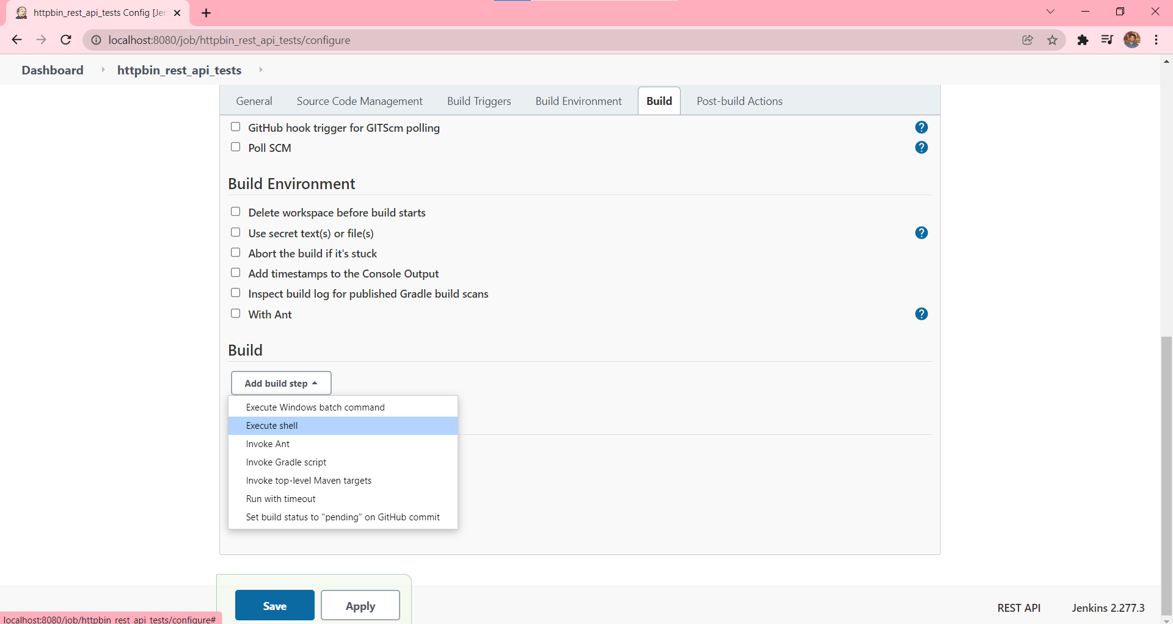

* **Enter all the details to check the version.**
* **Click save the configuration**

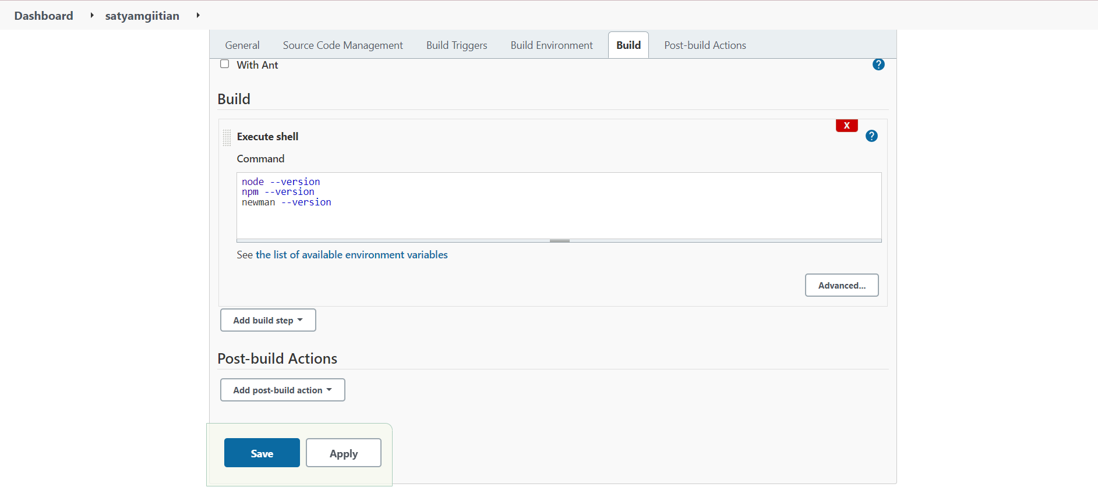

* **Our project has been created and now click build now, after build now click #1 to see the output .**

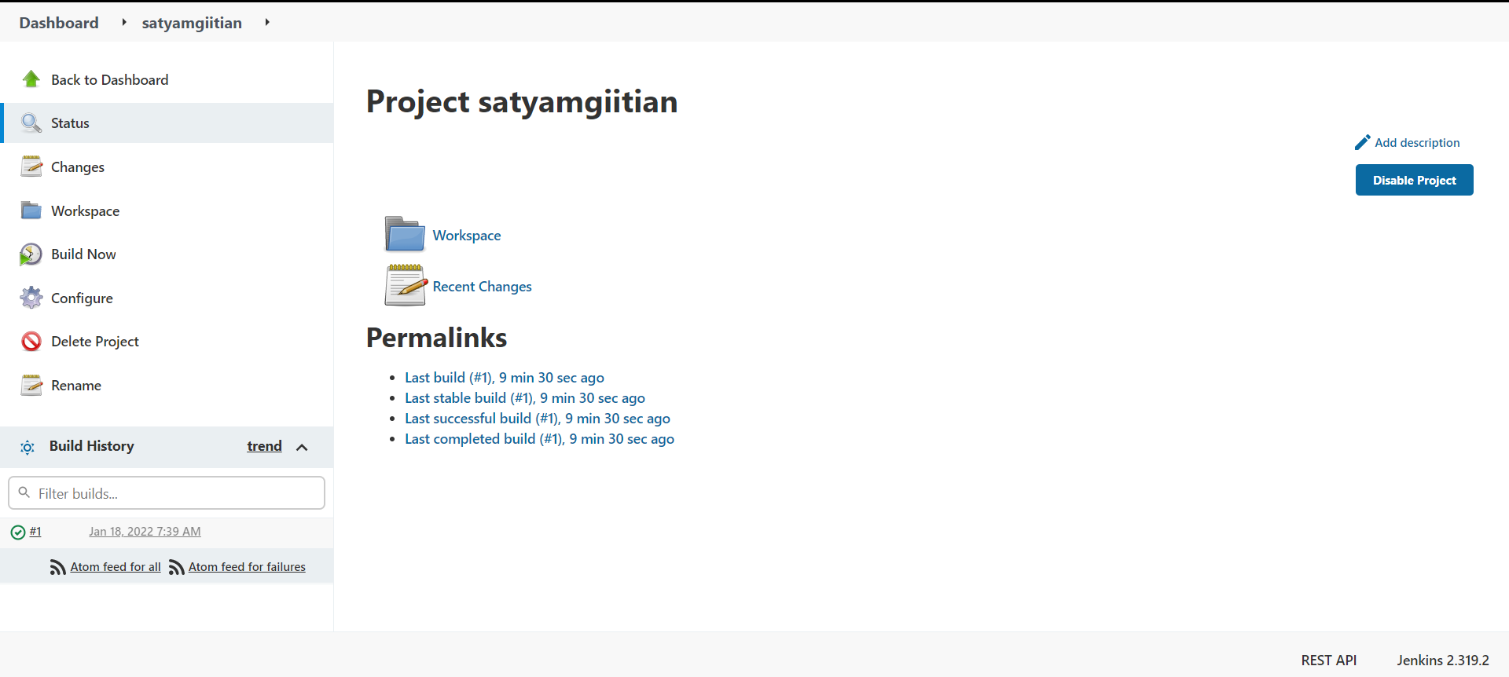

* **Open console output**

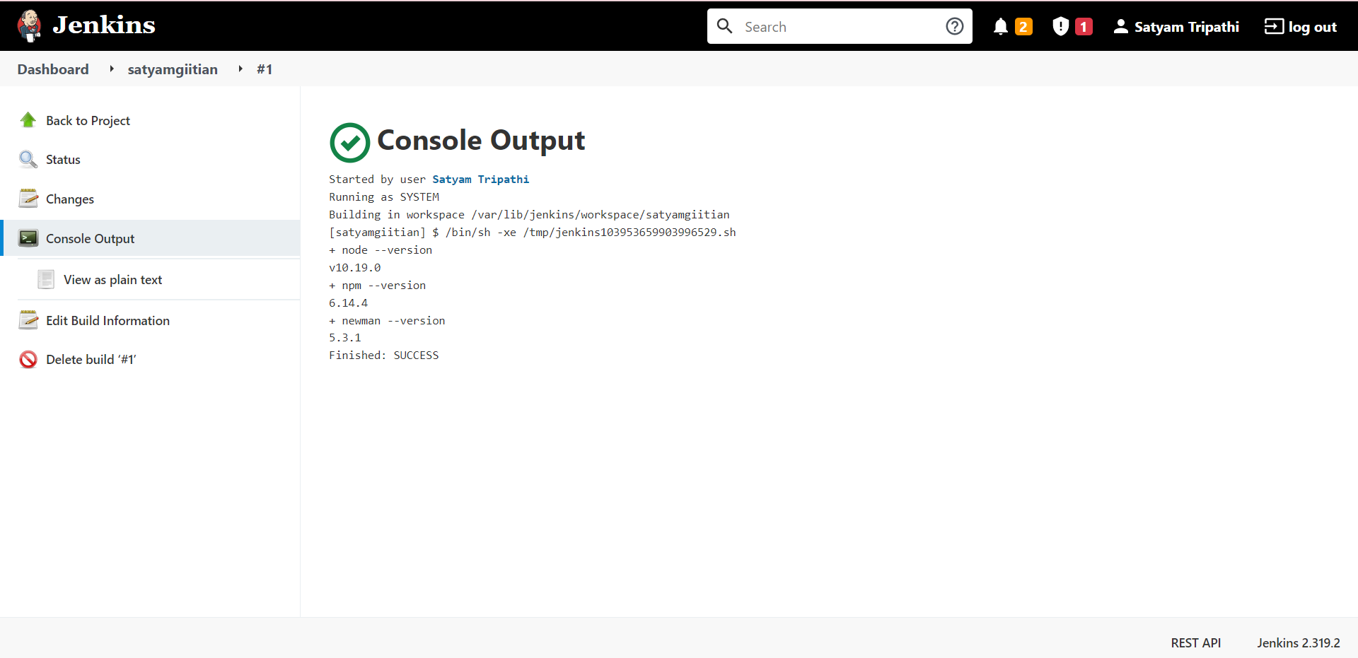

**Run Postman collection using Jenkins:-**

* **Copy collection link**

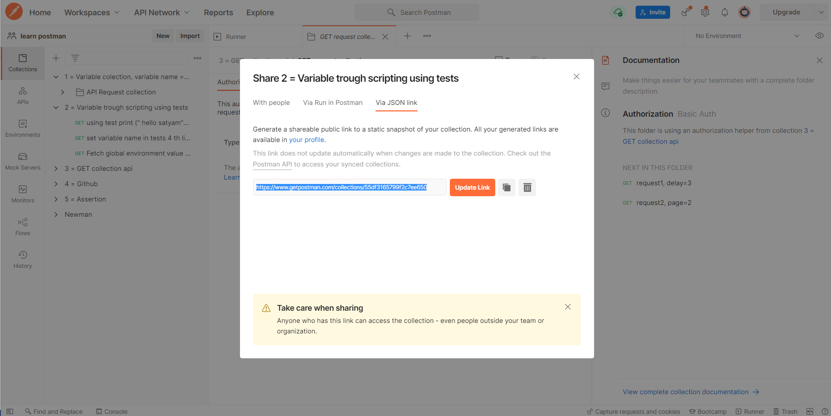

* **Create new project & paste the link before link use newman run to run the collection.**
* **Save it**

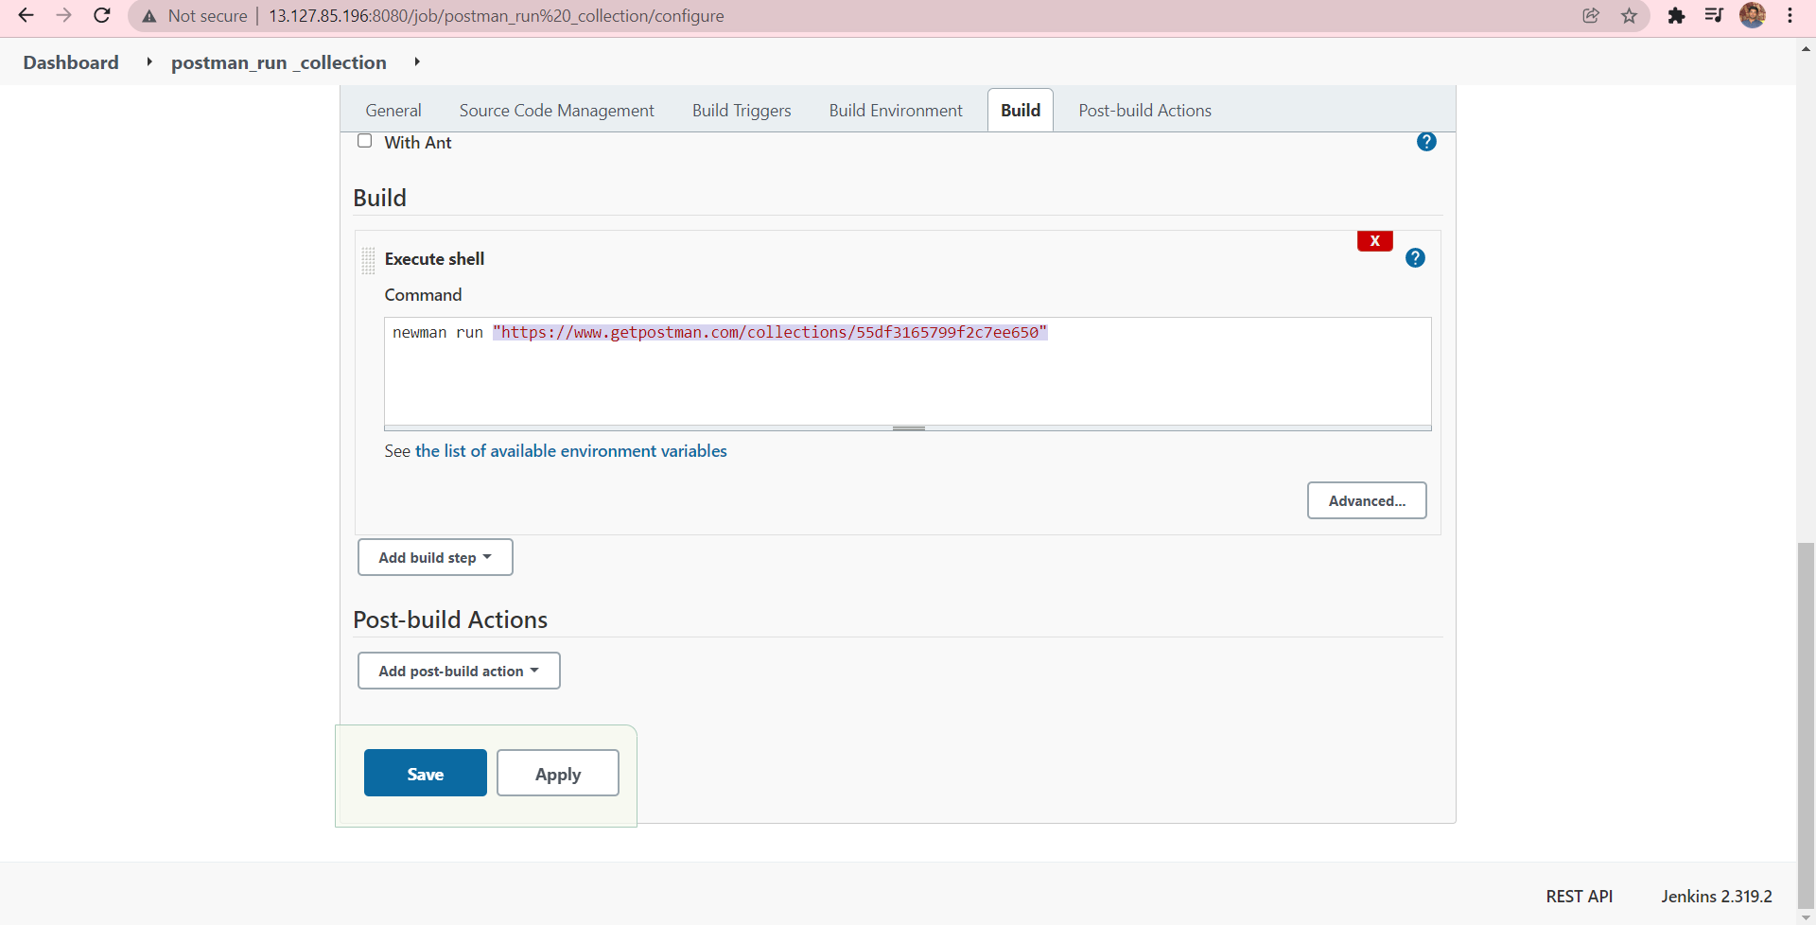

* **Our build is ready, click build #1 to see the console output.**

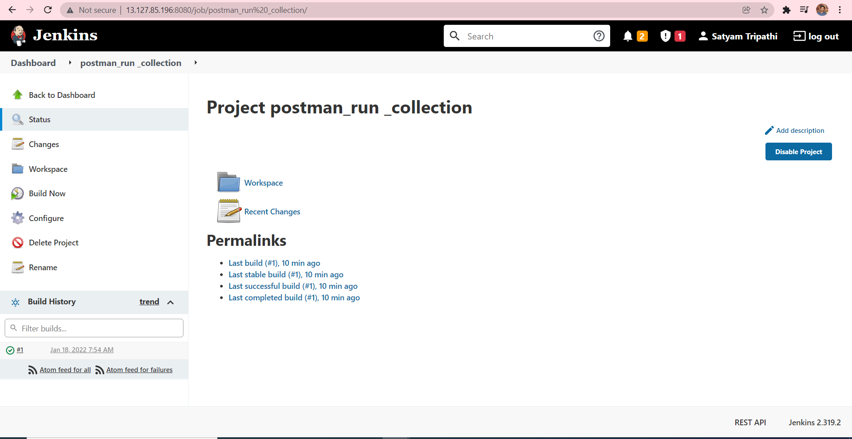

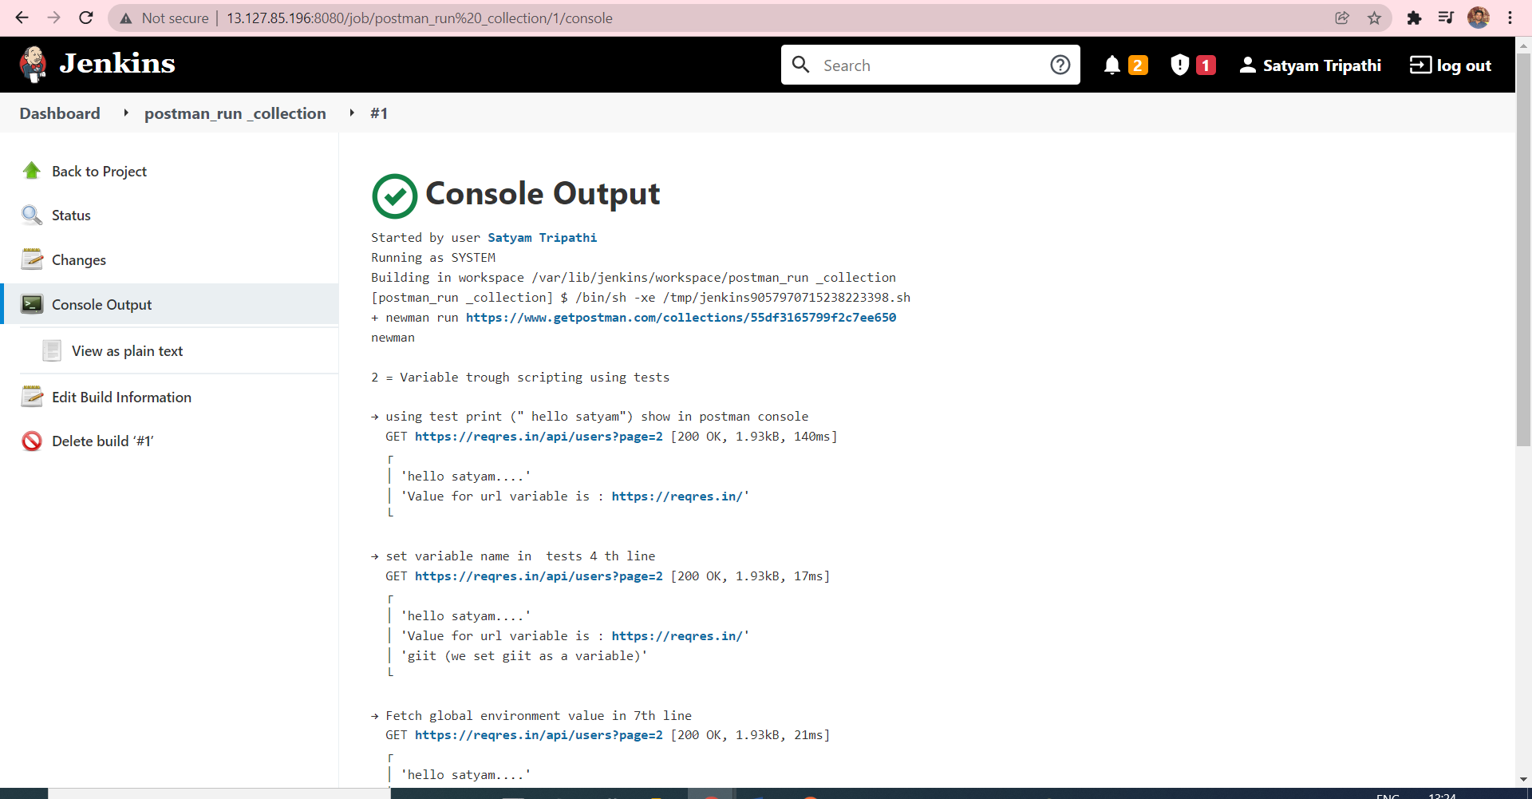

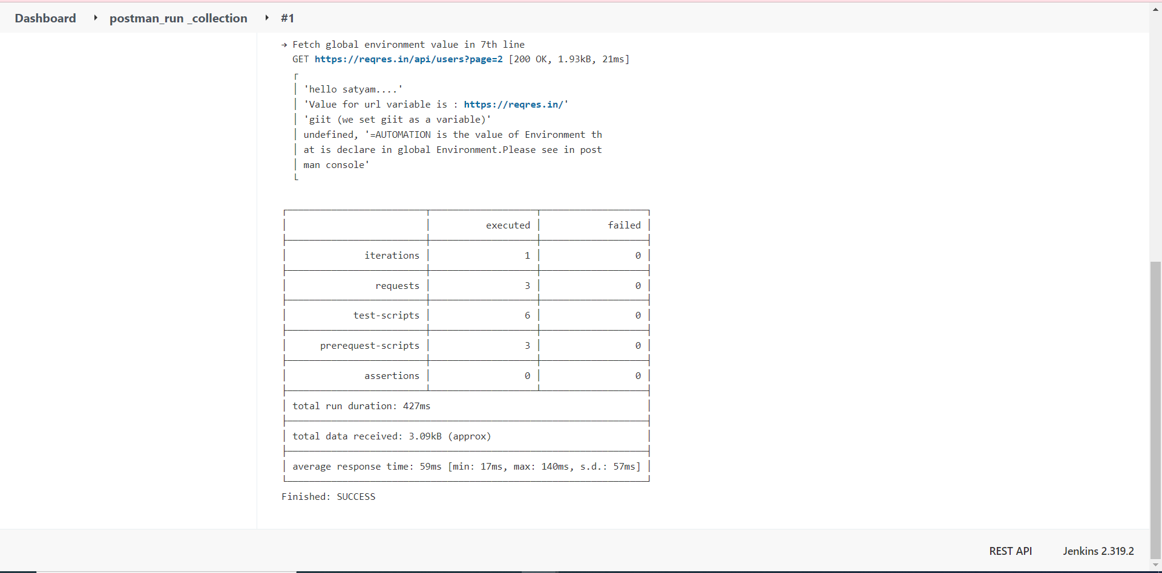

**Running a collection with Jenkins & Generating a report and html report**

* **We see in add post-build option we can’t see the htm**

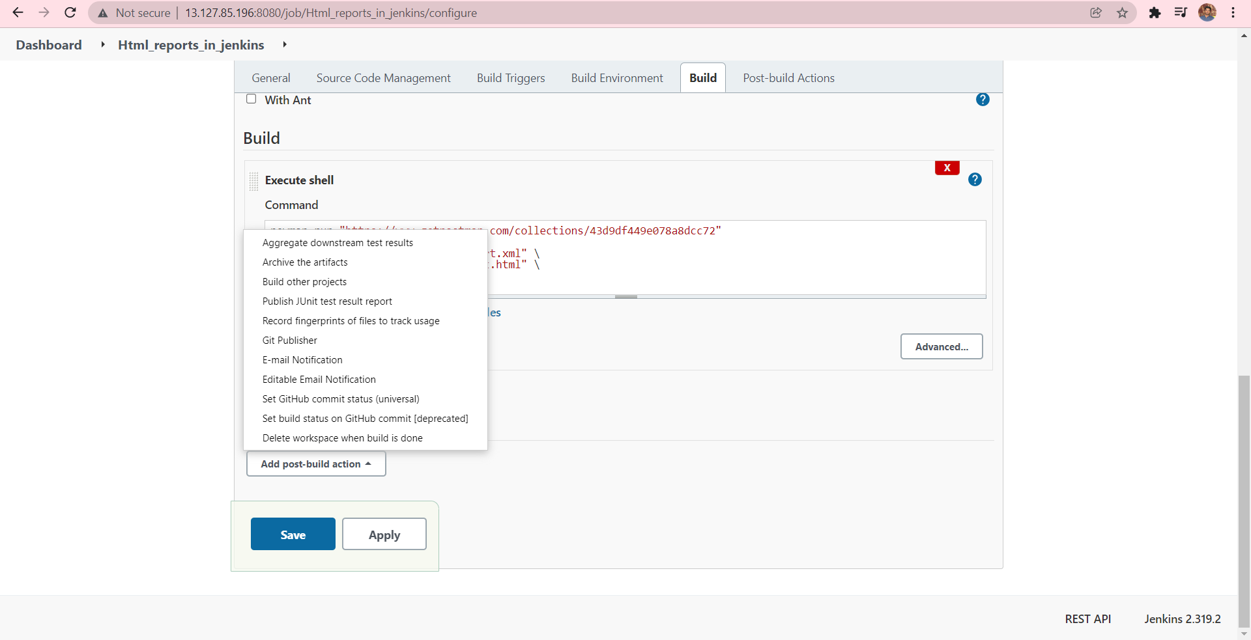

* **npm install -g newman-reporter-htmlextra**

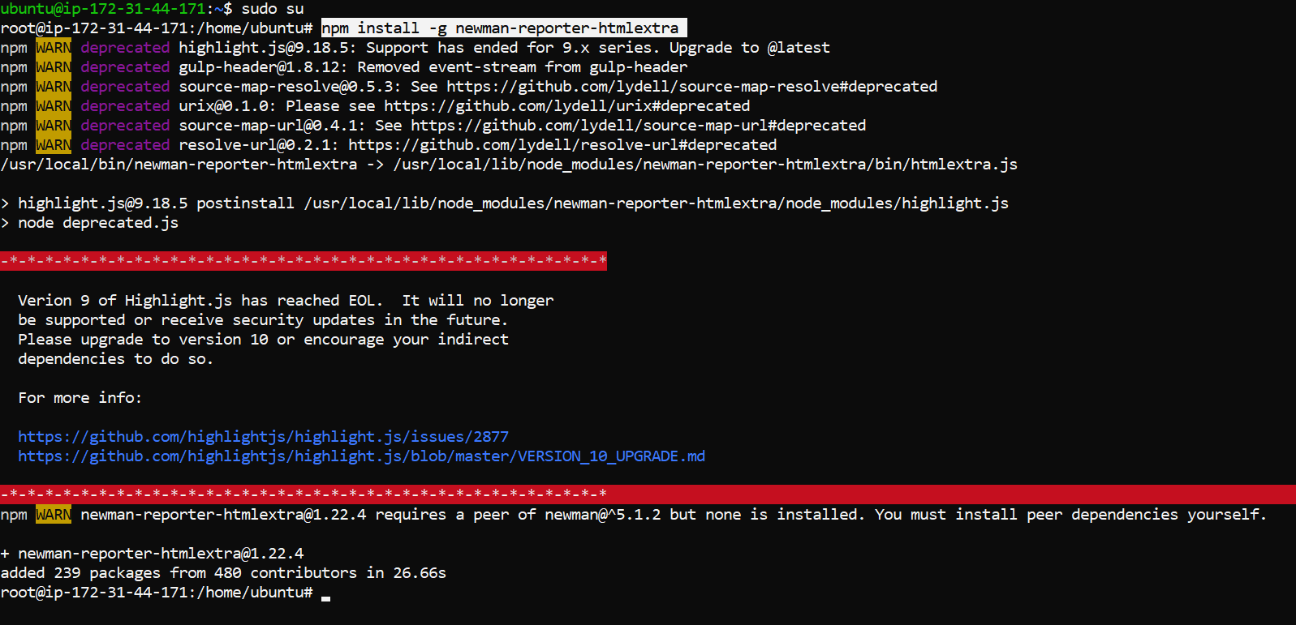

* **npm install -S newman-reporter-htmlextra**

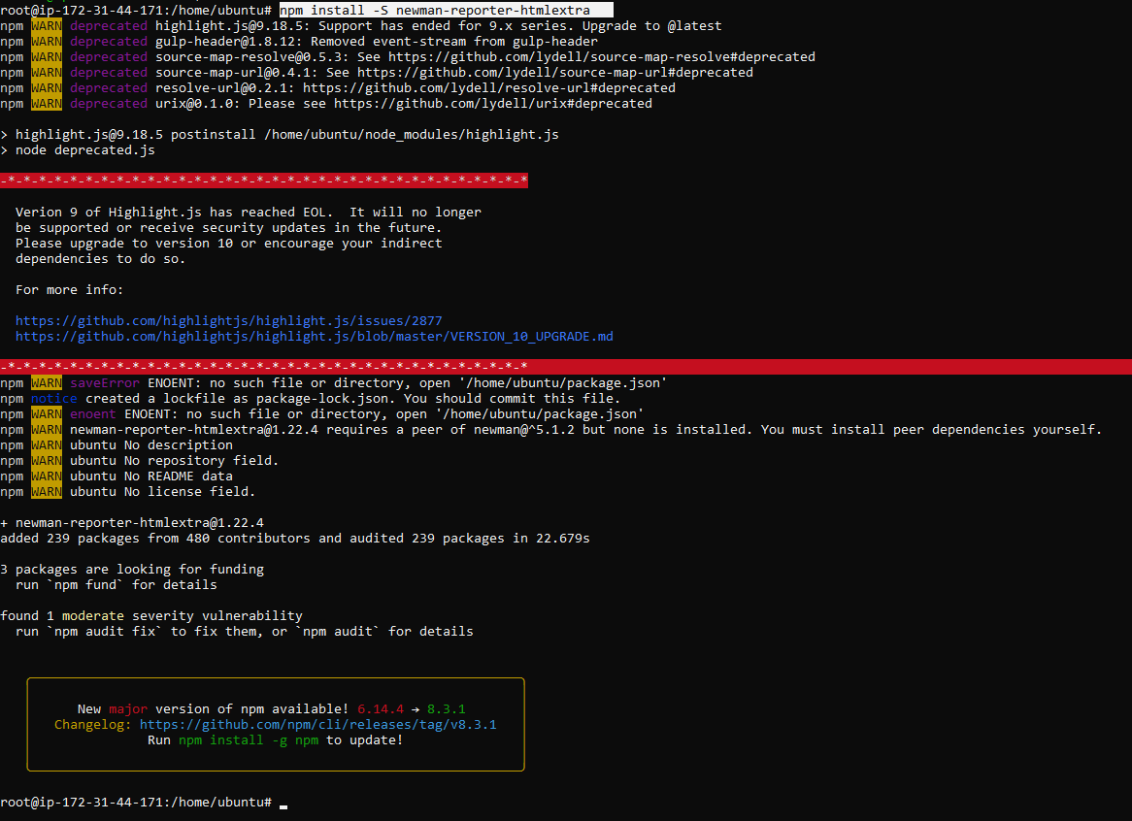

* **apt install docker.io**

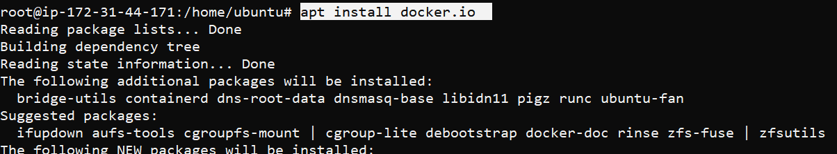

* **docker pull dannydainton/htmlextra**

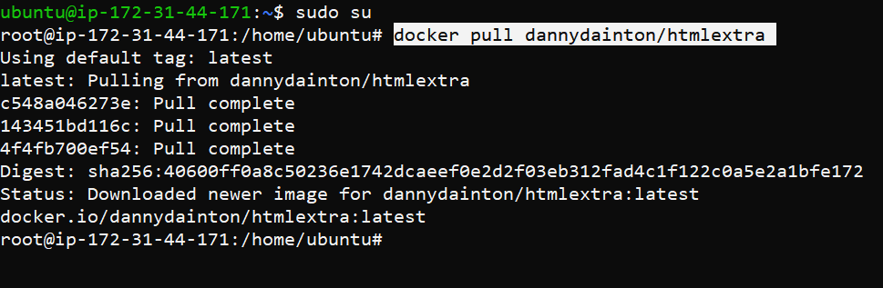

**Running Newman with gitlab**

**Docs to install gitlab =https://docs.gitlab.com/runner/install/linux-repository.html**

* **curl -L "https://packages.gitlab.com/install/repositories/runner/gitlab-runner/script.deb.sh" | sudo bash**

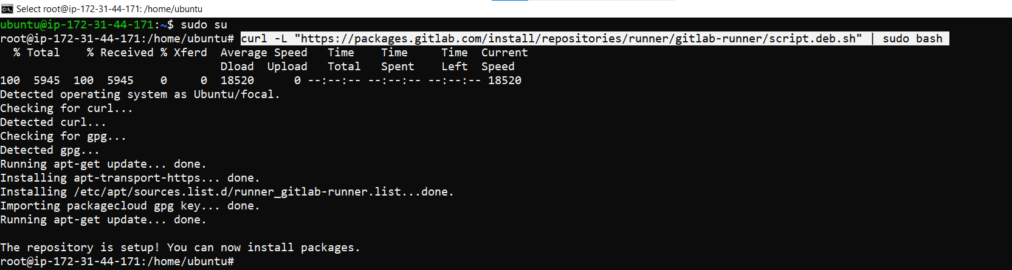

* **sudo apt-get install gitlab-runner**

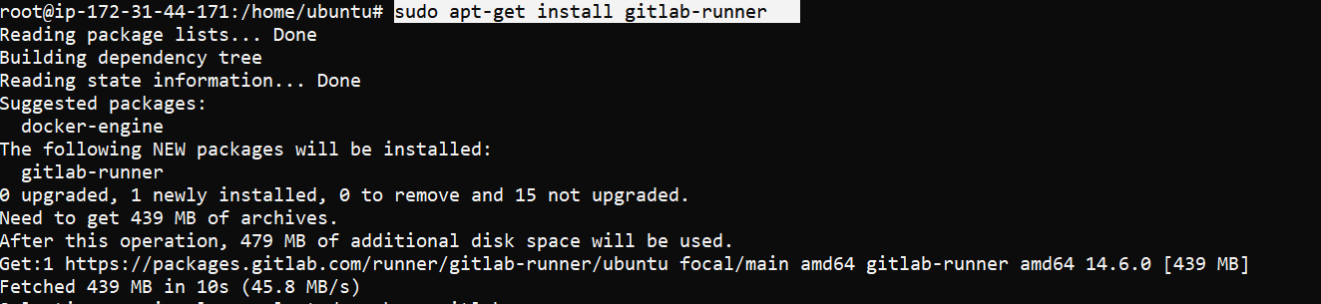

* **Sudo visudo**

**Add this line => gitlab-runner ALL=(ALL:ALL)ALL**

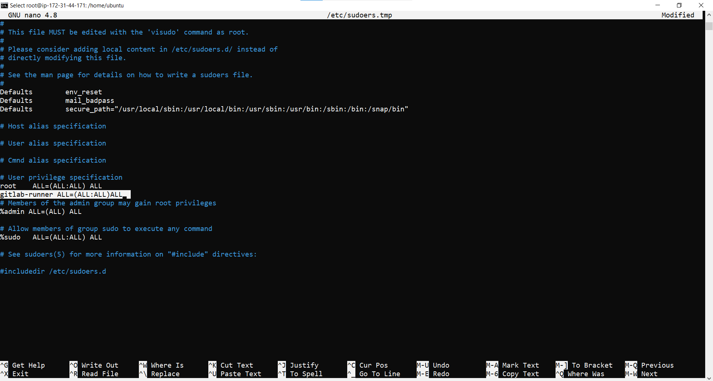

* **sudo gitlab-runner --version**

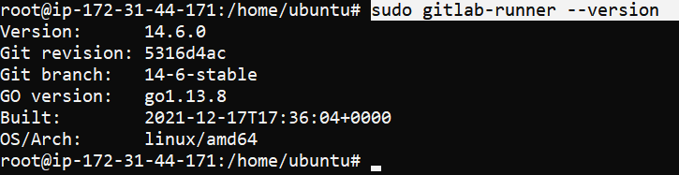

* **sudo gitlab-runner status**



* **Sudo gitlab-runner start**
* **Sudo gitlab-runner stop**
* **Sudo gitlab-runner restart**
* **Open this**
* **Copy, & enter this command to cli = sudo gitlab-runner register**

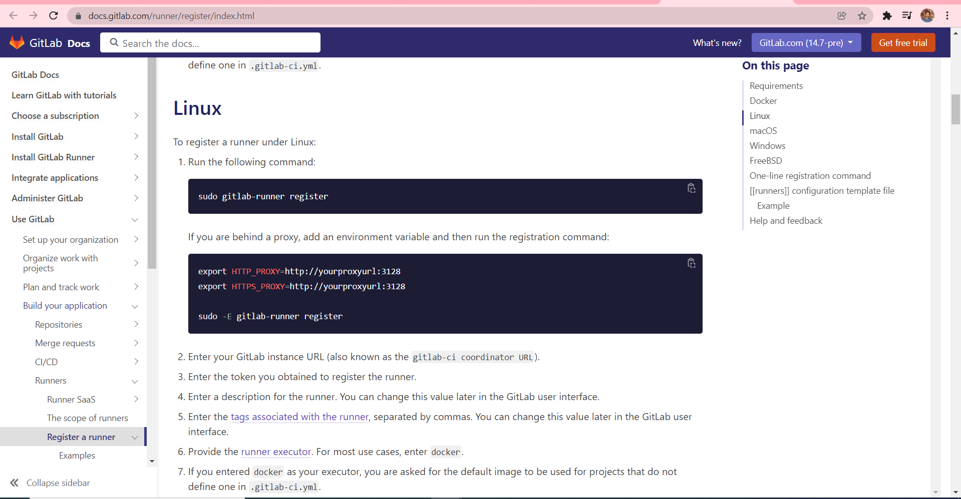

* **Open this path & copy this url & paste it console .**

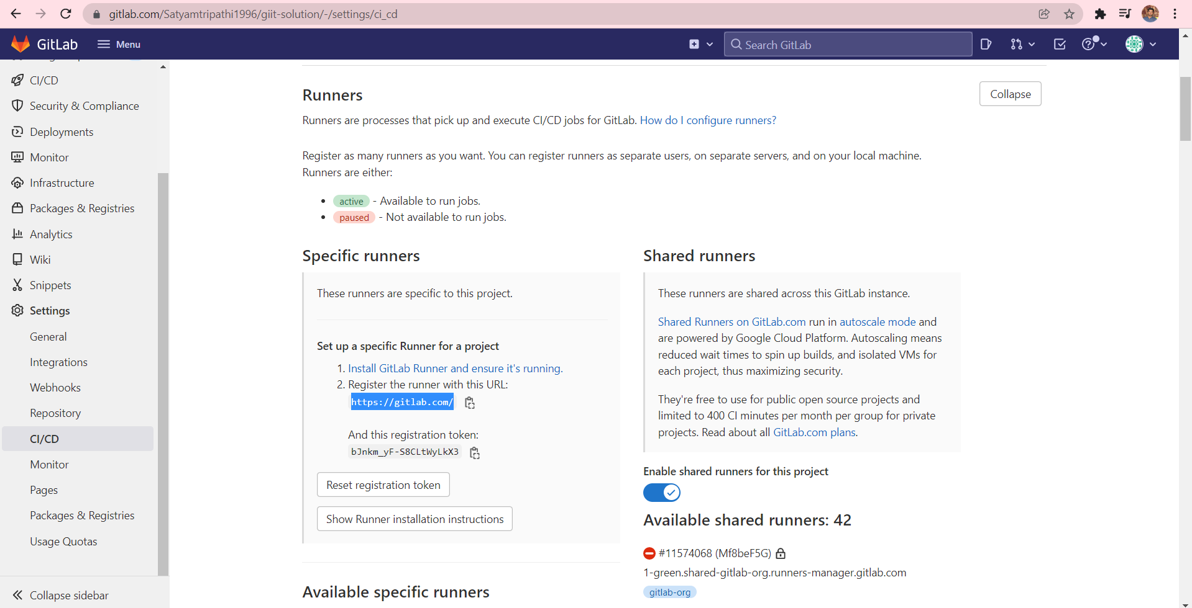



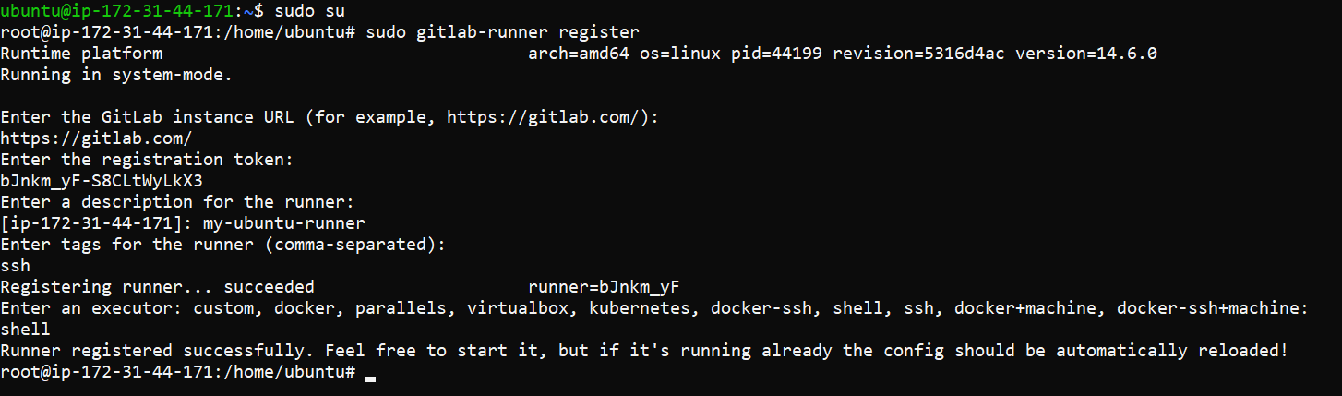

* **Now , again refresh a page we see our new available specific runner details .**

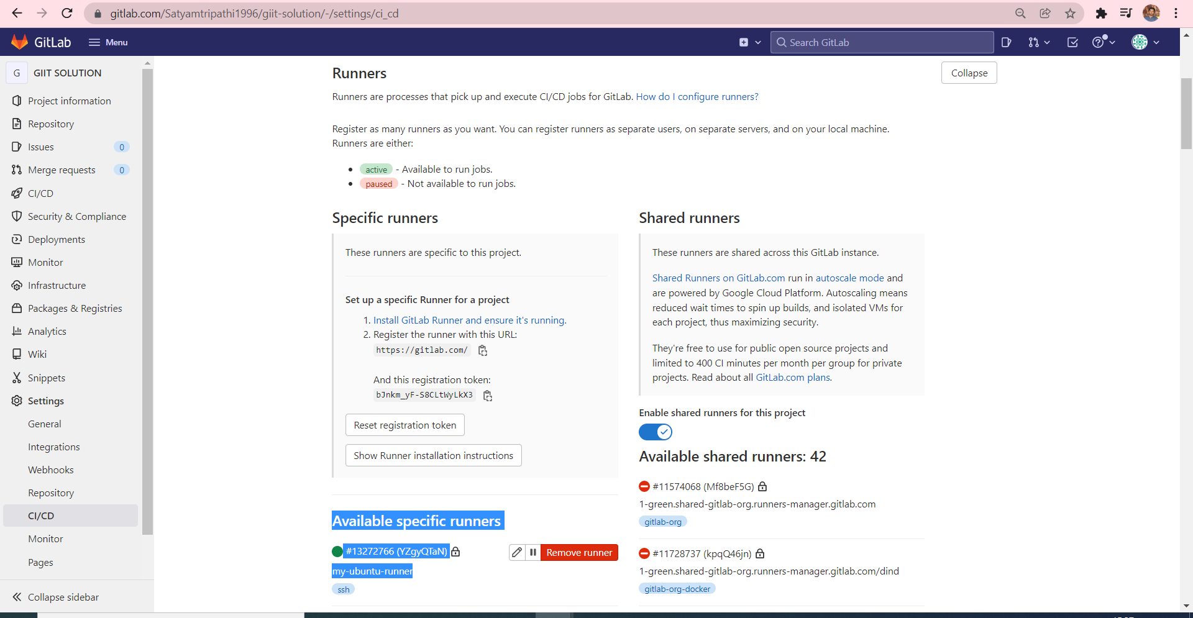

**RUN COLLECTION IN JENKINS BUT API ROUTE DIVERSION USING TEST CASE**

**(CREATE a basic workflow & scenario)**

**1=** 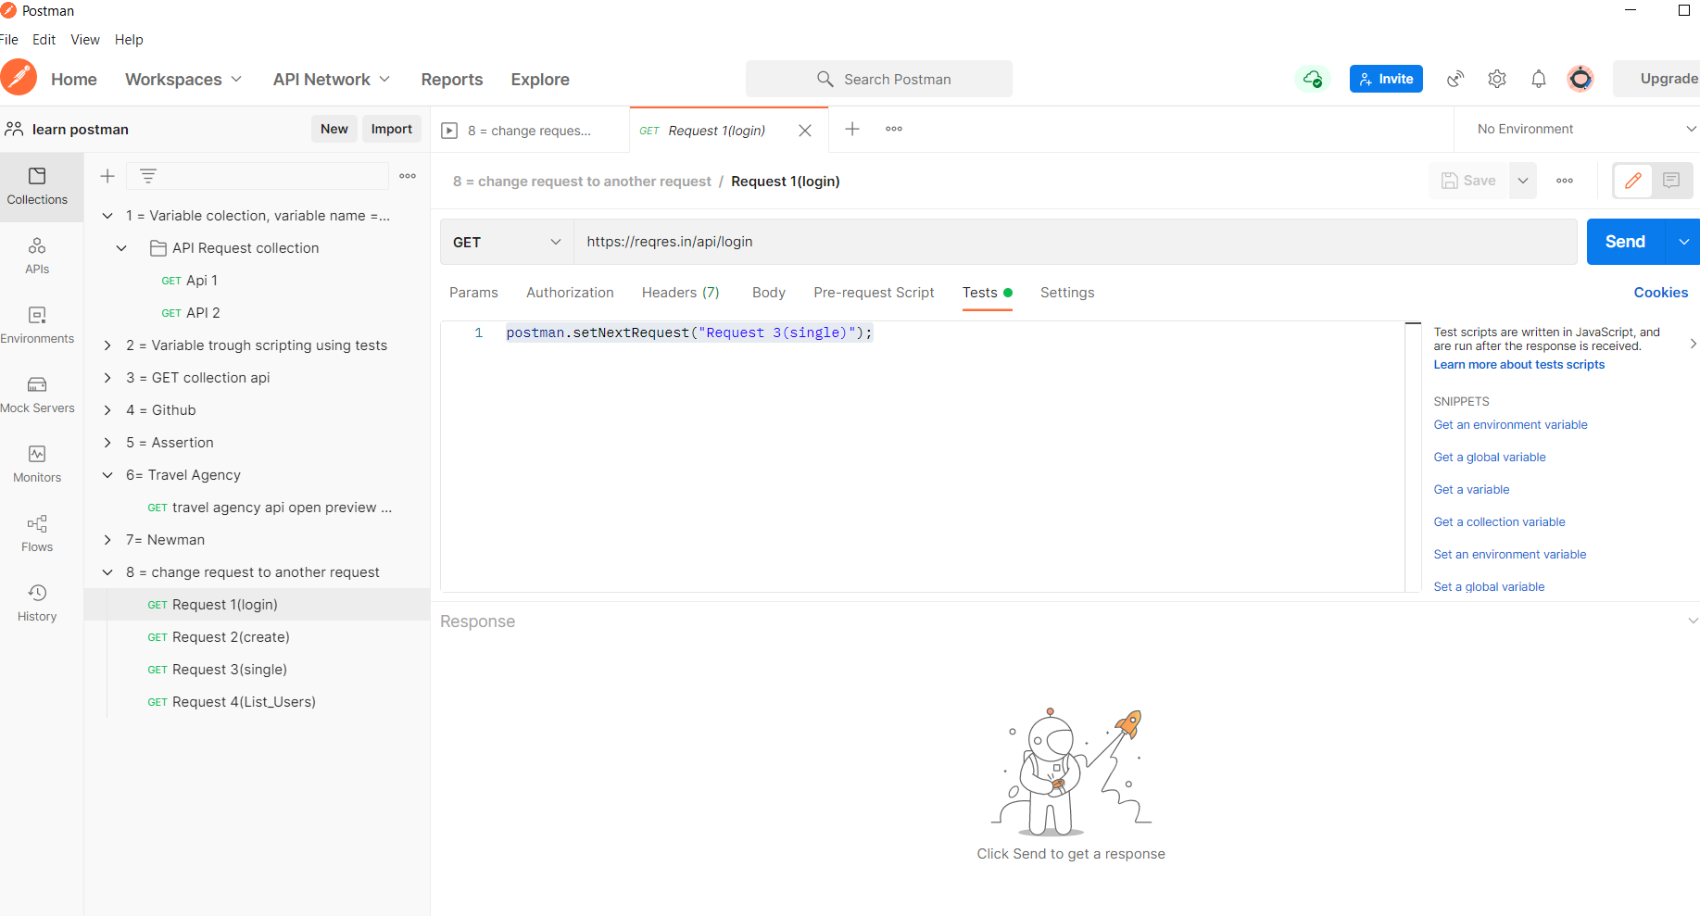

**2=** 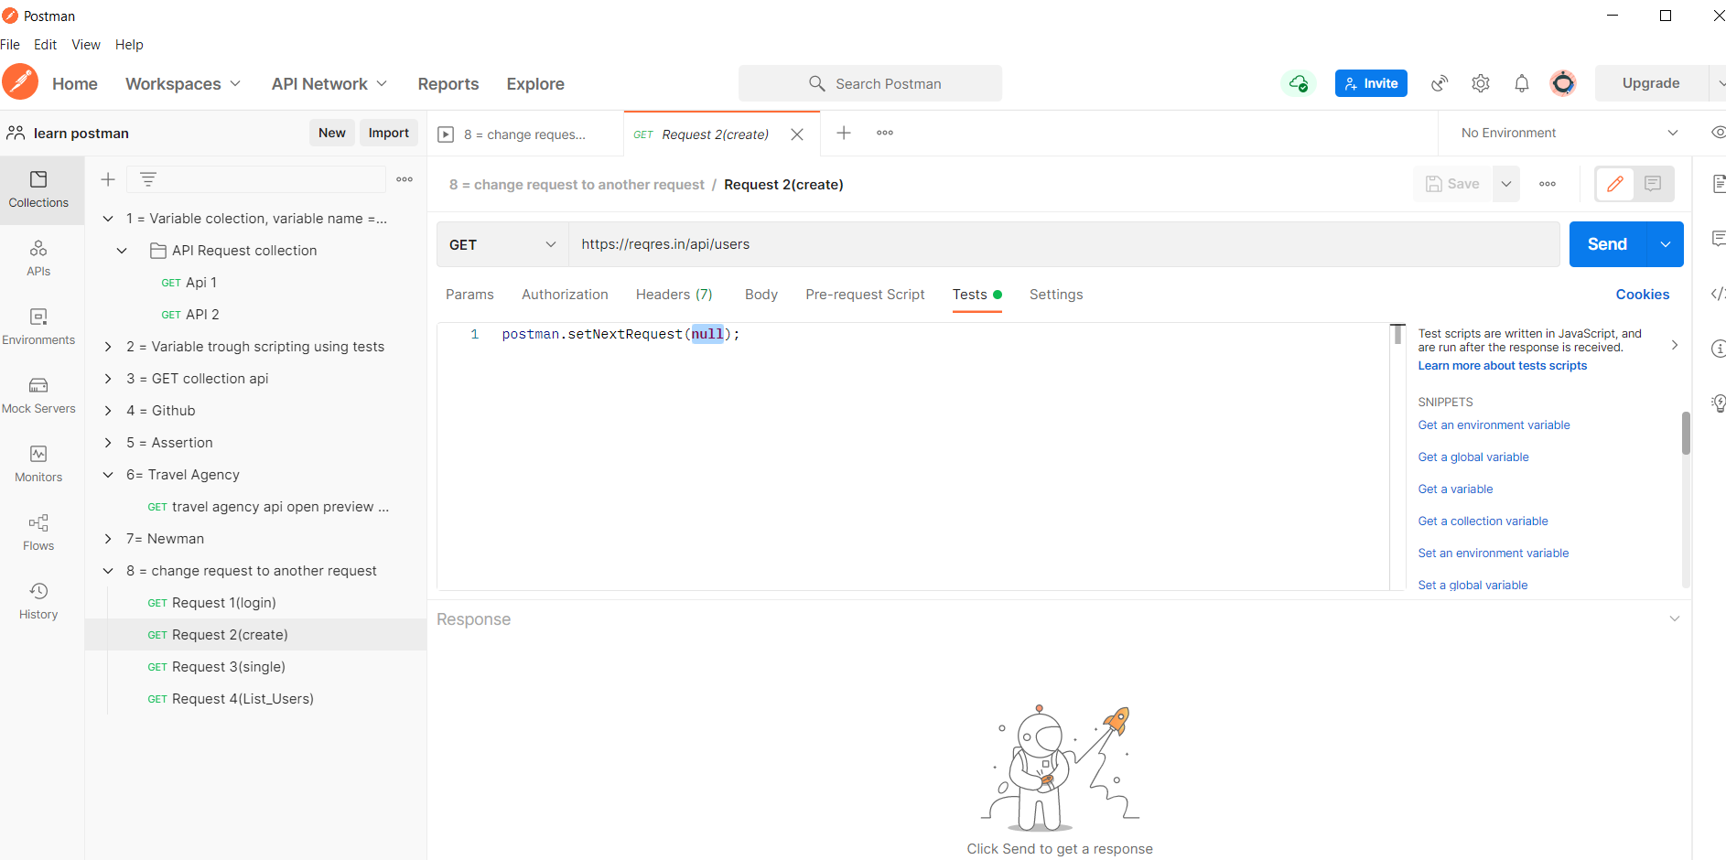

3= 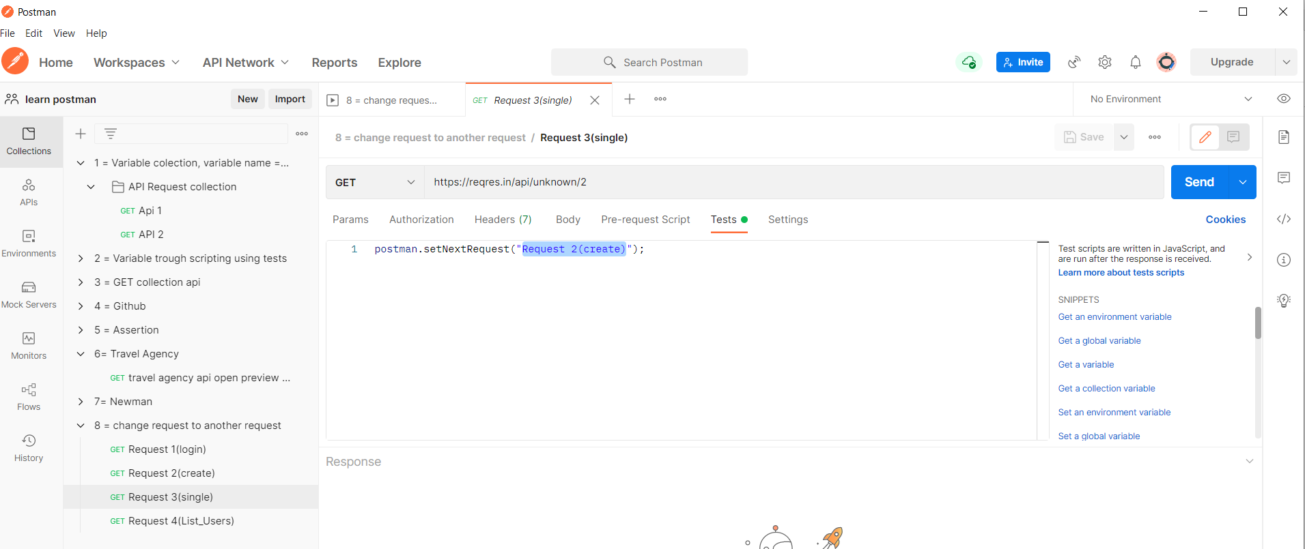

4=

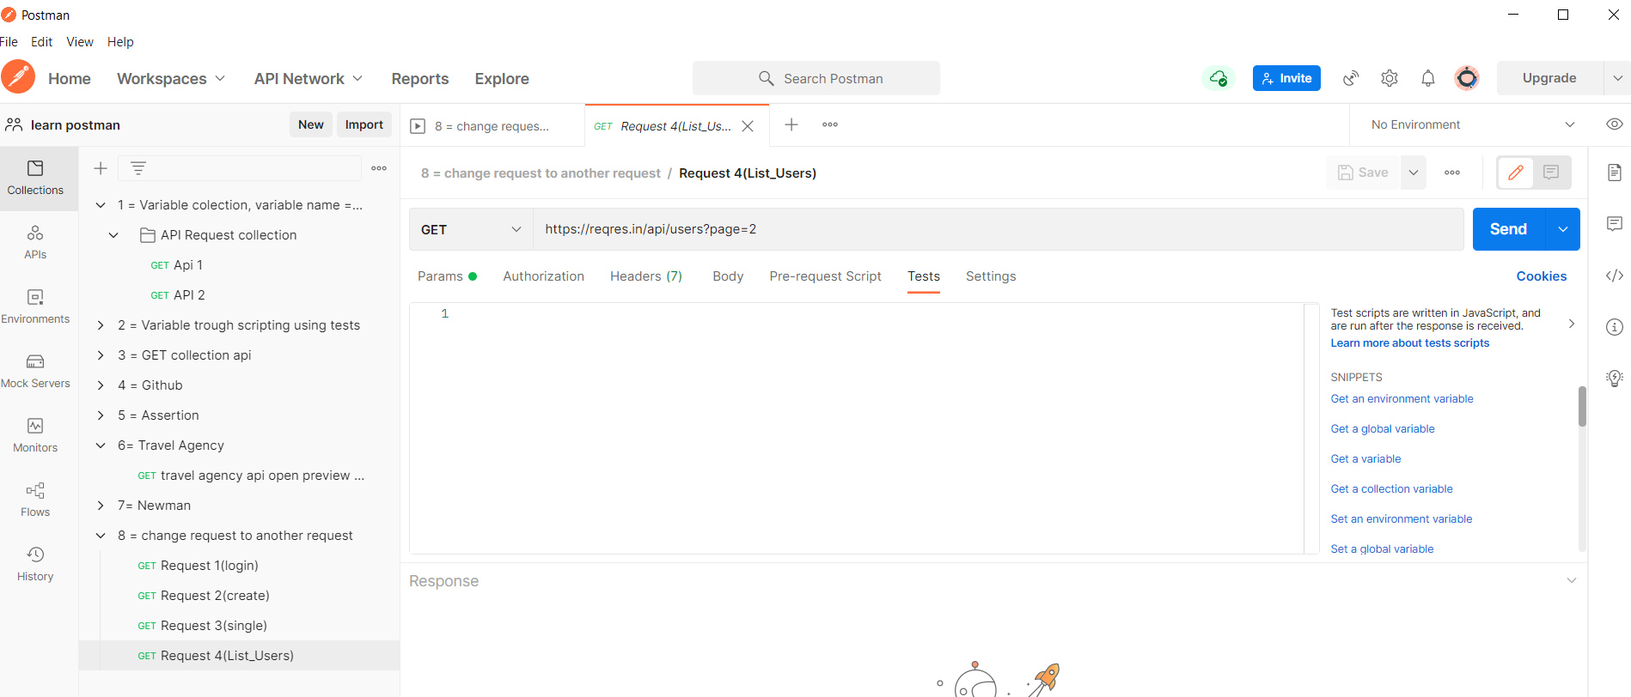S

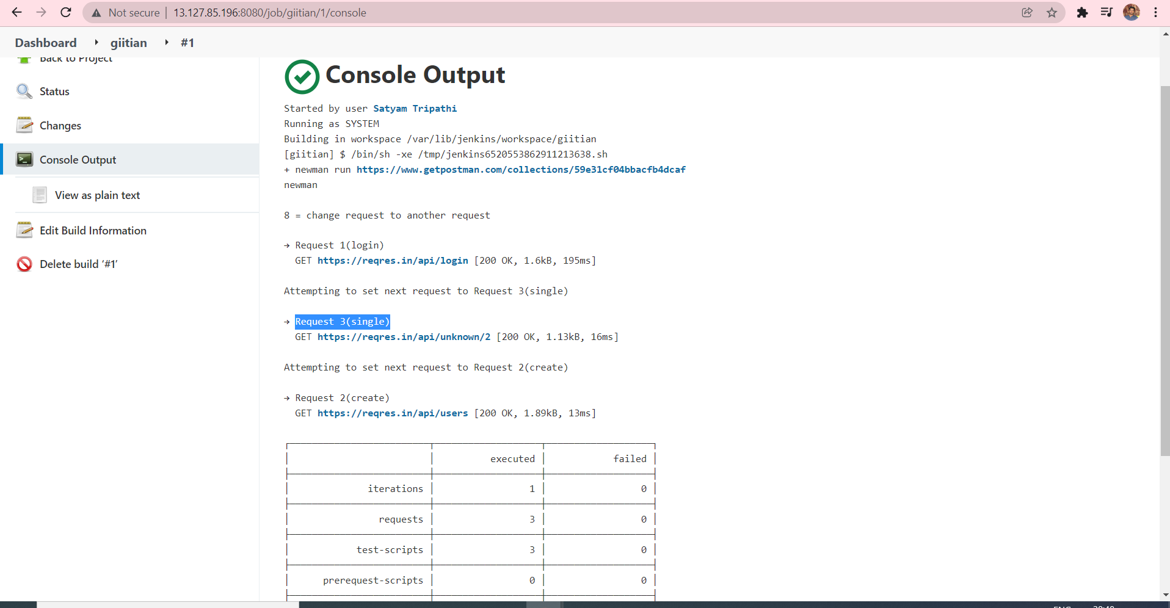

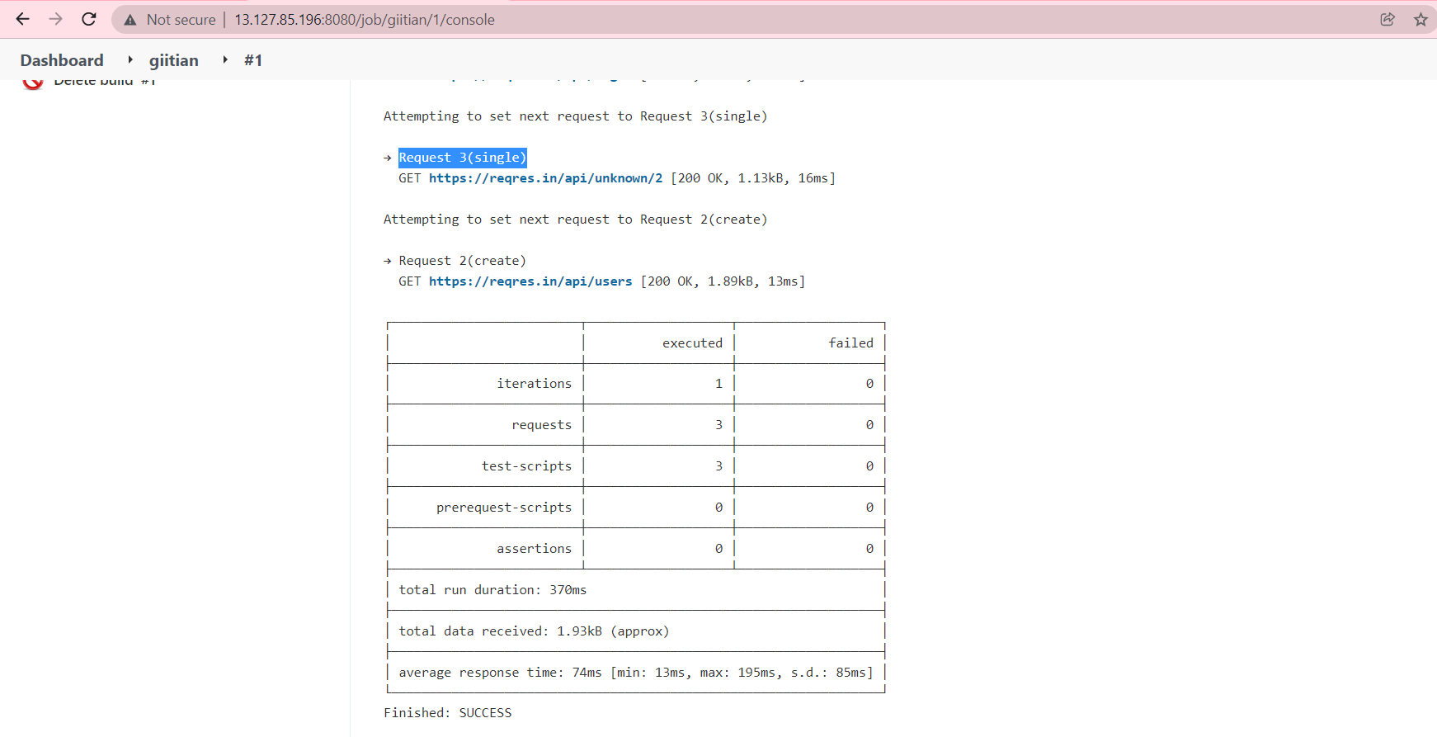

# **Advanced workflows (request chaining) with Postman**

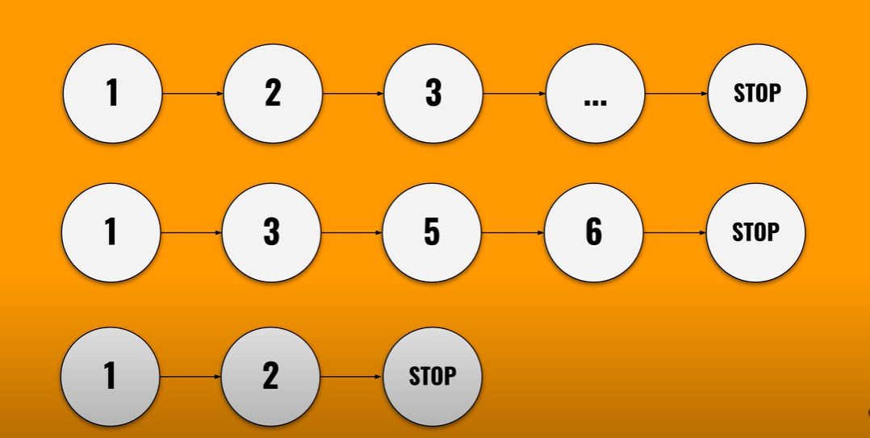

* We write this line to change the request
* For example :- I want always to go from the first request to the second one or from the second one to the fourth one from the fourth one to the third one .

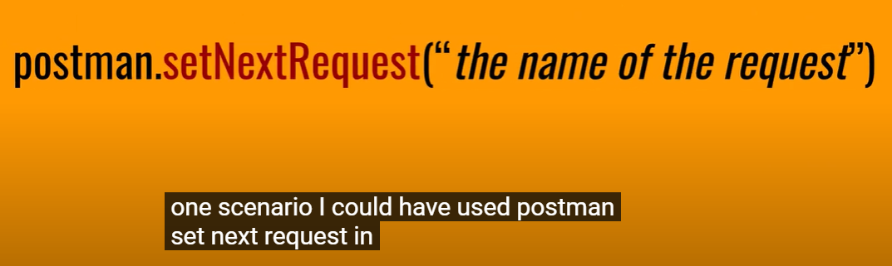

**Router = Router is usually used in web application in order to contain the information that is necessary in order to navigate somewhere , fore example :- to navigate from a page to another page**

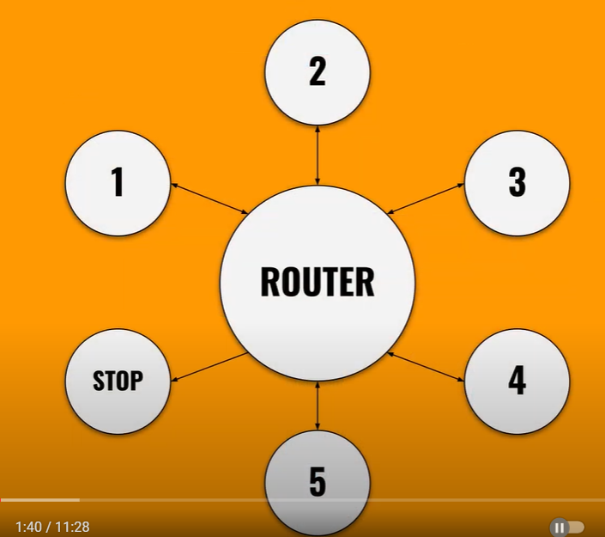

Convert postman request to code format

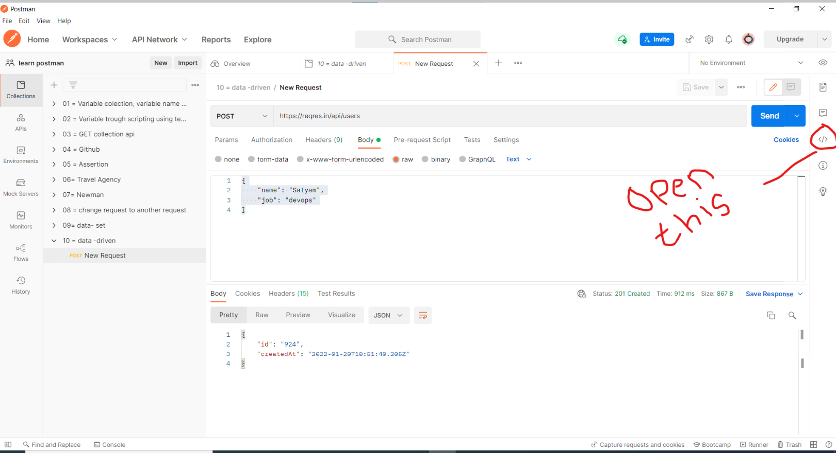

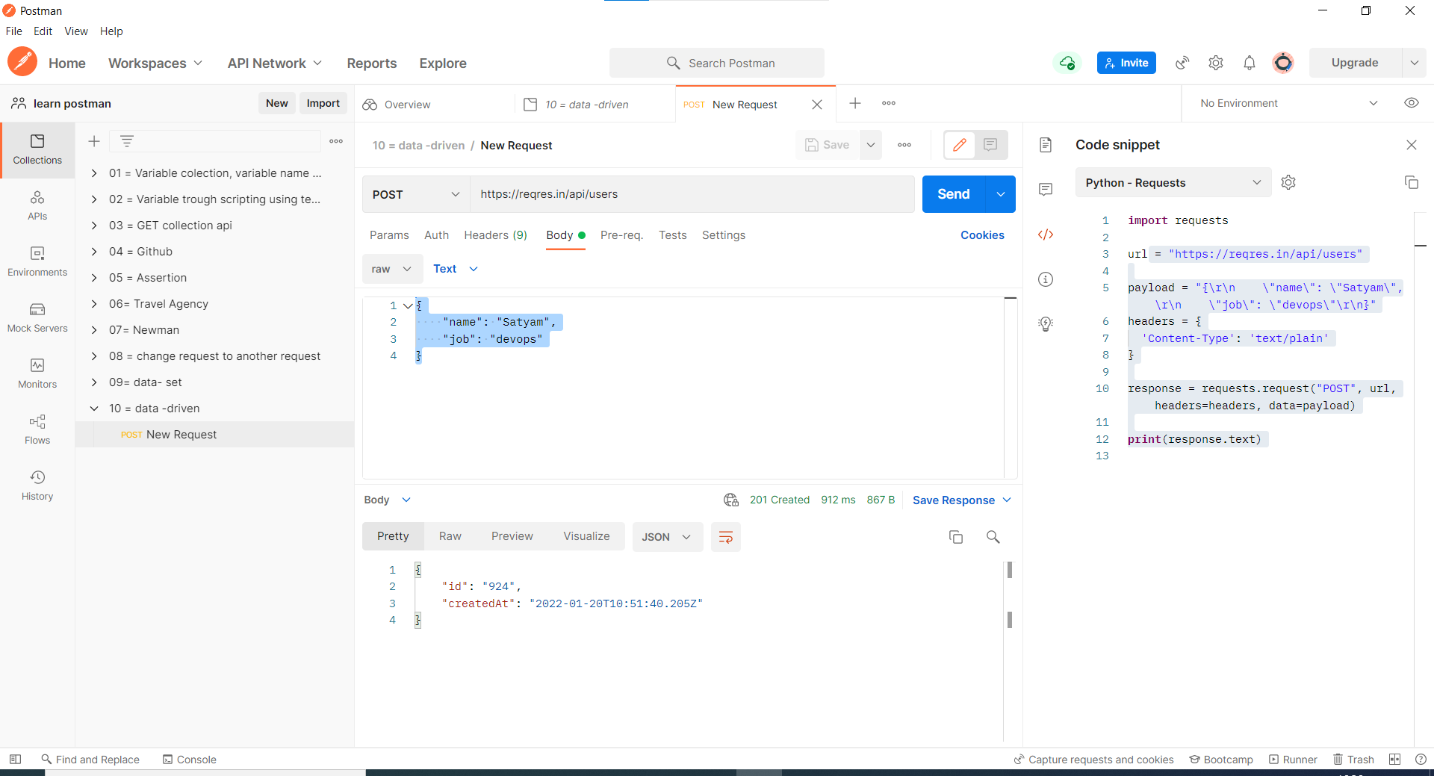

Cookies

* We have a option to add cookies.
* Cookies is like a key pair value we define cookies .
* when you create a cookies after 1 cookies will expire you have a option to extend it.

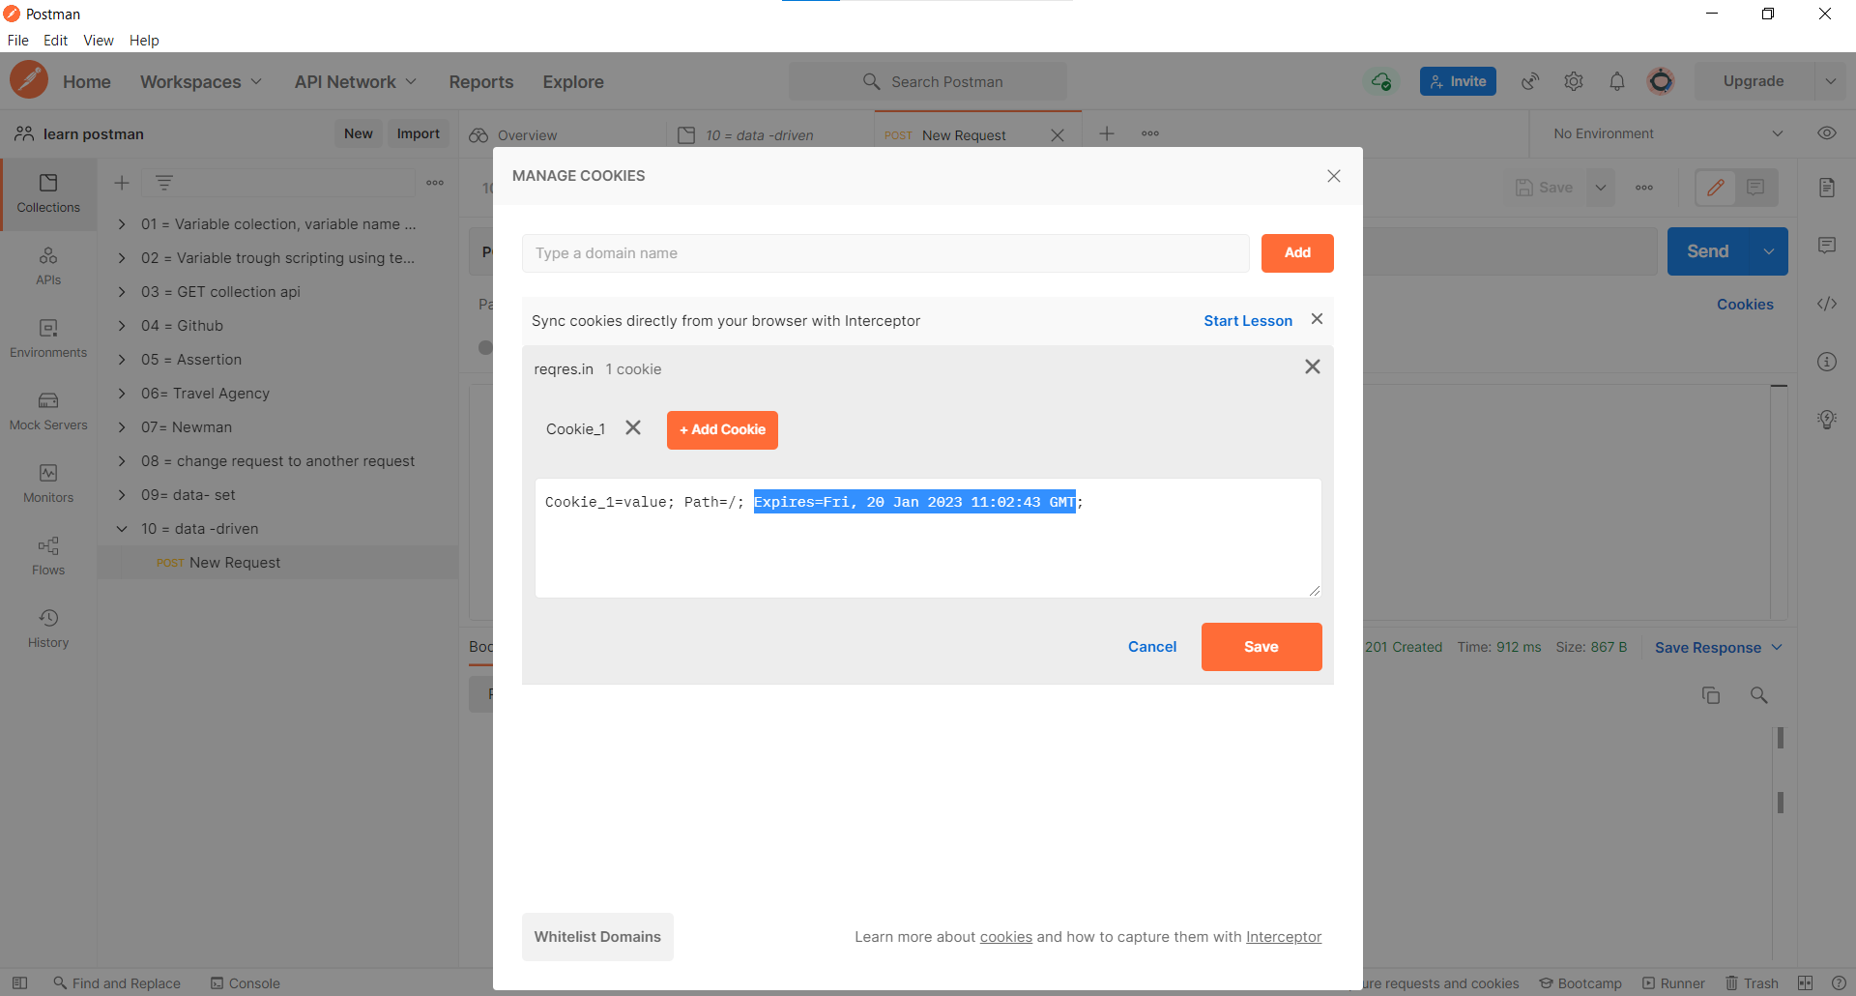

Authentication

* we mostly usse bearer token & Api Key

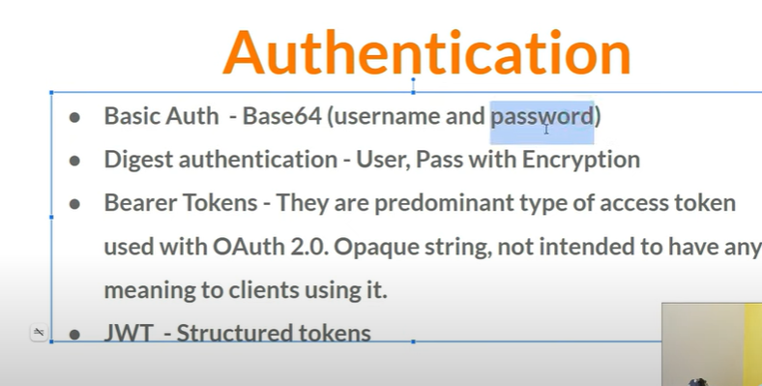

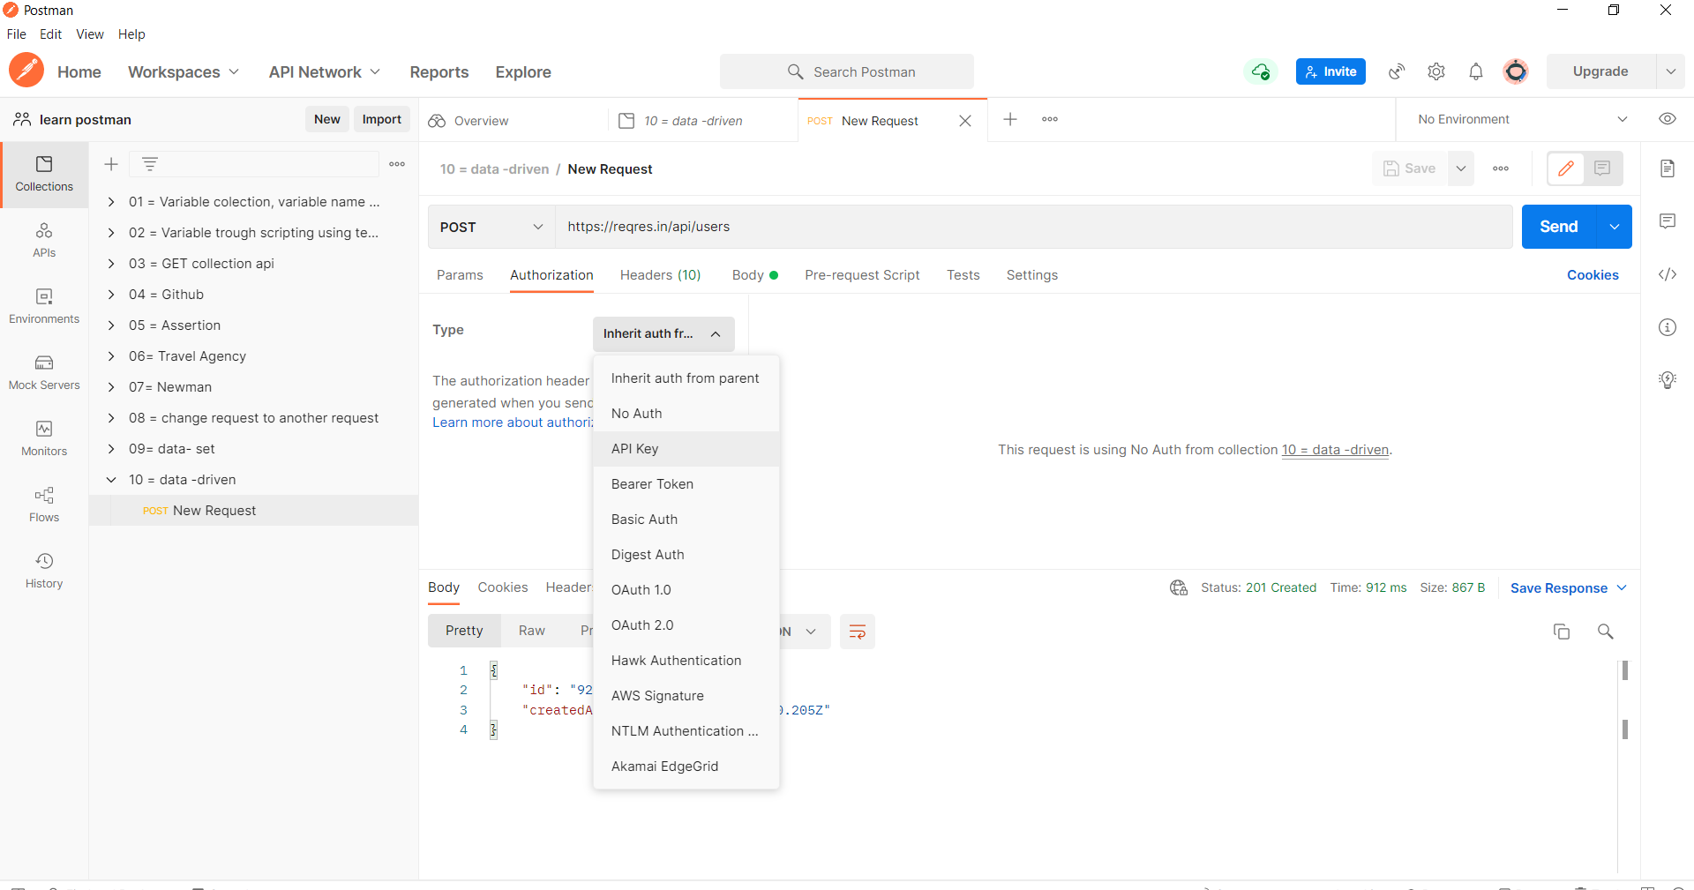

Postman Objects

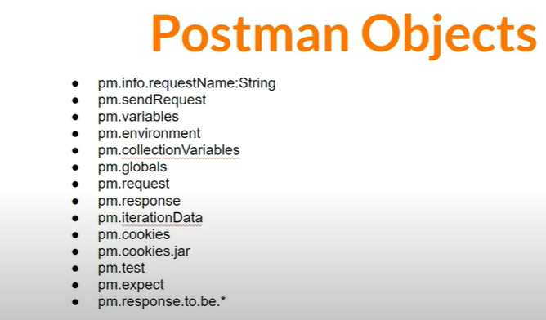

Postman Variables

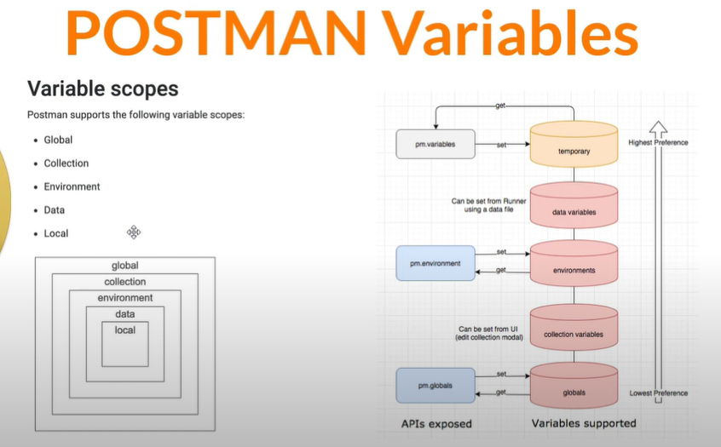

Crud = create read update delete

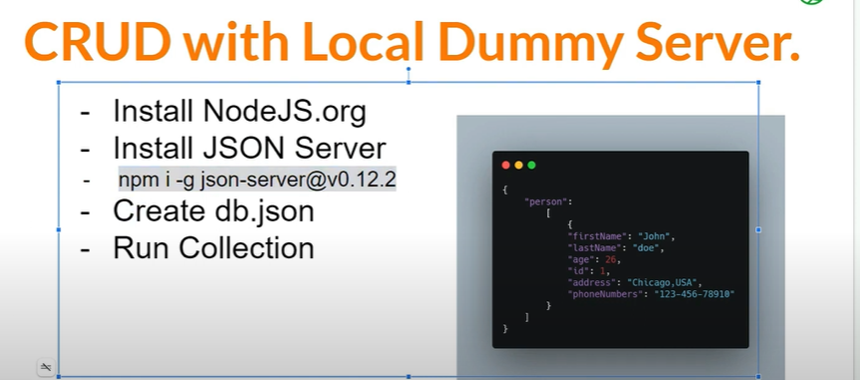

Data-Driven

* open this :-
* <https://app.vwo.com/#/login>
* Create a account for testing

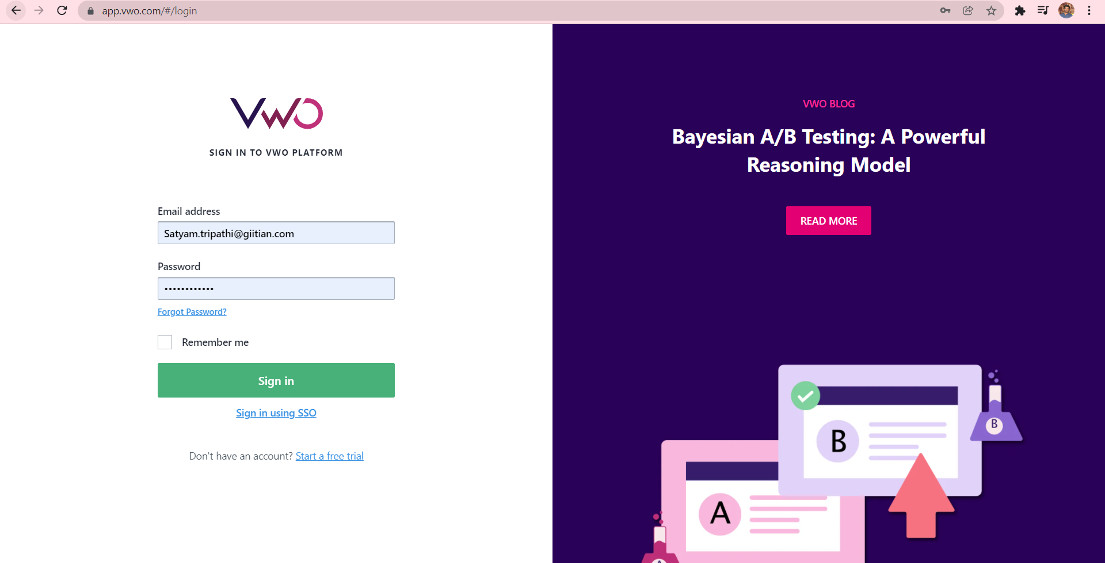

* Open inspect and go to network and clear all logs after clearing logs then sign it account.

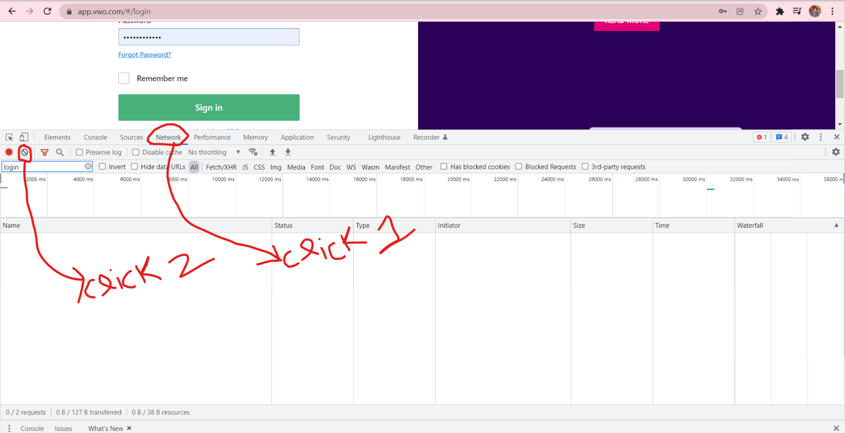

* After sign it filter login & after filtering click login left click and go to copy and copy , choose copy as cURL (bash)

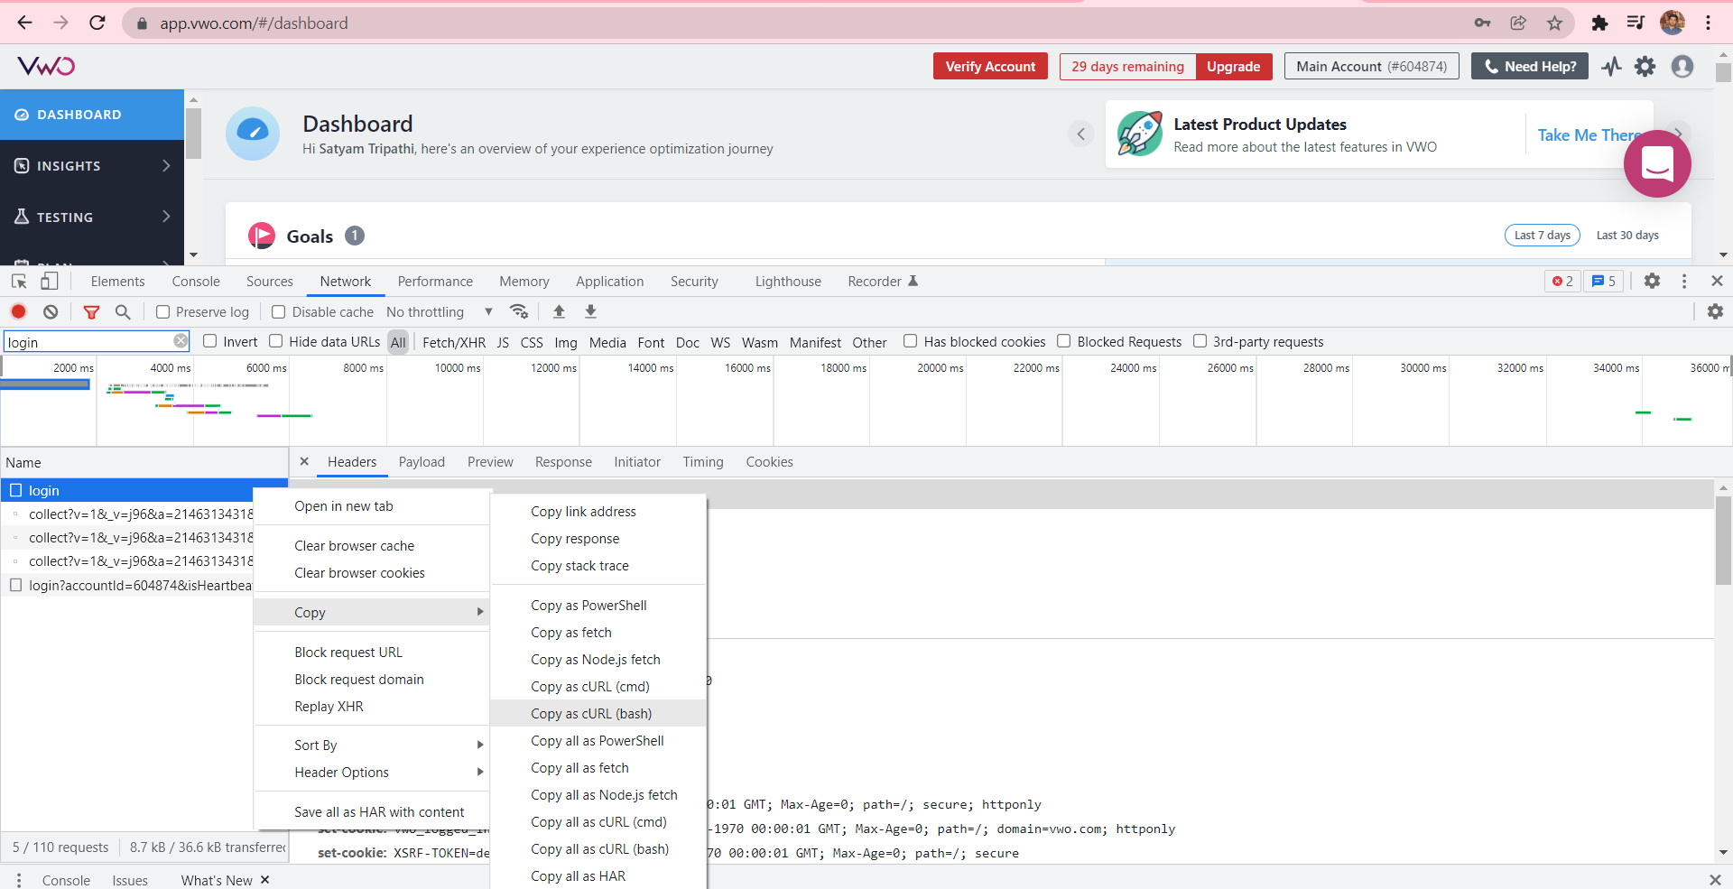

* Open postman and create a collection and select collection and then choose import option, when import option is open select raw text .

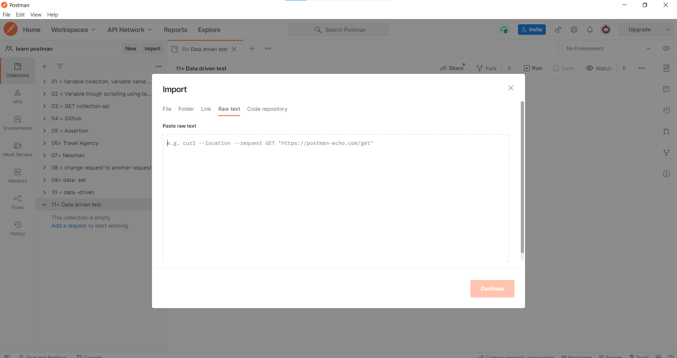

**-> paste in raw text,** copy as cURL (bash), then click continue

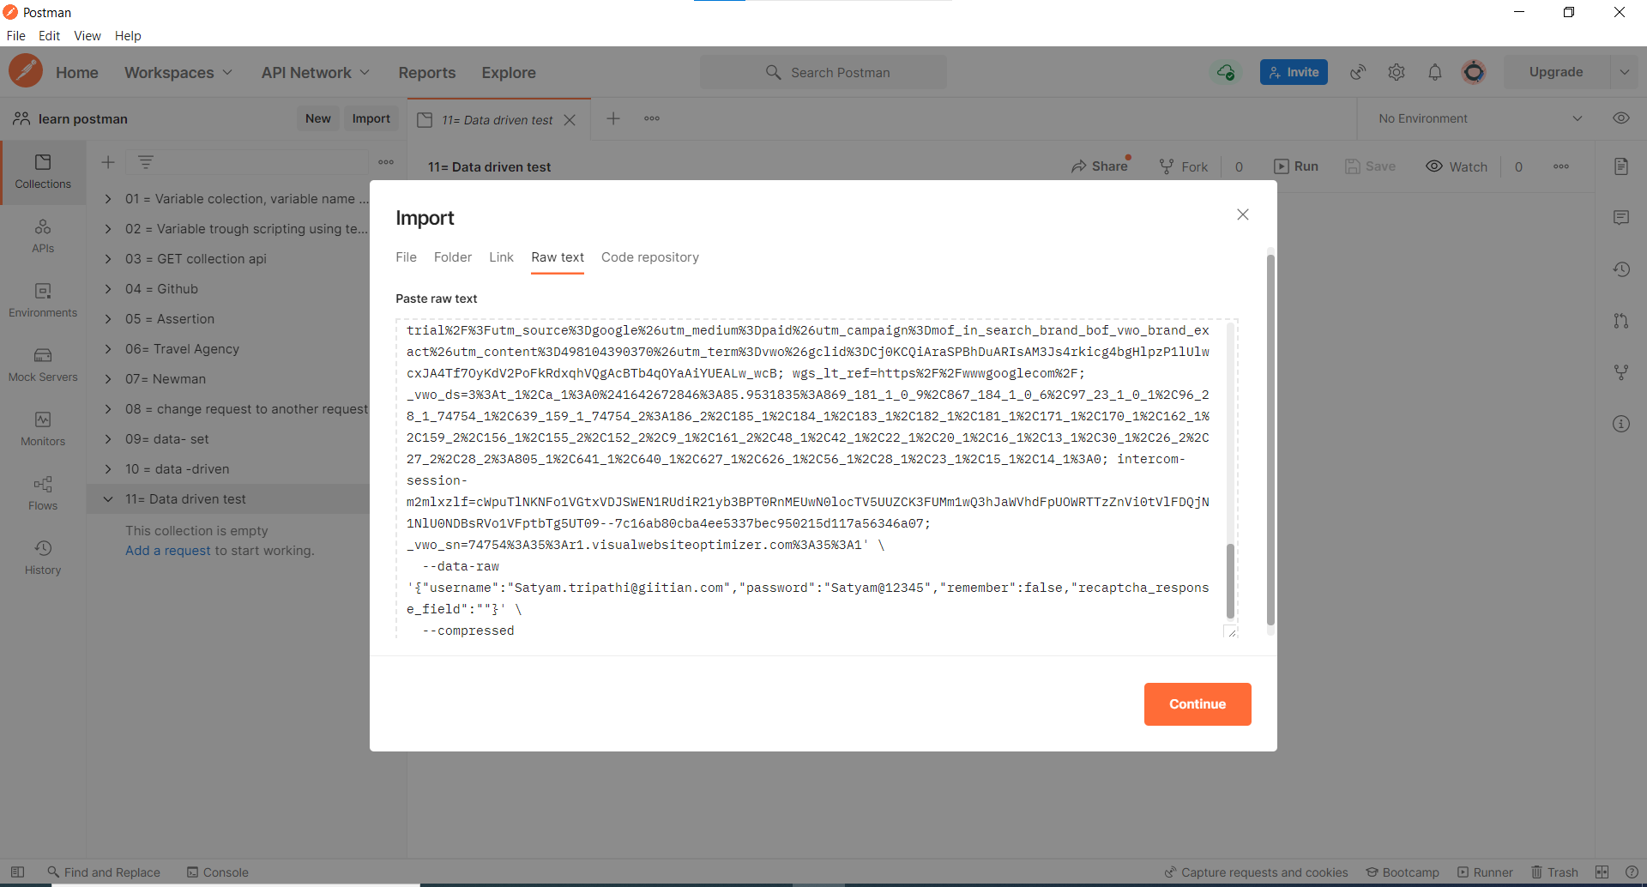

* **Click import**

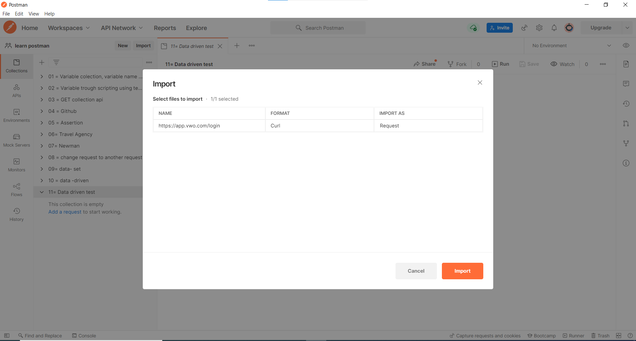

* **Open body and then send a request you see your login credentials are visible in body**
* **Status code is 200 come**

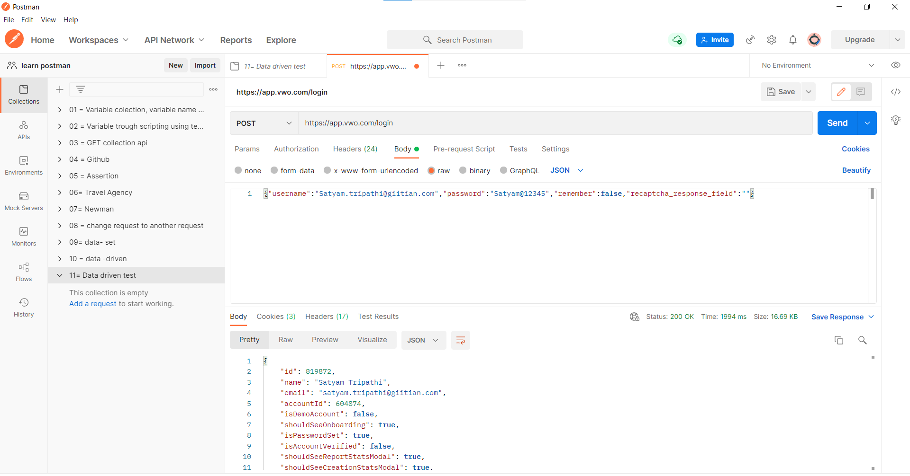

**Cross checking :-**

* **First clear all cookies in postman tool ,because everytime when you run your request, cookies can store your data, so before running your new request clear your cookies.**

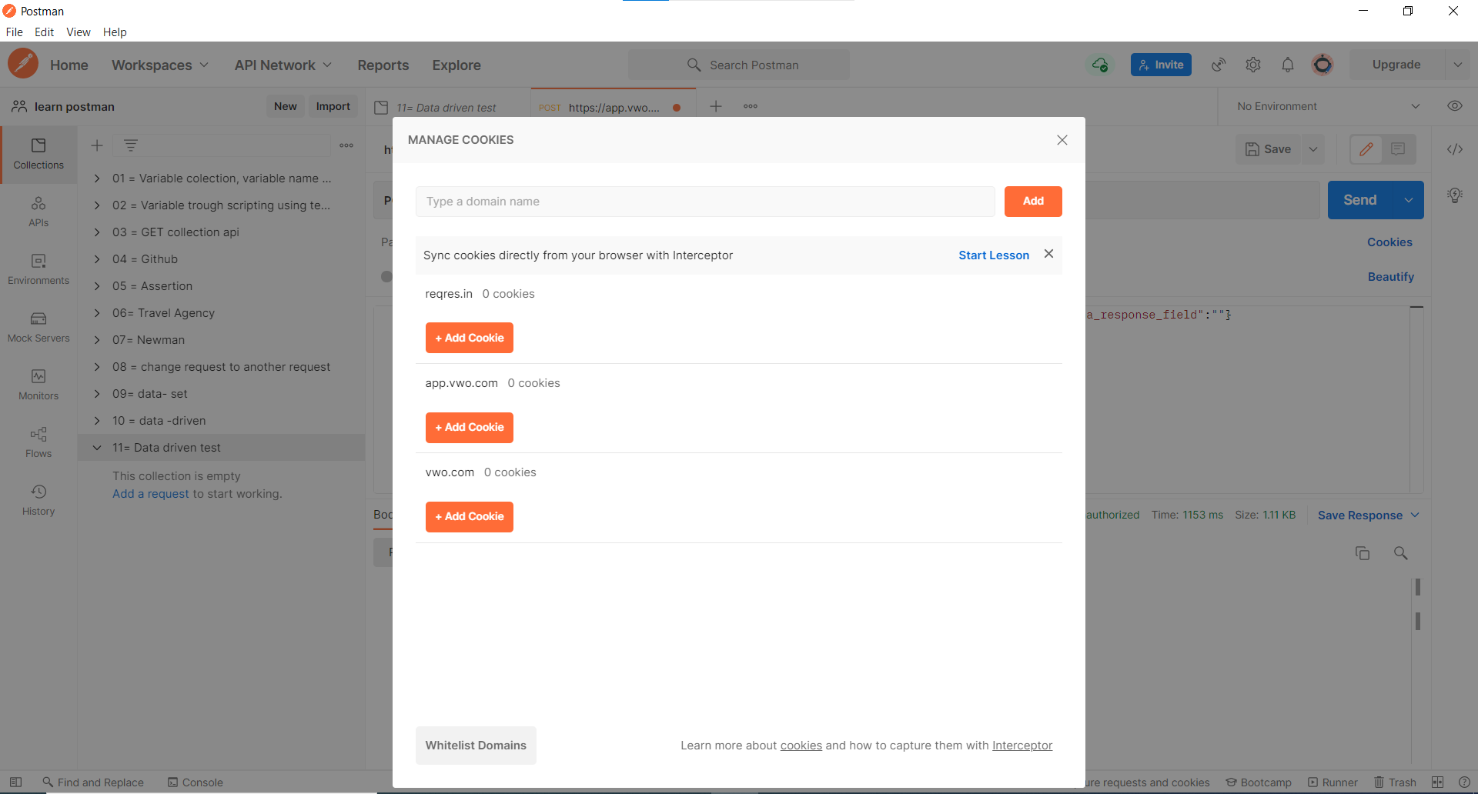

* **After clearing cookies, I change my password and send request I got invalid user.**

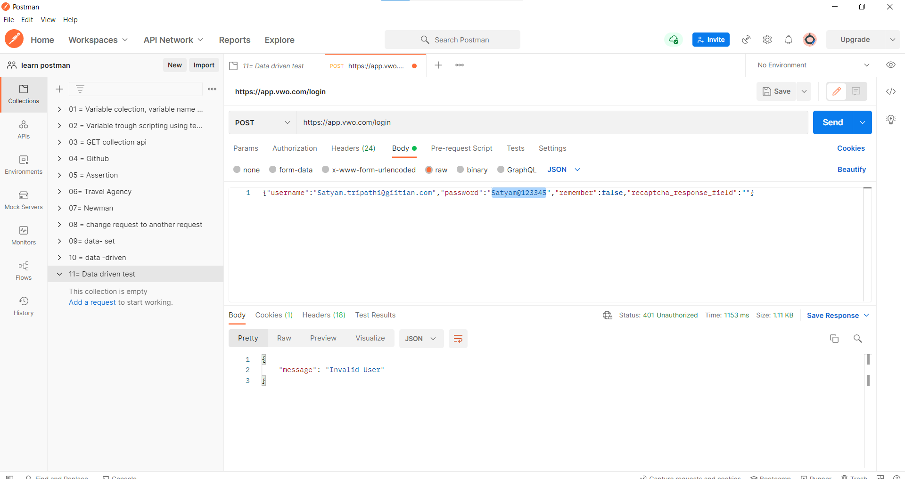

**Swagger**

* Swagger allows you to describe the structure of your APIs so that machines can read them
* Swagger includes automated documentation, code generation, and test-case generation.
* **Why is it so great?** Well, by reading your API’s structure, we can automatically build beautiful and interactive API documentation.

**DATA Driven Collection Run using CSV file**

* **Create csv file with login details.**

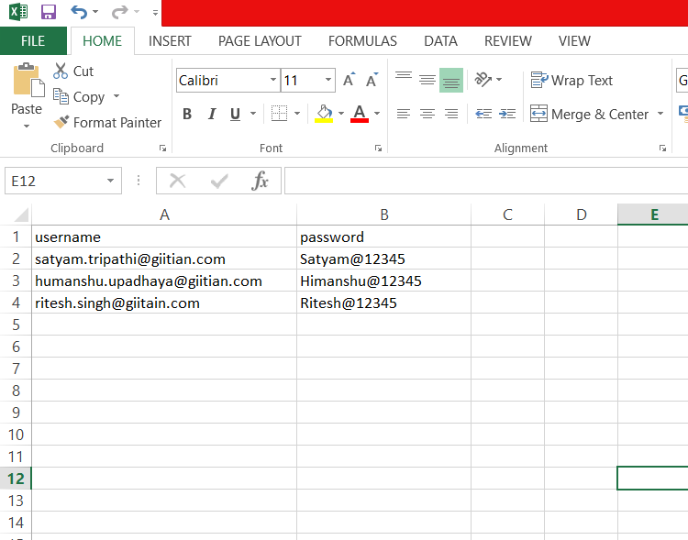

* **In body we define key value pair , key is username and value is also username, it means value username is fetch in csv file and same procedure in password also.**

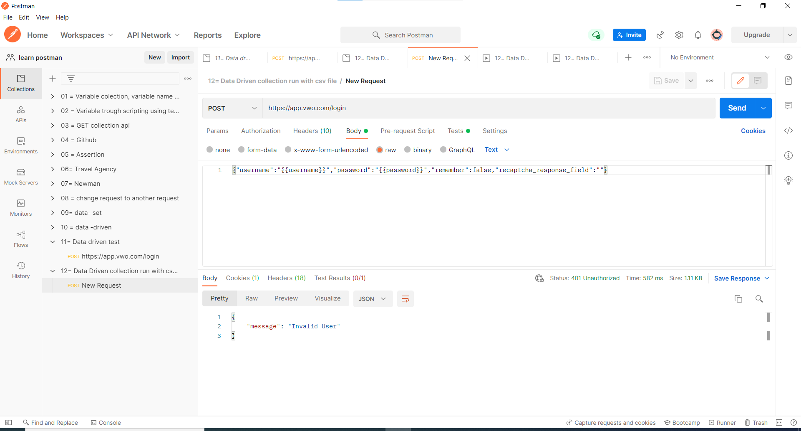

* **In test case we write status code is 200**

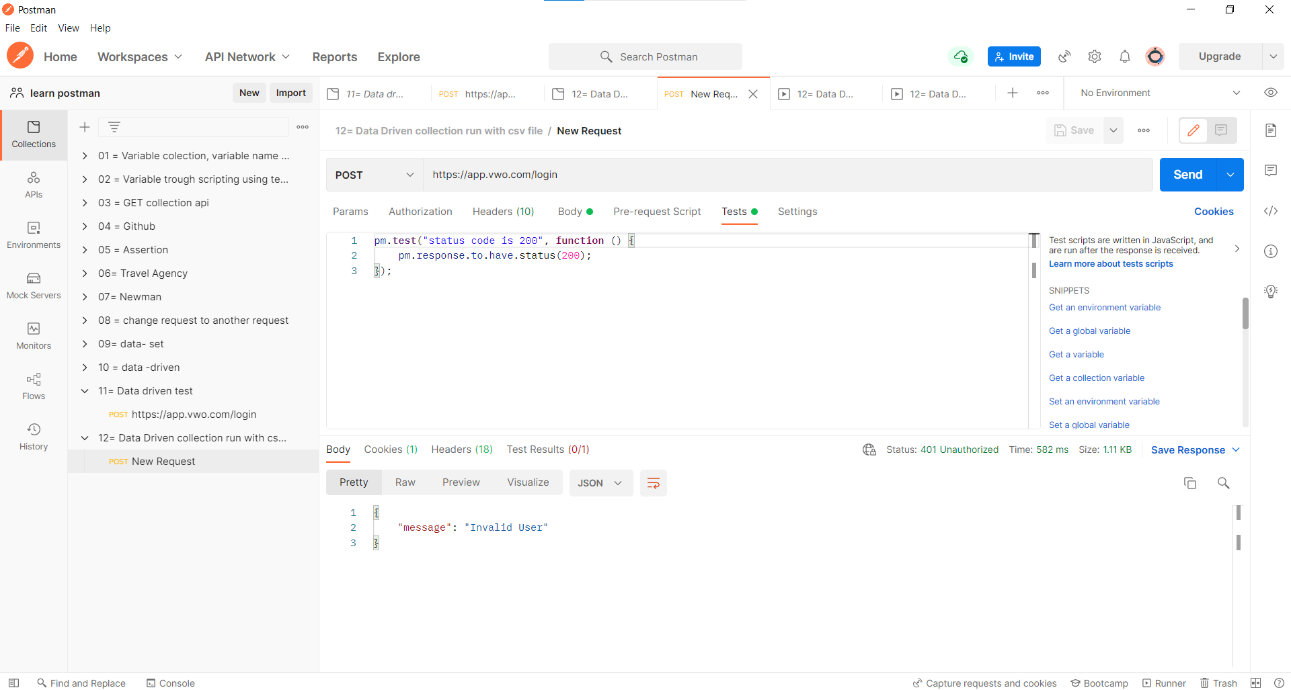

* **Run collection and select csv file**

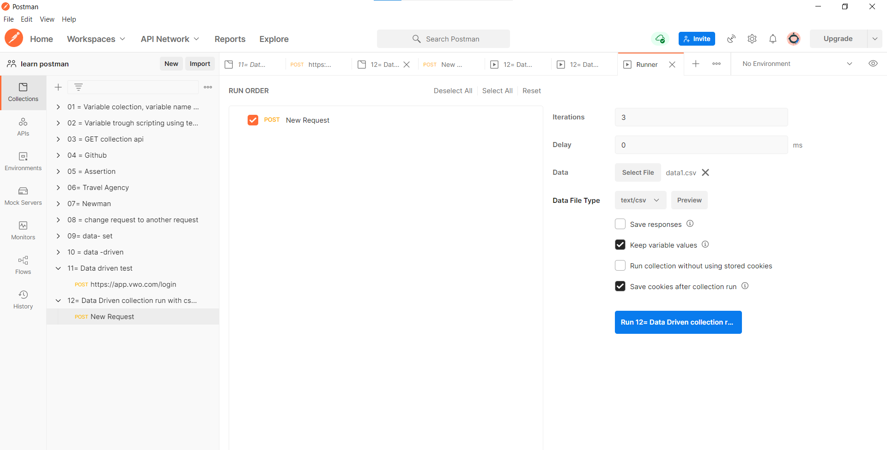

* **See csv file preview**

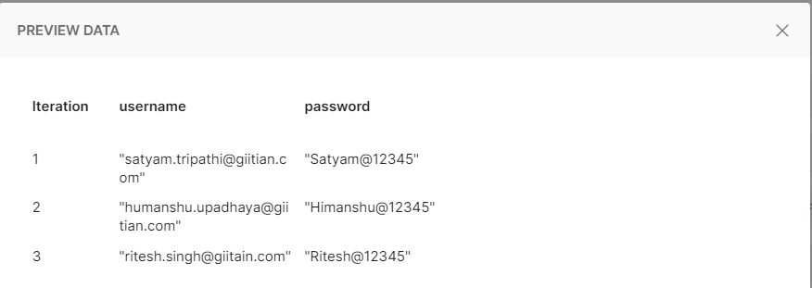

* **Run collection & we see the status .**

